Thoracolumbar junction traumatic injury: the role of crosslinks and pedicle screw insertion depth in lateroflexion
Oleksii S. Nekhlopochyn, MD, PhD, Department of spinal neurosurgery, Romodanov Neurosurgery Institute, Kiev, Ukraine
Vadim V. Verbov, MD, PhD; Iaroslav V. Tsymbaliuk, MD, PhD, Restorative Neurosurgery Department, Romodanov Neurosurgery Institute, Kyiv, Ukraine
Michael Yu. Karpinsky, MD, PhD; Oleksandr V. Yaresko; Laboratory of biomechanics, Sytenko Institute of Spine and Joint Pathology, Kharkiv, Ukraine

The zone of the thoracolumbar junction is the most susceptible to traumatic injuries due to anatomical and physiological features. Accordingly, the stabilization of this spine requires high reliability. Extensive clinical experience of transpedicular stabilization usage has revealed a number of factors hypothetically or actually determining the reliability of fixation.

Objective: to study the stress-strain state of the model of the thoracolumbar spine after resection of the Th12‒L1 vertebrae with different types of transpedicular fixation under asymmetric loads (lateroflexion).

Materials and methods. We used a mathematical finite element model to study the result of decompression-stabilizing surgery of the thoracolumbar junction. Lateroflexion was modeled by applying a load of 350 N acting from right to left on the body and facet processes of the Th9 vertebra. We studied the depth of screw insertion and the use of crosslinks.

Results. When evaluating the model without crosslinks and using monocortical pedicle screws, it was found that the maximum loading values in the Th10, Th11, L2, and L3 vertebral bodies were 3.4, 2.0, 3.5, and 8.6 MPa, respectively; and in the screws in these vertebrae - 48.4, 48.3, 23.3 and 43.5 MPa. When using bicortical screws without crosslinks - respectively 3.1, 2.5, 3.8, 9.6 MPa and 49.9, 51.9, 25.8, 44.8 MPa for bodies and screws; when using a combination of short screws and crosslinks - 3.2, 2.0, 2.6, 7.5 MPa and 47.6, 47.5, 22.6, 41.2 MPa; when using crosslinks and bicortical screws - 3.0, 2.2, 2.7, 8.8 MPa and 48.3, 49.6, 24.3, 42.5 MPa.

Conclusions. In lateroflexion monocortical pedicle screws cause lower critical loading rates compared to long screws at all control points of the model. Crosslinks in combination with both short and long screws help to reduce stress levels.

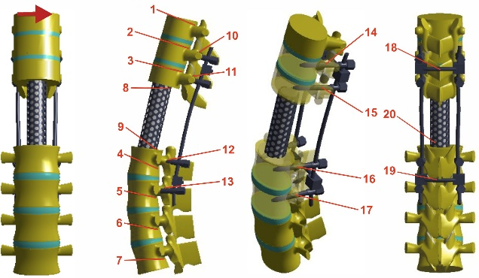
Fig. 1. The scheme of the load and the arrangement of control points.
- Kuklo TR, Dmitriev AE, Cardoso MJ, Lehman RA, Jr., Erickson M, et al. (2008) Biomechanical contribution of transverse connectors to segmental stability following long segment instrumentation with thoracic pedicle screws. Spine (Phila Pa 1976) 33(15):E482-487.
- Lynn G, Mukherjee DP, Kruse RN, Sadasivan KK, Albright JA (1997) Mechanical stability of thoracolumbar pedicle screw fixation. The effect of crosslinks. Spine (Phila Pa 1976) 22(14):1568-1572; discussion 1573.
- Mina A, Mohammed RAK. (2018) Biomechanical Evaluation of Segmental Pedicle Screw Fixation in Thoracolumbar Fracture: A Finite Element Study. Orthopedics and Rheumatology Open Access Journal 12(3).
- Nekhlopochyn OS, Verbov VV, Karpinsky MY, Yaresko OV (2021) Biomechanical evaluation of the pedicle screw insertion depth and role of cross-link in thoracolumbar junction fracture surgery: a finite element study under compressive loads. Ukrainian Neurosurgical Journal 27(3):25-32.
- Wang T, Cai Z, Zhao Y, Wang W, Zheng G, Wang Z, et al. (2019) The Influence of Cross-Links on Long-Segment Instrumentation Following Spinal Osteotomy: A Finite Element Analysis. World Neurosurg 123:e294-e302.



Dr. Nekhlopochyn Oleksii specialized in neurosurgery and traumatology. He is a researcher at the Clinic of Spinal Neurosurgery of Romodanov Neurosurgery Institute of National Academy of Medical Sciences of Ukraine. The main direction of scientific activity is the development and optimization of methods of therapy for patients with traumatic spine and spinal cord injuries.

Email: AlexeyNS@gmail.com
Mobile no/Whatsapp no: +380950330448

Additional Details
Abstract Category:

