Posterior surgery for irreducible traumatic spondyloptosis of thoracolumbar junction (a small case series)
Oleksii S. Nekhlopochyn, MD, PhD, Department of spinal neurosurgery, Romodanov Neurosurgery Institute, Kiev, Ukraine
Vadim V. Verbov, MD, PhD; Iaroslav V. Tsymbaliuk, MD, PhD; Milan V. Vorodi, MD; Ievgen V. Cheshuk, MD, Restorative Neurosurgery Department, Romodanov Neurosurgery Institute, Kyiv, Ukraine

The thoracolumbar junction is the most common location of traumatic spinal injuries. Spondyloptosis is rather rare, but one of the most severe types of traumatic injury.

Objective. To determine the optimal surgical technique for traumatic irreducible spondyloptosis of thoracolumbar junction.

Materials and methods. We analyzed treatment outcomes of five patients with irreducible spondyloptosis of thoracolumbar junction (mean age 31.2 years). The minimum period from the moment of injury to surgery was 14 days, the maximum was 3 months and 2 days (on average 42.2 days).

Results. At the time of admission all patients had a neurological deficit that corresponds to the functional class A on the American spine injury associatin ASIA scale of severity of spinal cord injury. The TLICS score was 8 points. All the patients had the injury of lateral spondyloptosis type: in three cases as an isolated displacement only in the coronal plane, in two – as a combined one - in the coronal and sagittal plane. Surgical intervention in all cases was performed from the posterior approach. As a body replacement system in 2 patients, a vertical cylindrical implant was used, in 3 patients - a telescopic body replacing implant. The transpedicular system was strengthened by two cross links of the rod-to-rod type. In all cases the restoration of spinal axis was achieved in both the coronal and sagittal planes. Follow-up examinations were carried out 2, 6 and 12-18 months of the postoperative period. Regression of neurological disorders was registered in two patients, in one case to ASIA B, in the other to ASIA C.

Conclusions. Isolated posterior approach has demonstrated high efficacy in the surgical management of traumatic irreducible spondyloptosis of the thoracolumbar junction both in restoring the axis of the spine and in ensuring the stability of fixation.

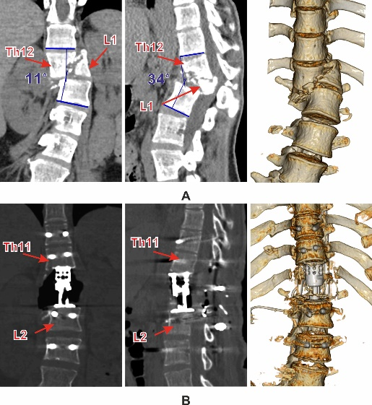
Fig. 1. Clinical case: 21 yo F. A – before surgery; B – after surgery

- Bellew MP, Bartholomew BJ (2007) Dramatic neurological recovery with delayed correction of traumatic lumbar spondyloptosis. Case report and review of the literature. J Neurosurg Spine 6(6), 606-610.
- Garg M, Kumar A, Sawarkar DP, Singh PK, Agarwal D, et al (2018) Traumatic Lateral Spondyloptosis: Case Series. World Neurosurg, 113, e166-e171.
- Kumar S, Patralekh MK, Boruah T, Kareem S A, Kumar A, et al (2020) Thoracolumbar fracture dislocation (AO type C injury): A systematic review of surgical reduction techniques. J Clin Orthop Trauma 11(5), 730-741.
- Meneghini RM, DeWald CJ (2003) Traumatic posterior spondyloptosis at the lumbosacral junction. A case report. J Bone Joint Surg Am 85(2), 346-350.
- Nekhlopochyn OS, Verbov VV, Cheshuk IV, Vorodi MV (2021) Surgical management of traumatic irreducible spondyloptosis of thoracolumbar junction. Ukrainian Neurosurgical Journal 27(2), 56-64.



Dr. Nekhlopochyn Oleksii specialized in neurosurgery and traumatology. He is a researcher at the Clinic of Spinal Neurosurgery of Romodanov Neurosurgery Institute of National Academy of Medical Sciences of Ukraine. The main direction of scientific activity is the development and optimization of methods of therapy for patients with traumatic spine and spinal cord injuries.

Email: AlexeyNS@gmail.com
Mobile no/Whatsapp no: +380950330448

Additional Details
Abstract Category:

