Our experience of hyperbaric oxygenation therapy usage in treatment of spinal cord injury
Oleksii S. Nekhlopochyn, MD, PhD, Department of spinal neurosurgery, Romodanov Neurosurgery Institute, Kiev, Ukraine
Igor V. Voronov, MD, Department of Hyperbaric Oxygenation, Romodanov Neurosurgery Institute, Kyiv, Ukraine
Vadim V. Verbov, MD, PhD, Restorative Neurosurgery Department, Romodanov Neurosurgery Institute, Kyiv, Ukraine

One of the promising directions in the treatment and rehabilitation of patients with spinal cord traumatic injury is the use of hyperbaric oxygenation (HBO). Experimental models have shown that HBO has a neuroprotective effect in spinal cord injury, but the results of clinical application of the method are still contradictory.

Objective: to determine the effectiveness of HBO in the complex therapy of victims with traumatic spinal cord injury and the feasibility of further study of this area.

Materials and Methods: Study design - pilot observational retrospective case - control. When selecting a control for each clinical case, the following factors were considered: gender, age, circumstances of injury, type of damage to the osteoligamentous apparatus, level of neurological deficit, degree of damage and compression of the spinal cord, time elapsed from the moment of injury to surgery. We analyzed 28 "case ‒ control" pairs. The main criterion for the effectiveness of therapy was the change in the functional class according to the ASIA scale.

Results. Positive dynamics was registered in 57% of victims, including in the group of patients receiving HBO therapy - in 71%, in the control group - in 43%. HBO therapy in the postoperative period significantly affects the dynamics of regression of neurological disorders (p = 0.0295). Odds ratio - 3.333 (95% confidence interval - 1.098‒10.116, p = 0.0335). The calculation of the odds ratio, adjusted for additional analyzed factors, showed a more pronounced efficiency - 4.519 (95% confidence interval - 1.279‒15.962, p = 0.0192).

Conclusions. The obtained results indicate that usage of HBO as a method of complex therapy for traumatic spinal cord injury is promising for further study in order to determine the effectiveness of the method, the optimal timing of treatment initiation in the postoperative period and its duration.

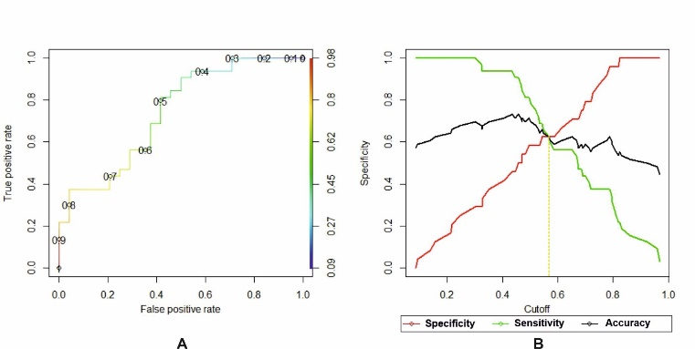
Fig. 1. Graphic characteristic of the predictive efficiency of the model: A - ROC-curve; B - the ratio of sensitivity and specificity of the model, determination of the cut-off level

- Ahmadi F, Khalatbary AR (2021) A review on the neuroprotective effects of hyperbaric oxygen therapy. Medical gas research. 11(2):72-82.
- Nekhlopochyn OS, Voronov IV, Verbov VV (2021) Hyperbaric oxygenation therapy in treatment of traumatic spinal cord injury: a pilot study Ukrainian Neurosurgical Journal, 27(4), 16-22.
- Patel NP, Huang JH (2017) Hyperbaric oxygen therapy of spinal cord injury. Medical gas research. 7(2):133-143.
- Tai PA, Chang CK, Niu KC, Lin MT, Chiu WT, Lin CM (2010) Attenuating experimental spinal cord injury by hyperbaric oxygen: stimulating production of vasculoendothelial and glial cell line-derived neurotrophic growth factors and interleukin-10. J Neurotrauma 27(6):1121-1127.
- Wang L, Li W, Kang Z, Liu Y, Deng X, Tao H, et al (2009) Hyperbaric oxygen preconditioning attenuates early apoptosis after spinal cord ischemia in rats. J Neurotrauma 26(1):55-66.



Dr. Nekhlopochyn Oleksii specialized in neurosurgery and traumatology. He is a researcher at the Clinic of Spinal Neurosurgery of Romodanov Neurosurgery Institute of National Academy of Medical Sciences of Ukraine. The main direction of scientific activity is the development and optimization of methods of therapy for patients with traumatic spine and spinal cord injuries.

Email: AlexeyNS@gmail.com
Mobile no/Whatsapp no: +380950330448

Additional Details
Abstract Category:

