Neuropathic pain and neurological disorders regression after spinal cord injury
Oleksii S. Nekhlopochyn, MD, PhD, Department of spinal neurosurgery, Romodanov Neurosurgery Institute, Kiev, Ukraine
Vadim V. Verbov, MD, PhD; Iaroslav V. Tsymbaliuk, MD, PhD; Milan V. Vorodi, MD; Ievgen V. Cheshuk, MD, Restorative Neurosurgery Department, Romodanov Neurosurgery Institute, Kyiv, Ukraine

Neuropathic pain is one of the main secondary complications of spinal cord injury. This type of pain is formed directly in the area of the spinal cord injury; therefore, it can be assumed that its intensity can characterize both degenerative and reparative processes.

Objective: to assess the possible relationship between the intensity of neuropathic pain in patients with spinal cord injury and the dynamics of neurological disorders regression.

Materials and methods. We performed a retrospective analysis 102 patients. The level of neurological disorders and the intensity of neuropathic pain were assessed within 5–7 and 11–13 months after spinal cord injury. All patients were divided into three groups depending on the pain intensity: 1) absence of constant pain sensations - 19.6% of victims, 2) moderate pain - 56.9%, 3) severe neuropathic pain – 23.5%.

Results. In the first group, the regression of neurological disorders was 3.5 (95% CI 2.15-6.15) points, in the second - 25.0 (95% CI 24.14-29.58) points, in the third - 13.0 (95% CI 10.87-16.55) points (p <0.0001). In patients with severe neurological disorders, the dynamics of recovery did not correlate with the pain intensity. With ASIA B patients in group 1 the dynamics was 8.5 (95% CI -10.56-27.56) points, in group 2 - 15.0 (95% CI 13.41-18.41) points, in the 3rd group - 10.5 (95% CI 7.45-14.89) points. In patients with functional class ASIA C the difference is even more pronounced: in group 1, the median was 8.0 (95% CI -0.83–20.83) points, in group 2 - 32.0 (95% CI 25.41-36.86) points, in the third - 15.5 (95% CI 10.27-27.4) points. With ASIA D, a similar trend was observed.

Conclusions. The worst regression of neurological disorders is observed in patients without clinically significant pain, the best results showed patients with moderate neuropathic pain.

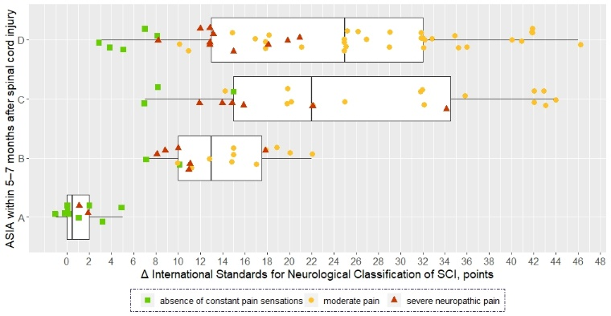
Fig.1. Dynamics of neurological disorders regression in patients with different ASIA functional class of and the severity of neuropathic pain

- Cragg J J, Haefeli J, Jutzeler C. R, Rohrich F, Weidner N, Saur M, et al (2016) Effects of Pain and Pain Management on Motor Recovery of Spinal Cord-Injured Patients: A Longitudinal Study. Neurorehabil Neural Repair 30(8): 753-761.
- Felix E R (2014) Chronic neuropathic pain in SCI: evaluation and treatment. Phys Med Rehabil Clin N Am 25(3): 545-571, viii.
- Nekhlopochyn O S, Verbov V V, Tsymbaliuk I V (2021) Pain type and intensity in long-term spinal cord injury. International neurological journal 17(4): 15-25.
- Nekhlopochyn O S, Verbov V V, Tsymbaliuk I V, Vorodi M V, Cheshuk I V (2021) Neuropathic pain as a predictor of neurological disorders regression in patients with spinal cord traumatic injury. Pain. Joints. Spine. 11(3): 25 - 32.
- Siddall P J, Middleton J W (2015) Spinal cord injury-induced pain: mechanisms and treatments. Pain Manag 5(6): 493-507.



Dr. Nekhlopochyn Oleksii specialized in neurosurgery and traumatology. He is a researcher at the Clinic of Spinal Neurosurgery of Romodanov Neurosurgery Institute of National Academy of Medical Sciences of Ukraine. The main direction of scientific activity is the development and optimization of methods of therapy for patients with traumatic spine and spinal cord injuries.

Email: AlexeyNS@gmail.com
Mobile no/Whatsapp no: +380950330448

Additional Details
Abstract Category:

