Safety and Effectiveness of Posterior Cervical Stabilization System (PCSS) as an adjunct to posterior cervical fusion (PCF) when used in combination with ACDF in the treatment of multi-level degenerative disc disease (FUSE STUDY)
Author: Dr. Bruce McCormack UCSF Clinical Faculty Department of Neurosurgery

Abstract
Anterior cervical discectomy and fusion is the most common surgical treatment for cervical spondylosis with radiculopathy and myelopathy. Non union remains a significant problem in patients with multilevel fusions, and those patients with diabetes, poor bone quality and smokers. Rates of pseudoarthrosis vary from 0-20% in 1-2 level fusions to > 60% in multilevel fusions. While 25-30% of those patients with pseudoarthrosis are asymptomatic, many require revision fusion.
Dr. McCormack and Providence Medical Technology is conducting an FDA investigational devise exemption study comparing outcomes of patients with 3 level ACDF versus 3 level ACDF plus adjunctive posterior cervical fusion (PCF) using a posterior stabilization system (PCSS). PCSS is non-segmental instrumentation with integrated screw fixation intended to provide immobilization and stabilization of spinal segments. PCSS achieves bilateral facet fixation by spanning the interspace at each level with points of fixation at each end of the construct.
Patients are randomly assigned to ACDF alone or a circumferential cervical fusion (CCF). Those patient with diabetes, history of tobacco use and osteopenia are not excluded from enrollment so the study reflects real world use scenarios.
The study is enrolling 300 patients at 18 sites in the United States. Primary endpoint is fusion on CT scan and dynamic x-ray films at 12 months. Non-inferiority composite safety success in CCF compared to ACDF is determined at 24 months. An individual subject is considered a success if all of the following criteria are met: a. Fusion success as evidence of bridging trabecular bone across endplates and < 2° total angular motion, b. improvement in neck disability Index (NDI), c. improvement in neurologic function, d. absence of secondary surgical interventions.
For those patients with ACDF and symptomatic non union at 12 months they can cross over to the circumferential arm.
Dr. McCormack will discuss the study rationale, design and status and his personal experience with cervical non-union.

Image
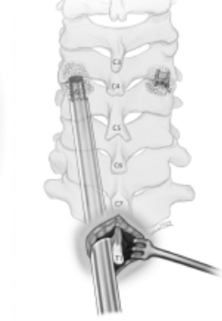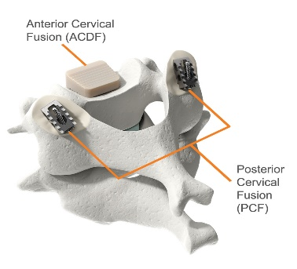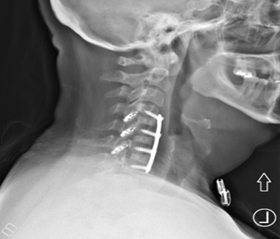

Recent Publications
- Leo Cheng MD, Bruce McCormack MD, Edward Eyster MD (2019) Posterior cervical fusion utilizing cages placed bilaterally in the facets for the treatment of the upper cervical adjacent segment disease in the elderly. Journal of Clinical Neuroscience 63 (2019) 149-154.
- William Smith MD, Mark Gillespy MD, Jason Huffman MD, Veasna Vong BS, Bruce McCormack MD. (2017) Anterior Cervical Pseudoarthrosis Treated with Bilateral Posterior Cervical Cages. DOI: 10.1093/ons/opx103.
- Bruce McCormack MD, Edward Eyster MD, John Chiu MD, Kris Siemionow (2016) Minimally Disruptive Posterior Cervical Fusion with DTRAX Cervical Cage for Single Level Radiculopathy – Results in 10 Patients at 1-Year. iMedPub Journals http://www.imedpub.com/
- Krzysztof Siemionow, Pawel Glowka, Robert Blok, Mark Gillespy, Mukund Gundanna, William Smith, Zeshan Hyder, Bruce McCormack (2017) Perioperative Complications in patients treated with posterior cervical fusion and bilateral cages. DOI: 10.4103/jcvjs.JCVJS_61_17.

5. Kris Siemionow, Piotr Janusz, Frank Phillips, Jim Youssef, Robert Isaacs, Marcin Tyrakowski, Bruce McCormack (2016) Clinical and Radiographic Results of Indirect Decompression and Posterior Cervical Fusion for Single-level Cervical Radiculopathy Using an Expandable Implant with 2-Year Follow-Up. J Neurol Surg A 2016;77:482-488.

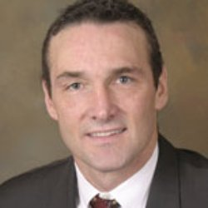

Biography

Dr. Bruce McCormack is a neurosurgeon in San Francisco. He graduated from Brown University in 1982 and obtained a medical degree from Columbia Physicians and Surgeons in 1986. He finished a six-year neurosurgery residency at NYU in 1992 and then two fellowships in spinal surgery at the University of Florida and University of New Mexico. In 1994 Dr. McCormack was Assistant Professor at UCSF, Department of Neurosurgery and later became Director of the Spine Neurosurgery Service. Dr. McCormack has published multiple articles, abstracts and chapters in the field of spine surgery. Dr. McCormack started a neurosurgery private practice in San Francisco in 1998 which remains active to present. Dr. McCormack founded 2 medical device companies and is an angel investor in several medical technology companies.
Email: bmccormack@neurospine.org
Office no/415-923-9222
Additional Details
Abstract Category:

