Spinal hydatidosis (About 05cases).

Dr GHOUL R B , Department of Neurosurgery ,Central Hospital of the Army, Algiers .Algeria.

Abstract
I- Introduction:
- Vertebral hydatidosis is a parasitosis caused by echinococcosis granulosus, it is rare, less than 0.2–1% of all locations.
- This localization is often discovered at the stage of neurological complications, it is burdened with significant morbidity and mortality.
II- Materials and methods:
We report five cases: Four men and one woman consult urgently for various symptoms: spinal pain, numbness in the lower limbs.
Neurological examination revealed in 4 cases dorsal spinal cord compression syndrome and in one case lumbar spinal syndrome.
- MRI of the spine performed in our 5 patients showed multiple cystic lesions of the vertebral body and intracanal and in one case and isolated involvement of the vertebral body.
Positive hydatid serology in all 4 cases.
The Treatment
-Four (4) patients operated on as part of the emergency with a wide laminectomy with evacuation of the vesicles (Fig.1).
-Microscopic examination concludes hydatid cysts.
- Adjuvant chemotherapy :Albendazoles.
Results:
The outcome was favorable in four cases, one re-operated for local recurrence..
III- Conclusion:
Spinal hydatidosis is a rare condition with a poor prognosis. Due to the risk of neurological damage, the frequency of recurrences and treatment difficulties.
.

Image
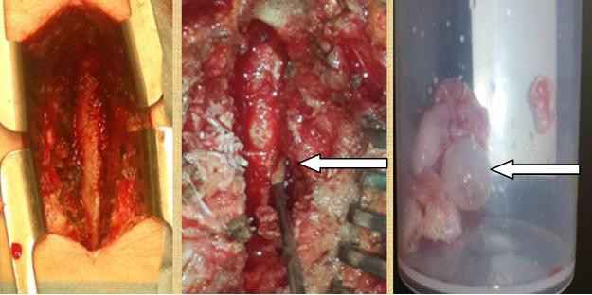

Fig .1: wide laminectomy with excision of cysts.

Recent Publications
- Gouse, M., et al., Recurrent Echinococcal Infection of the Lumbar Spine: An 11 Year Follow-up. Asian Spine J, 2013. 7(1): p. 39-43.
- Hamdan T. Hydatid disease of the spine: a report on nine patients. Int Orthop. 2012;36:427-32 .
- Bhake, A. and A. Agrawal, Hydatid disease of the spine. Journal of neurosciences in rural practice, 2010. 1(02): p. 061-062.
- Lakhdar F, Arkha Y, A, El Khamlichi A. Spinal intradural extramedullary hydatidosis: report of three cases. Neurosurgery. 2009;65:372-6; discussion 376-7 .
- -Briant JF,Richez P, Belliol E, Baréa D, Raillat A et all. Atteintes ostéo-articulaires d’origine parasitaire: L’échinococcose osseuse. J Radiol 1998;79:1351-7.

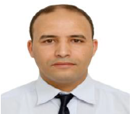Biography
Dr GHOUL Born May 28, 1978 in TIARET, ALGIERS, bachelor in 1996, science of life and nature, to join the faculty of medicine in ORAN and graduated in 2003 general practitioner.
He trained at the Faculty of Medicine of ALGIERS, to become a neurosurgeon in 2012
Doctor of medical science in 2020 after his thesis defense entitled (place of surgery in the treatment of degenerative painful lumbar disc disease)
Currently he is working as a professor of neurosurgeon at Department of Neurosurgery - Central Hospital of the Army, Algiers .Algeria..
Email: ghoulrachid16@gmail.com

