MR Neurography and MR tractography of the brachial plexus
Ibrahim Ibrahim, MSc., PhD, IKEM, Prague, Czech public
Antonín Škoch, MD, Ph.D. IKEM, Prague, Czech public
Ivan Humhej, MD, Ph.D., Department of Neurosurgery, Masaryk Hospital, Ústí nad Labem, Czech Republic
Beran Jan, MD, Flusserová Vlasta, MD, Juhaňákova Martina, MD, Brzák Michal, MD,
Eva Rolencová, MD, and Jaroslav Tintěra, Ph.D., IKEM, Prague, Czech public

Abstract
The brachial plexus (BP) represents an important neural structure that provides motor and sensitive innervation of the upper extremity. Brachial plexus injury is one of the most common injury in young people of working age, causing socio-economic problems and psychiatric disorders. The goal of the proposed study is to optimize, improve and develop new techniques for imaging of the brachial plexus using qualitative and quantitative advanced MRI methods including structural 3D MR neurography (MRN) and diffusion tensor imaging (DTI). MRN provides an excellent evaluation of 3D anatomy of peripheral nerves in multiple planes. DTI methods can be used to assess the microstructure of axonal bundles and to depict the integrity of brachial plexopathies based on diffusion properties of the PB tissue. Methodology: 12 subjects (8 controls/4 patients with root avulsions) underwent MR examination on a 3T MR scanner with DWI using spin-echo echo-planar imaging (SE-EPI) sequence, and 3-dimensional T2-weighted STIR sequence used for high-resolution MRN. The MRN was performed in MedINRIA and post-processed using the maximum intensity projection (MIP) method to demonstrate BP tracts in multiple planes. Fiber tracking of the BP was performed using DSI studio and the DTI data was calculated to extract diffusion parameters (e.g. Fractional anisotropy (FA), mean diffusivity (MD), etc.) from the left and right sides of the BP. Data were statistically analyzed using the paired-sample T-test. Findings: The T-test showed no significant effect of laterality in diffusion parameters (NS = p > 0.05) of the brachial plexus in control subjects. Representative MRN and MRT are shown in figure1. The above-mentioned methods are challenging and not yet well-established in clinical practice, but have potential to help in decision making in many neuropathies and plexopathies in terms of correct diagnosis establishment, conservative versus surgical treatment, presurgical planning and post-operative follow-up.

"Supported by grant No. 17-28587A.

Image
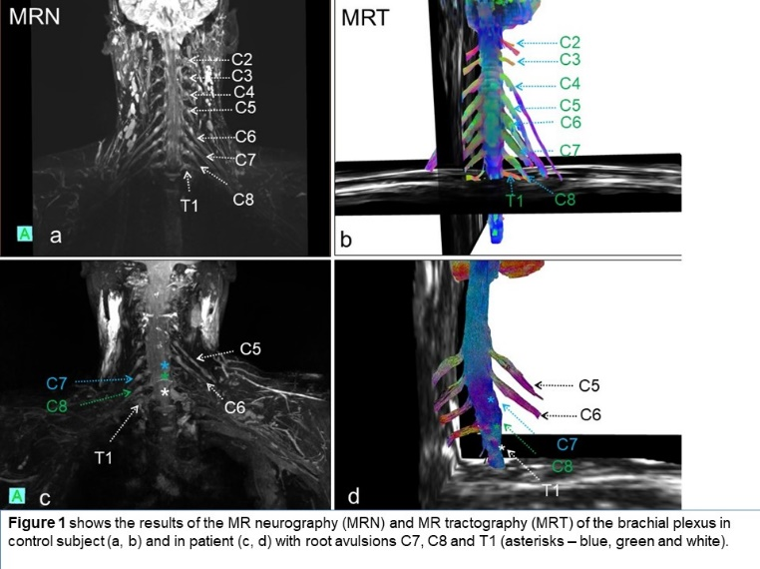

Recent Publications
- Gilcrease-Garcia BM, Deshmukh SD, Parsons MS. (2020) Anatomy, Imaging, and Pathologic Conditions of the Brachial Plexus. Radiographics 40:1686-1714.
- Su X, Kong X, Alwalid O, Wang J, Zhang H, Lu Z, Zheng C (2021). Multisequence Quantitative Magnetic Resonance Neurography of Brachial and Lumbosacral Plexus in Chronic Inflammatory Demyelinating Polyneuropathy. Front Neurosci. 23:649071.
- Martín-Noguerol T, Montesinos P, Barousse R, Luna A (2021) RadioGraphics Update: Functional MR Neurography in Evaluation of Peripheral Nerve Trauma and Postsurgical Assessment. Radiographics. 41:E40-E44.
- Zhai H, Lv Y, Kong X, Liu X, Liu D. (2019) Magnetic resonance neurography appearance and diagnostic evaluation of peripheral nerve sheath tumors. Sci Rep. 6;9:6939.
5. Gersing AS, Cervantes B, Knebel C, Schwaiger BJ, Kirschke JS, Weidlich D, Claudi C, Peeters JM, Pfeiffer D, Rummeny EJ, Karampinos DC, Woertler K. (2020) Diffusion tensor imaging and tractography for preoperative assessment of benign peripheral nerve sheath tumors. Eur J Radiol. 129:109110.

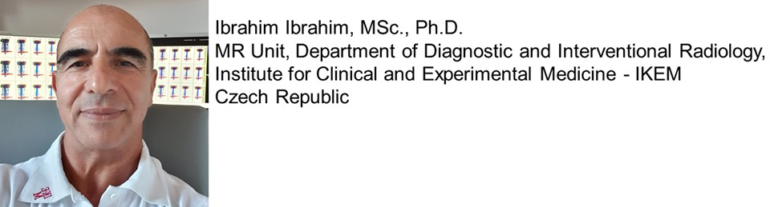
Ibrahim Ibrahim is graduated from Charles University of Medicine, Prague, Czech Republic (field of study: Medical Technology and informatics, master's degree, MSc. (2004), and completed his doctoral study in Medical biophysics, Ph.D. (2012)), He interested in all aspects of neurology, though has specific interests in peripheral nerve disorders (brachial and lumbosacral plexopathies) and their imaging using advanced MRI techniques using MR tractography (MRT) and MR neurography (MRN).
ORCID: https://orcid.org/0000-0003-3530-5165., Email: ibib@ikem.cz,
Notes/Comments:

