Title:
EOS LOW-DOSE RADIATION IMAGING FOR SPINAL DEFORMITY: THE NEW GOLD STANDARD
Author: Rose LD, St George’s University Hospital, London
Co-Authors: Williams R, Al-Ahmed S, Fenner C, Fragkakis A, Lupu C, Ajayi B, Bernard J, Bishop T, Papadakos N, Lui DF, St Goerge’s University Hospital London.

Abstract (300 word limit)
The advent of EOS imaging has offered clinicians the opportunity to image the whole skeleton in the anatomical standing position with a smaller radiation dose than standard spine roentgenograms. Current NICE guidelines do not recommend EOS scans over x-rays.
We retrospectively reviewed 103 adult and 103 paediatric EOS scans of standing whole spines for those undergoing investigation for spinal deformity in a tertiary spinal centre. We matched this against a retrospective control group who underwent traditional roentgenograms whole spine imaging. We aimed to compare the average radiation dose between the two modalities. We utilised a validated lifetime risk of cancer calculator to estimate the additional mean risk per study.
In the Adult EOS Group (AEG) the mean estimated effective dose of AP was 0.08 mSv (0.04-0.15) and Lateral 0.06 mSv (0.03-0.14). Conversely in the Adult Roentgenograms Group (ARG) the mean AP was 0.49 mSv (0.15-1.88) and Lateral was 0.29 mSv (0.07-1.20).
In the Paediatric EOS Group (PEG): the mean dose of AP was 0.07 mSv (0.02-0.21) and Lateral 0.04 mSv (0.02-0.11). Conversely Paediatric Roentgenograms Group (PRG) had a mean dose in AP of 0.37 mSv (0.03-5.92) and in lateral of 0.17 mSv (0.03-0.44).
Differences in additional lifetime risk of cancer per scan: ARG:AES Male 557%, Female 557%, PRG:PEG Male 491%, Females 491%.
Standard plain film imaging of the whole spine requires approximately five-times higher doses of radiation compared to dual planar EOS scans. There is approximately 5-fold increase in risk of cancer for all groups with roentgenograms over EOS.
We directly challenge the NICE guidance and recommend EOS dual planar imaging in favour of plane roentgenograms for investigation of spinal deformity.

Image

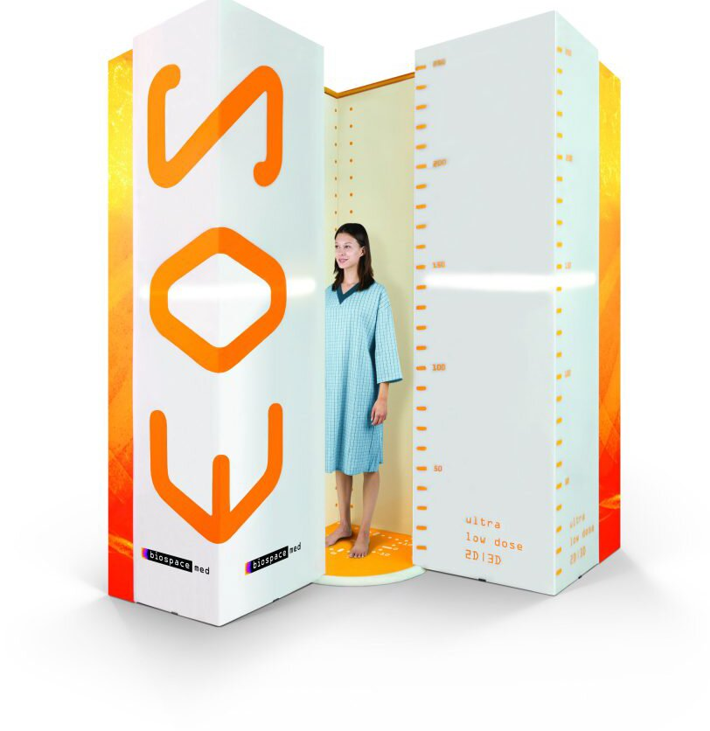
Recent Publications (minimum 5)
- Alrehily F et al. (2019) Scoliosis imaging: An analysis of radiation risk in the CT scan projection radiograph and a comparison with projection radiography and EOS. Radiography 25(3):68-74.
- Wade R et al. (2013) A systematic review of the clinical effectiveness of the EOS 2D/3D x-ray imaging system. EuroSPine J. 22(2):296-305.
- Melhem E et al. (2016) EOS Biplanar imaging x-ray: concept, development, benefit and limitations. J Child Orthop. 10(1):1-14.
- Rehm J et al. (2017) 3D modeling of the spine using EOS imaging system: Inter-reader reproducibility and reliability. PLoS One 12(2):e071258
- Branchini M et al. (2018) Organ doses and lifetime attributable risk evluations for scoliosis examinations of adolescent patients with the EOS imagine system. Radiol Med. 123(4)-305-313.



Photograph

Biography (150 word limit)
Mr Liam Rose is an Orthopaedic Surgical Registrar in South West London, and has an interest in Spinal Surgery.
Email: ld.rose@nhs.net

