Title: Free hand technique in placement of thoracic transpedicular screws
Author, Mohamed Abdelrahman Abdalla Affiliation: Neurosurgery department, St George’s hospital. London
hospital

Abstract (300 word limit)
Abstract:

Free hand placement of thoracic screws is a useful technique that is mandatory in complex spine surgery. Not only does it help save time, but it is also of paramount imprtance in deformity correction surgery. Knowing the anatomical landmarks and progressing through a learning curve to master the technique allow more efficient fixation surgery for various indications.

Recent Publications (minimum 5)
- Abdalla, M., Nyanzu, M. and Lui, D., 2021. CURRENT CONCEPTS IN MANAGEMENT OF SPINAL HAEMATOLOGICAL MALIGNANCIES: A SINGLE-CENTRE EXPERIENCE. Orthopaedic Proceedings., 103-B(SUPP_11).
- Mohamed Abdalla , Abteen Mostofi , Anan Shtaya & Francis G. Johnston (2020): Acute foot drop secondary to lumbar disc prolapse after seizure, British Journal of Neurosurgery, DOI: 10.1080/02688697.2020.1839632
- Mohamed Abdelrahman Abdalla , Zayid Omer , Saad Hassan Bashir & M. C. Papadopoulos (2020): Extradural hematoma from trauma to midline skull tumour, British Journal of Neurosurgery, DOI: 10.1080/02688697.2020.1849552
- Abdalla, M., Kareem, H., Rodrigues, R., Vardanyan, R., Williams, M. and Ulbricht, C., 2021. The impact of COVID-19 pandemic on the metastatic spine disease management: a single tertiary centre experience. BJNS,.365: 519-530.
- Abdalla, M., 2021. The Buoyant Brain. Scienceopen, [online, preprint] Available at: <https://www.scienceopen.com/document?vid=a5ace311-e5f-4a13-9693-48662c52d962>

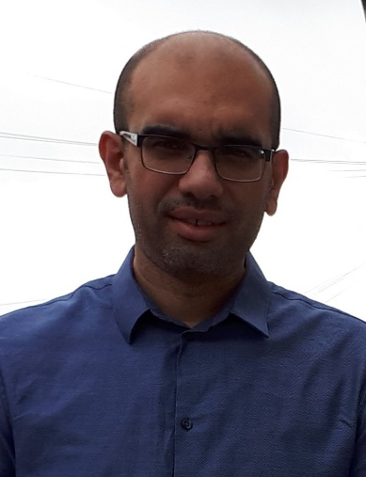

Biography (150 word limit)
Mr Abdalla is a senior clinical fellow in complex spine surgery at St George’s university hospital. He completed his basic neurosurgical training in Egypt and pursued further international experience in KSA and UK. He has done a fellowship in complex spine surgery in Imperial college health trust and is finishing another one in St George’s hospital. He has special interest in MSCC and deformity surgery and he is heading for another spinal fellowship in deformity correction surgery.
Email: maelsadek@yahoo.com

