Title: Surgical Site Infection Following Pedicle Screw Fixation of Thoracic and Lumbar Fractures
Ainur Karchalova, MD,
Department of neurological diseases and neurosurgery, Asfendiyarov Kazakh National Medical University, 94 Tole bi Street, Almaty, 050012, Kazakhstan
Zhanibek Zhanaidarov, MD,PhD,
Department of neurological diseases and neurosurgery, Asfendiyarov Kazakh National Medical University, 94 Tole bi Street, Almaty, 050012, Kazakhstan
Zhadyra Bizhanova, MD,
Graduate School of Public Health University of Pittsburgh, 3500 Victoria Street, 361 Victoria Building, Pittsburgh, PA, 15261, USA

Abstract (300 word limit)
Statement of the Problem: Posterior approach with pedicle screw fixation is widely used for thoracic and lumbar fractures. The urgency of surgery and use of contact medical devices may lead to an increase in postoperative surgical site infections (SSI). The study objective was to determine risk factors of SSI following posterior approach with pedicle screw fixation. Methodology & Theoretical Orientation: A retrospective case-control study aimed to identify characteristics of patients with SSI following an open pedicle screw fixation of thoracic and lumbar fractures. Eighteen patients with a superficial or deep SSI were identified and compared with 150 uninfected control patients. Risk factors for SSI were determined with univariate analyses. Findings: We reviewed medical records of with 168 patients receiving posterior approach with pedicle screw fixation for thoracic and lumbar fractures from 2015 to 2020 in Almaty, Kazakhstan. Eighteen (10.7%) patients with acute postoperative wound infections were identified. These included 7 deep and 11 superficial infections. The majority of patients (61.1%) had cultures of grampositive microorganisms (i.e., Staphylococcus aureus and Staphylococcus epidermidis). There were significantly higher risks of SSI in the patients with complete neurologic injury (ASIA A type) as compared with those with no deficit or incomplete injuries (p=0.027). The significance risk factors included laminectomy, delayed dural leak, and the duration of the surgery > 3 hours.Conclusion & Significance: The risk of SSI is higher in the trauma patients than in the other surgery populations. The cases with complete neurologic deficit were at greater risks of having SSI.

Image
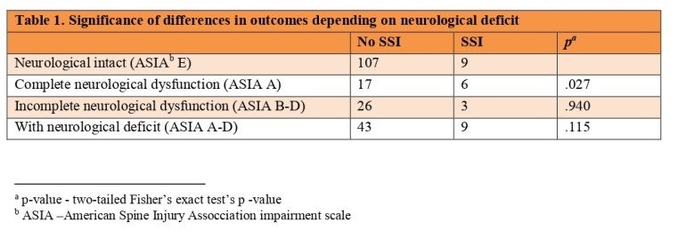
Recent Publications (minimum 5)
- Ying H, Luo ZW, Peng AF, Yang QK, Wu X, Chen XY, Huang SH, Liu JM, Liu ZL. Incidences and reasons of postoperative surgical site infection after lumbar spinal surgery: a large population study. Eur Spine J. 2021 Aug 19. doi: 10.1007/s00586-021-06967-1.
- Ross MN, Iyer S, Gundle KR, Ross DA. Association of Preoperative Hemoglobin A1c and Body Mass Index with Wound Infection Rate in Spinal Surgery. Int J Spine Surg. 2021 Aug;15(4):811-817. doi: 10.14444/8104. Epub 2021 Jul 20.
- White AJ, Fiani B, Jarrah R, Momin AA, Rasouli J. Surgical Site Infection Prophylaxis and Wound Management in Spine Surgery. Asian Spine J. 2021 Jun 28. doi: 10.31616/asj.2020.0674. Epub ahead of print. PMID: 34167274.
- Imabayashi H, Miyake A, Chiba K. A novel approach for identifying serological markers indicative of surgical-site infection following spine surgery: Postoperative lymphopenia is a risk factor. J Orthop Sci. 2021 May 25:S0949-2658(21)00095-6. doi: 10.1016/j.jos.2021.03.003. Epub ahead of print. PMID: 34049755.
5. Alghamdi S, Alawi M, Bokhari R, Bajunaid K, Mukhtar A, Baeesa SS. Risk factors for surgical site infection following spinal surgery in Saudi Arabia: A retrospective case-control study. Medicine (Baltimore). 2021 Apr 30;100(17):e25567. doi: 10.1097/MD.0000000000025567. PMID: 33907106; PMCID: PMC8084009.


Photograph
Biography (150 word limit)
Dr Ainur Karchalova is a 33-year-old young neurosurgeon studying the problem of infectious complications after spinal operations using instrumentations. She studies the factors that affect these complications and methods of their prevention.
Email: a.m.karchalova@gmail.com

