Less invasive bipolar fixation fusion free (B3F) for correction of major adult spinal deformities: Results of a prospective study after 5 years.

Dr RIOUALLON G. MD, Paris Saint Joseph Hospital Group, FRANCE
Dr WOLFF S. MD, Paris Saint Joseph Hospital Group, FRANCE
Dr MOREAU P.E. MD, Paris Saint Joseph Hospital Group, FRANCE
Dr MILADI L. MD, Necker-Enfant Malades Hospital, Paris, FRANCE

Abstract
Statement of the Problem: Posterior fixation and fusion is the most commonly used surgical technique for the treatment of adult deformities. This technique has high rates of complications particularly in adults. In children, the use of instrumentations without graft has shown good reliability. We propose the use of posterior fixation without fusion in adults. The aim of this study is to evaluate correction, complications and morbidity of a new technique of fixation for major adult spinal deformities.
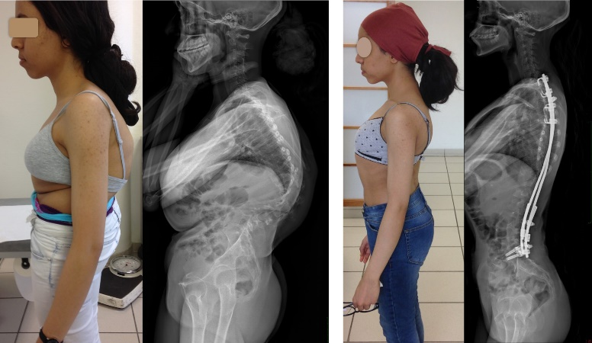
Methodology & Theoretical Orientation: We conducted a
monocentric prospective study. The operative technique is a posterior-only fixation via two separated approaches: one at the upper thoracic spine with eight hooks and one mini-open approach at the lumbosacral spine with two iliosacral screws. The rods are implanted via a subfascial tunnel. Radiological correction, rate of complications and morbidity were evaluated at last follow-up.
Findings: Seventy-seven patients were included with a mean age of 46 (18-76) with a mean follow-up of 3 years. Scoliosis etiologies were idiopathic scoliosis (40%), cerebral palsy (38%) and others (neurological deformities, camptocormia) (22%). Main curve angle was 77° (35-130). At the latest FU, main curvature angle was improved of 50%. Mean operating time was 262 min and mean blood loss (44cc/level) has decreased. Twenty-seven patients had no complications. 33 patients were not reoperated. Medical complications were very rare (3). Septic complications (16, 20%) were common in cerebral palsy. Mechanical complications were divided between rod fractures (22, 28%) and disconnections of the inferior fixation system (15, 19%), for an overall rate of 57%.
Conclusion & Significance: Despite not being a perfect method, most patients have had very simple post-operative management and are satisfied with the result. Improvement of the technique should focus on decreasing immediate mechanical complications. It remains necessary to follow this cohort to evaluate outcomes at a longer follow-up.

Image
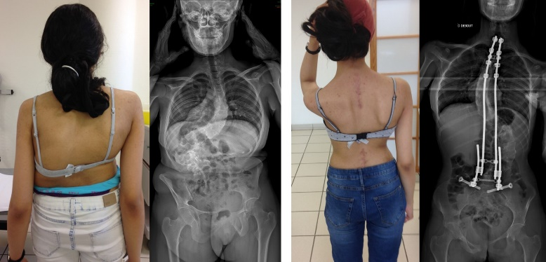
Figure: Example of the first patient operated with the technique; pre and postoperative clinical aspect and EOS radiographs. Result at five years of follow-up.

Recent relevant Publications

1. Marques MF, Fiere V, Obeid I, Charles Y-P, El-Youssef K, Lahoud A, et al. Pseudarthrosis in adult spine deformity surgery: risk factors and treatment options. Eur Spine J Off Publ Eur Spine Soc Eur Spinal Deform Soc Eur Sect Cerv Spine Res Soc. 5 mai 2021;
2. Guerin G, Laghmouche N, Moreau PE, Upex P, Jouffroy P, Riouallon G. Iliosacral screwing under navigation control: Technical note. Orthop Traumatol Surg Res OTSR. sept 2020;106(5):877‑80.
3. Wolff S, Habboubi K, Sebaaly A, Moreau PE, Miladi L, Riouallon G. Correction of adult spinal deformity with a minimally invasive fusionless bipolar construct: Preliminary results. Orthop Traumatol Surg Res OTSR. oct 2019;105(6):1149‑55.
4. Riouallon G, Morin C, Charles Y-P, Roussouly P, Kreichati G, Obeid I, et al. Posterior-only versus combined anterior/posterior fusion in Scheuermann disease: a large retrospective study. Eur Spine J Off Publ Eur Spine Soc Eur Spinal Deform Soc Eur Sect Cerv Spine Res Soc. sept 2018;27(9):2322‑30.

5. Bouyer B, Scemama C, Roussouly P, Laouissat F, Obeid I, Boissière L, et al. Evolution and complications after surgery for spine deformation in patients with Parkinson’s disease. Orthop Traumatol Surg Res OTSR. juin 2017;103(4):517‑22.
6. Riouallon G, Bouyer B, Wolff S. Risk of revision surgery for adult idiopathic scoliosis: a survival analysis of 517 cases over 25 years. Eur Spine J Off Publ Eur Spine Soc Eur Spinal Deform Soc Eur Sect Cerv Spine Res Soc. août 2016;25(8):2527‑34.
7. Wolff S, Riouallon G. [Scoliosis in adulthood: a constant evolution]. Rev Prat. mars 2016;66(3):298‑302.

Photograph

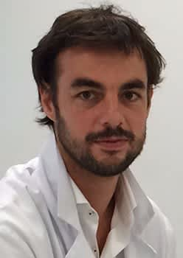
Biography
Dr Riouallon has his expertise in Spine surgery and more specifically in spinal deformities and Scoliosis. He is the head of the Spine surgery department at the Paris Saint Joseph Hospital. He is an active member of the board of the French Society of Spine Surgery. He is also member of the scientific council of the Cotrel Foundation which promotes fundamental and clinical research on scoliosis. He works with Pr Jean Dubousset in this board and develop the bipolar fixation presented in this abstract with his collaboration.

Email: griouallon@ghpsj.fr

Notes/Comments:

