Review of the effectiveness of stereotactic radiosurgery (SRS) treatment of spinal oligometastatic disease determined by local control, overall survival, pain response and toxicities: A Systematic Review
Priyanshu Saha, 4th Year Medical Student, St George’s University Hospital London

Abstract

Background: The objective was to determine whether there is a benefit to using stereotactic radiosurgery (SRS) versus surgery or conventional external beam radiotherapy for spinal oligometastatic disease in terms of tumor control, pain control, toxicity and morbidity.

Methods: A systematic review was conducted by searching electronic databases such as Pubmed, Medline (Ovid) and Oxford Academic using an adapted version of the Preferred Reporting Items for Systematic Reviews and Meta-Analyses” (PRISMA) checklist. Retrospective and prospective studies were identified that investigated methods of treatment such as SRS, surgery and radiotherapy of spinal oligometastatic disease. Local Control rates (LC), overall survival (OS) rates, pain response (PR) and toxicities were extracted to be investigated and compared. A study eligibility criterion was made to ensure results were valid, statistically significant and relevant to the investigation.

Results: 105 articles were found that were relevant to oligometastatic disease with the mention of spinal metastases however 89 of these articles were excluded based on irrelevance to investigation, title, abstract and duplication. 16 full text articles were thoroughly screened including 9 of them in the review. For 601 patients the average 1-year local control rate was 89%, average 1-year overall survival rate was 88%, evidence of pain relief was present, and some patients suffered low grade 1,2,3 and 4 toxicities.

Discussion: Stereotactic radiosurgery is an excellent modality of treatment of spinal oligometastatic disease as local control rates, overall survival rates, pain response and toxicities indicate improved outcomes in comparison to studies that investigated the same factors with the treatment of surgery or cEBRT. However, there is a lack of data here to make statistically valid claims and require more studies/data to be analyzed and compared.
Image
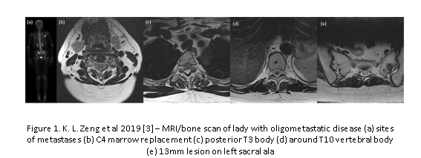
Recent Publications
- Hellman S, Weichselbaum R. Oligometastases. Journal of Clinical Oncology. 1995;13(1):8-10.
- Ho J, Tang C, Deegan B, Allen P, Jonasch E, Amini B et al. The use of spine stereotactic radiosurgery for oligometastatic disease. Journal of Neurosurgery: Spine. 2016;25(2):239-247
- Barzilai O, Versteeg A, Sahgal A, Rhines L, Bilsky M, Sciubba D et al. Survival, local control, and health‐related quality of life in patients with oligometastatic and polymetastatic spinal tumors: A multicenter, international study. Cancer. 2018;125(5):770-778.
- Zeng K, Tseng C, Soliman H, Weiss Y, Sahgal A, Myrehaug S. Stereotactic Body Radiotherapy (SBRT) for Oligometastatic Spine Metastases: An Overview. Frontiers in Oncology. 2019;9.5.
- Gerszten P. Spine Metastases: From Radiotherapy, Surgery, to Radiosurgery. Neurosurgery. 2014;61(CN_suppl_1):16-25.


Biography

Priyanshu Saha is a 4th year medical student currently pursuing an intercalated BSc in Genomics at St George’s University of London Hospital Medical School. He has special interests in trauma and orthopedic research particularly in spinal trauma, cancer, and deformities. He has a passion to improve healthcare conditions and accessibility in rural areas around the world. He has held national student positions of responsibility in the UK for academic societies and organizations. He has won first prize at in international student conference sponsored by the Royal College of Surgery Edinburgh and been granted bursaries for presenting at international conferences by the university. He enjoys teaching anatomy to his fellow medical students and working on research.
Email: m1800287@sgul.ac.uk

Notes/Comments:

