Challenges of scoliosis in bilateral upper limb amelia – sparing lumbar segments essential for function
Priyanshu Saha, 4th Year Medical Student, St George’s University Hospital London

Abstract

Amelia is described as a congenital abnormality in which there is a complete absence of at least one limb. Although amelia can occur in isolation, in cases with bilateral upper limb amelia, it has been reported than 100% of the patients also present with scoliosis. Despite this high incidence of scoliosis for the condition, there is a paucity of data on surgical correction in amelia. Key features when planning the Lowest Instrumented Vertebra (LIV) are that function could be significantly impaired if a long fusion is undertaken. Strong consideration for non fusion techniques or selective fusion should be given. We report a case of a 17-year-old boy presenting with bilateral upper limb amelia and atypical left thoracic scoliosis. The patient is fully independent and utilises his legs for all daily living activities. The Cobb angle was 86° from T6-T12, left side convex with Risser 5 and Sanders . The fulcrum unbending Cobb was 66°, indicating a stiff curve (23% flexibility). Skeletal maturity and stiffness precluded the use of Anterior Scoliosis Correction Vertebral Body Tethering (ASC VBT). The Harrington stable zone was L4 but the last touched vertebra (LTV) was L3. Selective thoracic fusion was performed from T3-L1 with 4 discs in the lumbar segment spared. SRS-22 preoperative was 2.8 and at 2 years was 3.55. Arthrodesis inevitability leads to loss of flexibly and motion in the areas of spinal fusion. Maintenance of function and sparing fusion levels is a surgeon’s aim but at the risk of further surgery required for curve progression due to adding-on effect. Due to maturity and stiffness ASC VBT was contra-indicated. This is a successful case report of a selective thoracic fusion in a patient with bilateral upper limb amelia where the theoretical LIV was more distal. This is an important case report that contributes to the extremely limited cases in the literature where orthopaedic intervention for amelia has been performed.
Image
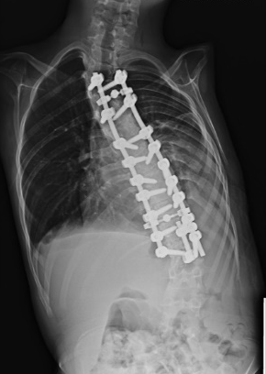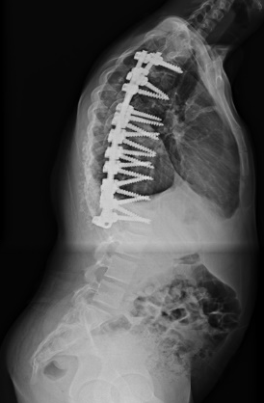
Recent Publications
- Herring JA, Goldberg MJ. Amelia and scoliosis. J Pediatr Orthop. 1985 Sep-Oct;5(5):605-9. doi: 10.1097/01241398-198509000-00021.
- Lester DK, Painter GL, Berman AT, Skinner SR. "Idiopathic" scoliosis associated with congenital upper-limb deficiency. Clin Orthop Relat Res. 1986 Jan;(202):205-10.
- AlMarshad A, AlMazrua I, Al-Haidey R, AlZayed Z. Functional outcomes in bilateral upper limb Amelia patient with scoliosis post vertical expandable prosthetic titanium rib (VEPTR) application: A case report. Int J Surg Case Rep. 2020;70:193-196.
- Powers TA, Haher TR, Devlin VJ, Spencer D, Millar EA. Abnormalities of the spine in relation to congenital upper limb deficiencies. J Pediatr Orthop. 1983 Sep;3(4):471-45. Sullivan EV, Zahr NM (2008)
- Samuelsson L, Hermansson LL, Norén L. Scoliosis and trunk asymmetry in upper limb transverse dysmelia. J Pediatr Orthop. 1997 Nov-Dec;17(6):769-72.

Photograph


Biography
Priyanshu Saha is a 4th year medical student currently pursuing an intercalated BSc in Genomics at St George’s University of London Hospital Medical School. He has special interests in trauma and orthopedic research particularly in spinal trauma, cancer, and deformities. He has a passion to improve healthcare conditions and accessibility in rural areas around the world. He has held national student positions of responsibility in the UK for academic societies and organizations. He has won first prize at in international student conference sponsored by the Royal College of Surgery Edinburgh and been granted bursaries for presenting at international conferences by the university. He enjoys teaching anatomy to his fellow medical students and working on research.
Email: m1800287@sgul.ac.uk

Notes/Comments:

