Title: Disc degeneration and vertebral endplate defects after the cervical fusion
Olga Leonova, Central Scientific Research Institute of Traumatology and Orthopedics, Moscow, Russia
Eugenii Baykov, Abdugafur Sanginov, Aleksandr Krutko, Central Scientific Research Institute of Traumatology and Orthopedics, Moscow, Russia

Abstract (300 word limit)
Summary of Background Data. The evolution of degenerative changes in the cervical spine is poorly understood. Endplate defects can be of great importance in progressive disc degeneration (DD). Clarification of this predictor may be important in determining the treatment tactics in patients with DDD. Objective. To evaluate the evolution of the degenerative changes in the C2-C7 cervical segments and to assess the association MRI parameters with clinical symptoms after surgical treatment in patients with DDD.
Methods. The study included patients who had 2-years’ follow-up after cervical fusion for spondylotic radiculo- with/without myelopathy. Demographic data (age, sex, surgical data) were assessed; clinical data (VAS neck, VAS arm, NDI) and cervical MRI (DD grades by Pfirrmann, Modic changes (MC), total endplate scores (TEPS) were compared to preoperative data.
Results. All patients reported a decrease neck pain and arm pain at follow-up (p<0.001). There was observed the change in MC types (p<0.001) and an increase of TEPS (p<0.05). 71.7% discs remained unchanged during the follow-up, but a significant number of discs went from Grade 2 to Grade 3 and from Grade 3 to Grade 4 by Pfirrmann (p<0.001). Clinical scores (VAS neck, VAS arm, NDI) had no correlation with MRI changes (p>0.05). DD was associated with TEPS (OR 2.05-5.47, p<0.05) and patients’ age (OR 1.11-2.33, p<0.05) at all cervical levels; with MC types, but only at C4-C5 and C6-C7 levels (OR=2.91 and 2.79, respectively, p<0.05). ROC analysis showed a TEPS threshold value of 7, above which the probability of DD significantly higher.
Conclusions. During 2 years’ follow-up the significant increase of DD grades by Pfirrmann was observed at C4-C6 levels (p<0.001). A significant association disc degeneration grades with TEPS and age at all cervical levels was determined.

Image
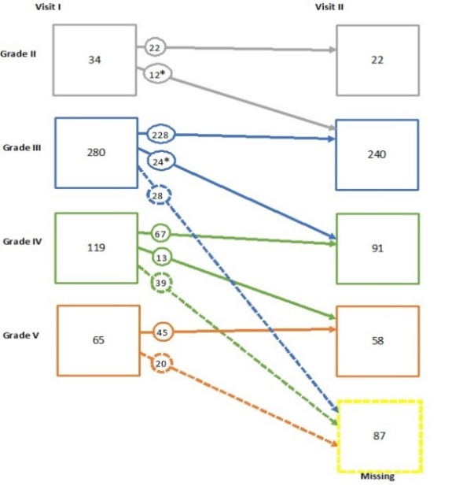
Figure 1. Diagram showing changes in Pfirrmann grades over time. The values of ‘n’ indicate the number of intervertebral discs. * indicates p-value <0.001.
Recent Publications (minimum 5)
- Leonova O, Baykov E, Sanginov A, Krutko A. Cervical Disc Degeneration and Vertebral Endplate Defects After the Fused Operation. Spine (Phila Pa 1976). 2021 Feb 16. doi: 10.1097/BRS.0000000000004007. Epub ahead of print. PMID: 33595261.
- Leonova ON, Cherepanov EA, Krutko AV. MIS-TLIF versus O-TLIF for single-level degenerative stenosis: study protocol for randomised controlled trial. BMJ Open. 2021 Mar 5;11(3):e041134. doi: 10.1136/bmjopen-2020-041134. PMID: 33674366; PMCID: PMC7938991.
- Intradiscal cervical injection in case of rotator cuff repair of the shoulder joint. Alexey Peleganchuk, Olga Leonova, Alexandr Alekperov. Hirurgiâ pozvonočnika (Spine Surgery). 2021. V. 27. №1.
- Screw fixation failure after 360° fusion at the lumbar level. Leonova O.N., Baykov E.S., Krutko A.V. // N.N. Priorov Journal of Traumatology and Orthopedics. - 2020. - Vol. 27. - N. 4. - P. 11-18. doi: 10.17816/vto58512
- Bone density in case of pedicle screw loosening in patients with degenerative lumbar disease. Olga Leonova, Evgenii Baykov, Abdugafur Sanginov, Aleksandr Krutko. N.N. Priorov Journal of Traumatology and Orthopedics. 2020. V. 27. №4. pp. 18-28.


Photograph

Biography (150 word limit)
Dr. Leonova is a leading specialist in the field of spinal neuroimaging, conducting clinical research related to spinal surgery. Dr. Leonova has received a number of government grants and awards. Since 2021, she has been working at the Central Institute of Traumatology and Orthopedics, Moscow, Russia, where she combines research and medical practice in the neurosurgical department. Currently, under the direction of Dr. Leonova, the center is conducting two prospective randomized studies and one basic translational study. In addition, Dr. Leonova is a practicing orthopedist, her main interest is degenerative spinal diseases, open and minimally invasive methods of surgical treatment, correction of the sagittal balance, assessment and predicting the results of surgical treatment.
Email: onleonova@gmail.com

