Different Concepts of Bracing in Adolescent Idiopathic Scoliosis (AIS), a
systematic review and meta-analysis.
Lorenzo Costa, MD
Tom P.C. Schlosser, MD PhD
Hanad Jimale, MS
Jelle F. Homans, MD PhD
Moyo C. Kruyt, MD PhD
René M. Castelein, MD PhD

Abstract (300 word limit)

Background: Adolescent idiopathic scoliosis (AIS) is a 3-dimensional deformity of the spine and occurs in 0.47-5.2% of the general population. AIS can progress during growth and brace therapy is generally applied to prevent progression of the curve. Multiple concepts of braces have been developed, however it is currently unknown whether there is a difference in effectiveness. Insight in the current brace treatment may assist in improving the understanding of the present limitations.
Aim: The aim of this systematic review and meta-analysis is to compare the effectiveness of the different brace concepts defined as prevention of the need of surgery and/or reduction of the curve magnitude.

Methods: This systematic review and meta-analysis was performed according to the PRISMA guidelines. All original studies on brace treatment within AIS were systematically searched for in PubMed and EMBASE up to December 2019. To include all types of studies critical appraisal was made through MINOR score. A distinction was made based on prescribed time of wearing and rigidity of the brace. Only papers that focused on a specific brace concept or type of brace were included in this study.
Results: 31 out of 2609 articles were included. 12 papers had high risk of bias and 6 did not report success as ≤5° curve progression. Rigid full-time brace had on average a success rate of 73.2%, night-time of 78.7%, soft braces of 62.4%, observation only of 50%. There was insufficient evidence on part-time, rigid braces for the meta-analysis.

Conclusion: In the included studies no significant difference in night-time versus full-time concepts could be identified and there were no important differences between part-time and full-time wear. Soft braces seem to have a worse outcome if compared to the rigid braces.

Image
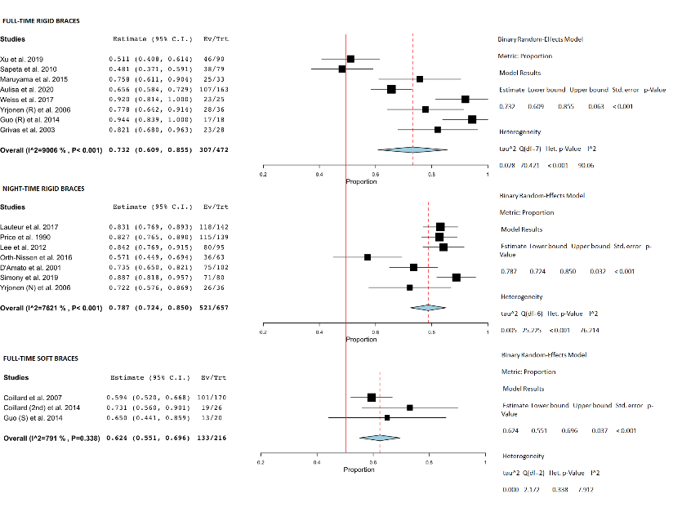
Recent Publications (minimum 5)
1. J. Guo et al., “A prospective randomized controlled study on the treatment outcome of SpineCor brace versus rigid brace for adolescent idiopathic scoliosis with follow-up according to the SRS standardized criteria.,” Eur. Spine J., vol. 23, no. 12, pp. 2650–2657, Dec. 2014,
2. G. Lateur, P. Grobost, J. Gerbelot, A. Eid, J. Griffet, and A. Courvoisier, “Efficacy of nighttime brace in preventing progression of idiopathic scoliosis of less than 25°.,” Orthop. Traumatol. Surg. Res., vol. 103, no. 2, pp. 275–278, 2017,
3. A. G. Aulisa, M. Giordano, R. M. Toniolo, and L. Aulisa, “Long term results after brace treatment with PASB in adolescent idipathic scoliosis,” Minerva Anestesiol., 2020, doi: 10.23736/S1973-9087.20.06129-8.
4. A. G. Aulisa, V Guzzanti, F. Falciglia, M. Galli, P. Pizzeti, and L. Aulisa, “Curve progression after long-term brace treatment in adolescent idiopathic scoliosis: Comparative results between over and under 30 Cobb degrees - SOSORT 2017 award winner,” Scoliosis Spin. Disord., vol. 12, no. 1, 2017,
5. A. Simony, I. Beuschau, L. Quisth, S. M. Jespersen, L. Y. Carreon, and M. O. Andersen, “Providence nighttime bracing is effective in treatment for adolescent idiopathic scoliosis even in curves larger than 35°.,” Eur. Spine J., vol. 28, no. 9, pp. 2020–2024, Sep. 2019, doi: 10.1007/s00586-019-06077-z

Biography (150 word limit)
MD Lorenzo Costa graduated in 2018 at “Università degli Studi di Genova” in Genoa, Italy. In 2019 started his PhD on Adolescent Idiopathic Scoliosis. The main aim of his project is to define a non-invasive treatment and work on non-ionizing radiation procedures for diagnosis of Scoliosis.
Email: l.costa-2@umcutrecht.nl

Notes/Comments:

