Effects of Posterior Spinal Fusion Surgery On Gait Biomechanics In
Patients With Adolescent Idiopathic Scoliosis
Dr Manish Gupta, Department of Orthopaedics, AIIMS, New Delhi, India
Dr Bhavuk Garg, Department of Orthopaedics, AIIMS, New Delhi, India
Dr Nishank Mehta, Department of Orthopaedics, AIIMS, New Delhi, India
Dr Rajesh Malhotra, Department of Orthopaedics, AIIMS, New Delhi, India

Abstract

Statement of the Problem:
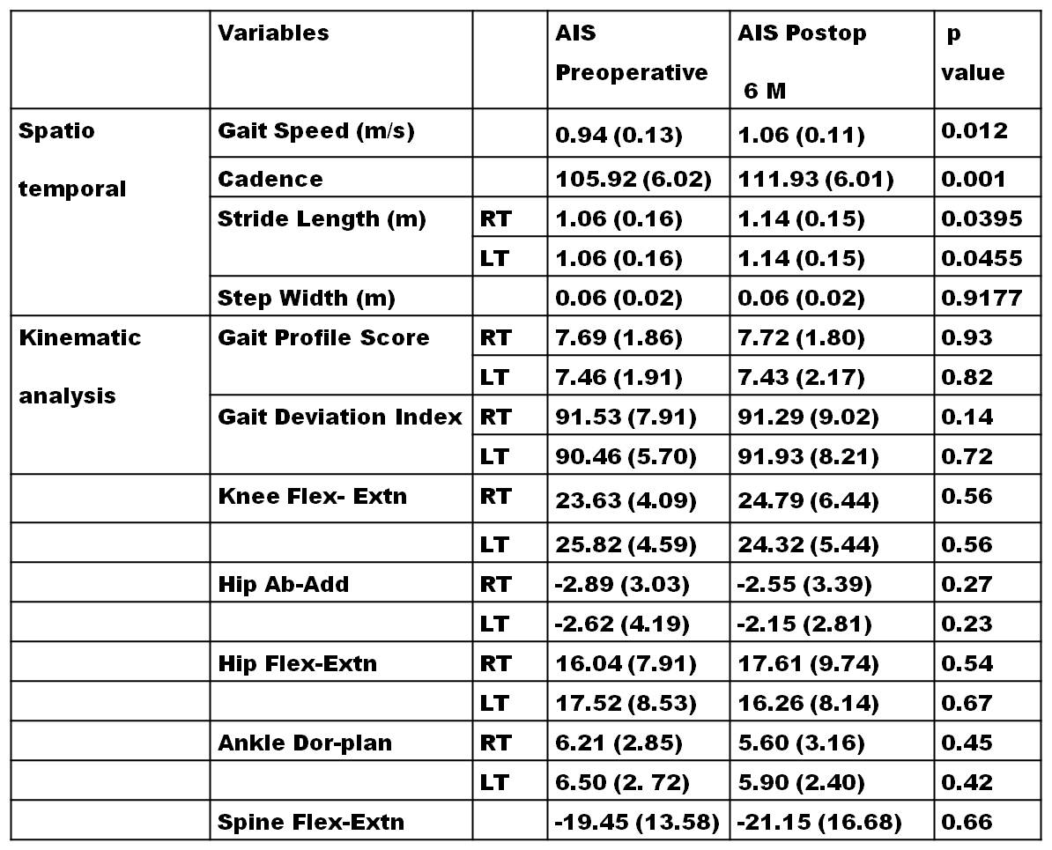
Scoliosis is a complex multidimensional spinal deformity which affects spinal anatomy, quality of movement and walking, and trunk symmetry. Posterior spinal fusion (PSF) is usually performed to stop curve progression, to reduce back pain and to restore asymmetric upper body ^{[1]}. Previous studies indicate that, there is an alteration of gait patterns in patients with Scoliosis and this gait pattern is substantially altered after surgical intervention. In India, these deformities are often neglected and present at a very late and much more deformed state (mean cobb angle ≥60⁰). So, we have planned a study to investigate the effects of posterior spinal fusion surgery on spatio-temporal and lower and upper body kinematics in severe Adolescent Idiopathic Scoliosis (AIS) patients during gait.
Methodology & Theoretical Orientation: This clinical prospective study after written informed consent included 20 subjects (12Female:8Male), mean age 16.3 Years, diagnosed with thoraco-lumbar/lumbar AIS (cobb angle MT 77.12 ± 7.10, TL/L 61.22 ± 6.12). Spatio-temporal parameters and upper and lower body kinematics were evaluated preoperatively and after 6 months of surgery using instrumented 3D gait analysis (BTS, Italy). Student T test was performed to find significant differences between pre and post operative AIS.
Table: 1 Comparisons of spatiotemporal and kinematics gait variables in AIS patients preoperatively and after 6 months of surgery. Values are in mean(SD).
Recent Publications:
- de Kleuver M, et al, Optimal surgical care for adolescent idiopathic scoliosis: an international consensus. Eur Spine J, 2014, 23(12):2603–2618.
- Haddas R, JuLK, Belanger T, Lieberman HI. The use of gait analysis in the assessment of patients afflicted with spinal disorders. Eur Spine J, 2018 Aug;27(8):1712-1723.
- Holewijn RM, Kingma I, de Kleuver M, Keijsers NLW. Posterior spinal surgery for adolescent idiopathic scoliosis does not induce compensatory increases in distal adjacent segment motion: a prospective gait analysis study. Spine J, 2018 Dec;18(12):2213-2219.
- Kruger KM, Garman CMR, Krzak JJ, et al. Effects of Spinal Fusion for Idiopathic Scoliosis on Lower Body Kinematics During Gait. Spine Deform, 2018;6(4):441-447.

Findings: Gait speed (p=0.012), cadence (p=0.001), stride length Rt (p=0.0395) were improved significantly after 6 months of surgery. Step width (p=0.0455), gait profile score (GPS) (p=0.012) and gait deviation index (GDI) (p=0.012), were not changed significantly postoperatively. No significant changes in mean angle (⁰) of knee flex extension (p=0.012), hip Ab-adduction (p=0.012), hip flex-extension (p=0.012), ankle dorsi-planterflexion (p=0.012), spine flex extension (p=0.012) were observed postoperatively.
Conclusion & Significance: The results of our study suggest that Surgical intervention did not cause any significant changes in the upper and lower limb kinematics during gait, despite of large part of spinal fusion. Postoperative significant improvements in spatio-temporal parameters explain the well functioning in daily life of subjects with Adolescent Idiopathic Scoliosis. A comprehensive study involving long-term post-operative follow-up of a large sample of AIS is needed to draw decisive conclusions regarding alteration in gait of scoliosis.

Photograph

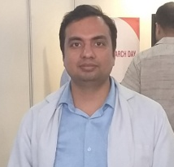
Biography (150 word limit)

Dr. Manish Gupta is currently working as Post Doctoral Research Associate in Department of Orthopaedics, AIIMS, Delhi, India. His current research is focused on the management of complex spinal deformity patients using Instrumented Gait analysis and 3D printing. He is expert in instrumented gait analysis and is also a team member in the surgery planning of Cerebral Palsy patients using 3D gait analysis. He has done his Ph.D. from DRDO, Delhi on a research problem of global importance and international challenge of developing a safe and effective radio-protective drug for human use. He has published his research work in various reputed international journals and presented in various national and international conferences and has been awarded with Gold medal, Best Poster awards, and Young Scientist Award.

Email: manishgupta1307@gmail.com

