Interobserver reproducibility assessment of the new AOSPINE classification for subaxial cervical lesions
Leandro Vinícius Vital, Universidade Federal de Minas Gerais; Biocor Instituto
Rogério Lúcio Chaves de Resende¹, Jefferson Soares Leal¹,Renato de Melo Guimarães², Ângelo Ribeiro Vaz de Faria²
¹ Universidade Federal de Minas Gerais, Biocor Instituto
² Universidade Federal de Minas Gerais

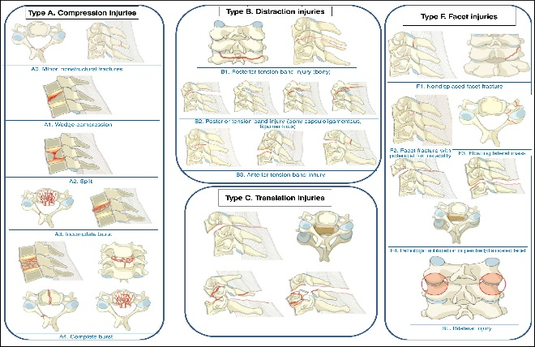
Abstract (300 word limit)
Statement of the Problem: The most recent classification of subaxial cervical injuries is that of the AOSpine group, which seeks to be comprehensive and include various types of subaxial cervical spine bone and soft tissue injuries, based on the AOSpine classification for thoracolumbar fractures. Earlier classifications for subaxial cervical lesions, such as that of Allen and Fergunson and more recently the SLICS classification, do not present adequate interobserver concordance and leave a lot to be desired in assisting with therapeutic decisions. Bearing in mind that the subaxial cervical spine is the most common location for cervical injuries, accounting for 65% of cervical fractures and more than 75% of cervical fracture-dislocations, which are a serious public health problem. A classification with good concordance among surgeons is needed to optimize the treatment of these injuries. Objective of this study was to evaluate the interobserver concordance of the most recent subaxial injury classification (AOSpine). Methodology & Theoretical Orientation: A descriptive study, which11 traumatic lesions of the subaxial cervical spine (through radiographic and tomographic images), were evaluated by 16 observers being: 6 senior surgeons, 4 fellows in spinal surgery and 6 physicians residents in Orthopedics and Traumatology by the new AOSpine classification, with subsequent statistical analysis of the results. An agreement analysis was performed using the Kappa coefficient, both individually and in combination, with an interpretation of the index performed using the standardized model for Landis and Koch. To determine the level of significance of the analyzes, values less than 0.05 were considered statistically significant.Conclusion & Significance: The results of the study indicate an intermediate agreement of the new AOSpine classification for subaxial cervical lesion and point to the need to carry out studies that seek to evaluate this new classification in order to better evaluate its strengths and weaknesses, contributing for its improvement.

Image

Recent Publications (minimum 5)
- Vaccaro AR, Koerner JD, Radcliff KE, Oner FC, Reinhold M, Schnake KJ, et al. AOSpinesubaxial cervical spine injury classification system. 2016;25(7):2173-84.
- Vaccaro AR, Oner C, Kepler CK, Dvorak M, Schnake K, Bellabarba C, et al. AOSpinethoracolumbarspine injury classification system: fracture description, neurological status, and key modifiers.(2013;38(23):2028–37
- Allen BL Jr, Ferguson RL, Lehmann TR, O'Brien RP. A mechanistic classification of closed, indirect fractures and dislocations of the lower cervical spine. 1982;7(1):1–27
- Vaccaro AR, Hulbert RJ, Patel AA, Fisher C, Dvorak M, Lehman Jr RA, et al. The subaxial cervical spine injury classification system: a novel approach to recognize the importance of morphology, neurology, and integrity of the discoligamentous complex. 2007;32(21):2365–74.
- Negrelli MAC, Oliveira RG, Rocha ID, Cristante AF, Marcon RM, Barros Filho TEP. Traumatic injuries ofthe cervical spine: current epidemiological panorama. Acta Ortop Bras. 2018;26(2):123-6



Photograph

Biography (150 word limit)
Dr has his expertise in evaluation and passion in spine surgery. Graduate at the Universidade Federal de Juiz de Fora, fellow in orthopedic surgery at Santa Casa de Santos and fellow in Spine Surgery at Universidade Federal de Minas Gerais. Nowadays study spine trauma and degenerative pathologies of spine.
Email: leandrovvital@gmail.com

