The Incidence of Odontoid Fractures Following Trauma in A Major Trauma Center, A Retrospective Study

Sami AlEissa, Department of Surgery, Division of Orthopedics, King Abdulaziz Medical City National Guard Health Affairs, Riyadh, Kingdom of Saudi Arabia

Ali Alhandi, Department of Surgery, Division of Orthopedics, King Abdulaziz Medical City National Guard Health Affairs, Riyadh, Kingdom of Saudi Arabia

Ahad Bugis, Department of Surgery, Division of Orthopedics, Dr.Suliman Alhabib Hospital, Alhabib Medical Group, Riyadh, Kingdom of Saudi Arabia

Raghad Alsalamah, Collage of Medicine, King Saud bin Abdulaziz University for Health Sciences, Riyadh, Kingdom of Saudi Arabia

Abdulellah Alsheddi, Department of Surgery, Division of Orthopedics, King Abdulaziz Medical City National Guard Health Affairs, Riyadh, Kingdom of Saudi Arabia

Abdulaziz Almubarak, King Abdullah International Medical Research Center, Riyadh, Kingdom of Saudi Arabia

Suhail Assiri, Department of Surgery, Division of Orthopedics, King Abdulaziz Medical City National Guard Health Affairs, Riyadh, Kingdom of Saudi Arabia

Faisal Konbaz, Department of Surgery, Division of Orthopedics, King Abdulaziz Medical City National Guard Health Affairs, Riyadh, Kingdom of Saudi Arabia

ABSTRACT:
BACKGROUND: Cervical spine injury is the most common vertebral injury after major trauma, 20% of all cervical fractures happen to be odontoid fractures, in young adults, odontoid fractures usually happens as a result of hight-energy trauma after motor vehicle accident (MVA). MVA in Riyadh represent 38.4% of all trauma cases, in which the head and neck are most injured body parts. This research aims to provide information about the incidence of odontoid process fracture post- MVA in Riyadh, Saudi Arabia.
METHODS: The design of this study was retrospective. A single level one trauma center database (trauma registry) was used to identify odontoid fractures post-MVA. All trauma cases from 2008 to the most recent were included, A total of 17,047 patients, to identify cervical spine fractures and further identify odontoid fracture incidence. The patients’ radiographs were reviewed retrospectively, and odontoid fractures were classified by a board-certified spine surgeon. A descriptive analysis was carried out to report basic data distribution. Pearson’s correlation was carried out to assess association.
RESULTS: A total number of cervical spine fractures was 1195 patients (6.6% of the total sample). The incidence of odontoid fractures during the entire study period from 2008 to 2018 was 42 of 480 patients with C2 cervical trauma, constituting 8.75 % C2 fractures, and 3.5% of cervical spine fractures. The mean age was 41.75 ± 18 years. There were three patients ( on male, two females) with type l odontoid fracture, 26 (all males) with type ll, and 13 (11 males, 2 females) with type lll. Most patients were managed conservatively (83.33%), whereas 16.67% underwent surgical management.
CONCLUSION: The incidence of posttrumatic odontoid fractures is low, given the younger population of this study. This does not predict future incidence rates with continued improvement of road traffic laws and awareness in the population.

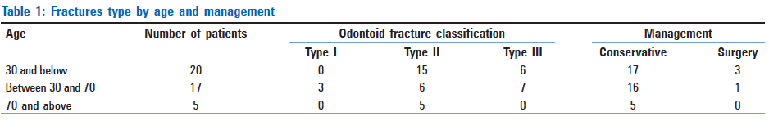

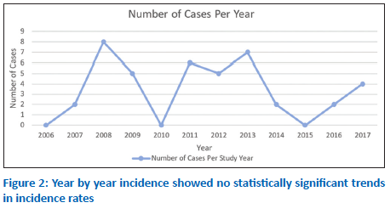
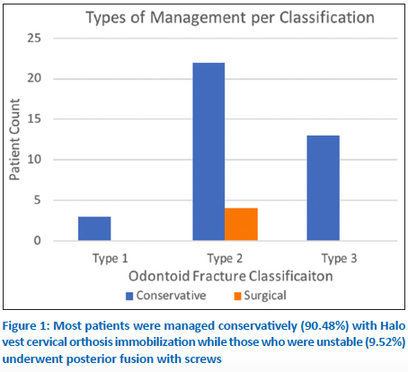

Dr. Ahad Abdullah Bugis
Orthopedic surgery resident
Habib medical group
Email: ahadbuqas@gamil.com

