CLINICO-RADIOLOGICAL OUTCOMES OF CONSERVATIVE MANAGEMENT OF THORACOLUMBAR SPINAL TUBERCULOSIS
Dr GHANSHYAM KAKADIYA, MS, TNMC & BYL Nair Hospital, INDIA

Abstract
Introduction: Spinal tuberculosis is a leading cause of non-traumatic paraplegia in developing country like India. There is an emerging trend to operate on patients early with spinal TB. A study aim was to reiterate the importance of conservative management in Spinal Tuberculosis. A study objective was to assess the clinical and radiological outcomes of the conservative management of thoracolumbar spine tuberculosis and reiterate the importance of conservative management.
Methods: A prospective study of 188 thoracolumbar tuberculosis patients included from May 2016 to April 2019. All the patients were subjected to computed tomography-guided biopsy followed by anti-tuberculous therapy (ATT) for 12-months. Indications for surgery included patients in which biopsy either failed and persistent/worsening of neurology. Preoperative and postoperative clinical and functional outcomes Visual Analog Scale (VAS), Oswestry Disability Index (ODI) and ASIA scale were measured.
Results: 160 patients had a neurological deficit of ASIA-C and ASIA-D in 28. A failed to performed biopsy was in 18 patients. Out of 170 successful biopsies,18 patients had persistent/worsening of neurology, these 18 (10.58%) patients required surgery. VAS was significantly improved from mean value preoperative 7.90±0.60 to 4.0±0.54 postoperative 1 month and 2.90±0.54 at the final follow‐up. ODI was improved from mean value preoperative 77.10±6.90 to 30.50±6.50 postoperative 1 month and 21.30±6.70 at final follow‐up. Pre-treatment mean kyphosis was 5.68±3.84 that improved to 6.51±3.88 post-treatment.
Conclusions: The results of conservative treatment consisting of biopsy and ATT for at least 12 months in compliant patients are excellent. A combined approach using clinical staging, biopsy, and ATT can minimize surgical intervention in most patients. Early diagnosis and early treatment lead to a good prognosis. Periodic evaluation is a must to look for evidence of improvement and the adverse effect of ATT.
Keywords: Spinal tuberculosis; biopsy; Conservative Management; ATT

Image
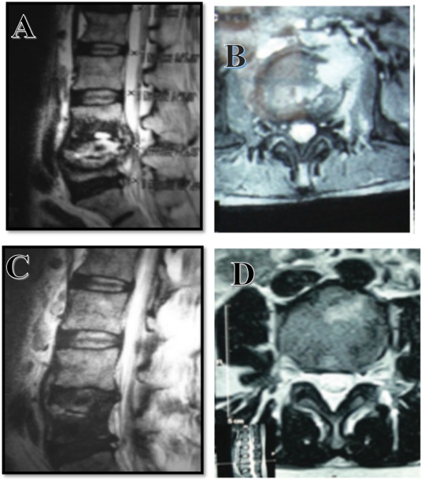
Figure 1. 66 years old female patients with spinal tuberculosis. (A & B) T2 weighted images of MRI shows L4-L5 tubercular spondylodiscitis, paradiscal involvement with compression over thecal sac. (C & D) T2 images of MRI after 12 months of ATT shows recovery from infection with fatty marrow changes.
Recent Publications
- Ravindra Kumar Garg,Dilip Singh Somvanshi, et al. Spinal tuberculosis: A review. J Spinal Cord Med. 2011 Sep; 34(5): 440–454.
- Dinc H, Ahmetoglu A, Baykal S, Sari A, Sayil O, Gumele HR. Image-guided percutaneous drainage of tuberculous iliopsoas and spondylodiskitic abscesses: midterm results. Radiology 2002;225:353-8.
- Rajasekaran S, Prasad Shetty A, Dheenadhayalan J, Shashidhar Reddy J, Naresh-Babu J, Kishen T. Morphological changes during growth in healed childhood spinal tuberculosis: a 15-year prospective study of 61 children treated with ambulatory chemotherapy. J Pediatr Orthop 2006;26:716-24.
- Dunn R. The medical management of spinal tuberculosis. SA Orthopaedic Journal 2010: 9(1): 37-41
- Nene A, Bhojraj S. Result of nonsurgical treatment of thoracic spine tuberculosis in adults. Spine J 2005;5(1)79-84

Photograph

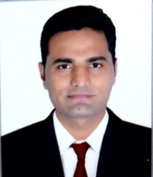 Biography
Dr Ghanshyam kakadiya is a young dynamic orthopaedic surgeon from Mumbai India. He has completed his postgeaduation from wellknown Topiwala Nationa medical College & BYL Nair hospital, Mumbai India and pursuing his training in spine surgery at Mumbai. Dr Ghanshyam has done number of research work and publication. He was a winner of prestigious ‘Young Research Award-SICOT 2019’. He is also working on various research projects of spinal tuberculosis and novel technics of spine surgery.
Email: drghanshyam89@gmail.com

