Utilisation of Tranexamic acid in a patient with Sickle Cell Disease undergoing posterior scoliosis correction surgery: safely mitigating blood loss and vaso-occlusive crises
Newall M, Hamdan TA, Weil S, Ajayi B, Lui DF.
St. George’s University Hospitals NHS Foundation Trust, UK.
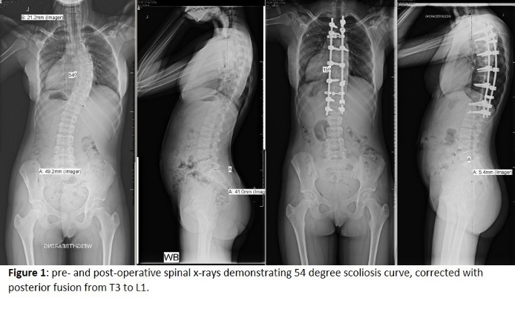

Abstract (300 word limit)
Patients with sickle cell disease (SSD) have high rates of surgical complications including blood loss and vaso-occlusive sickle cell crises (VOSCC); they require careful management including transfusions and meticulous haemostasis. There are no previous case reports of tranexamic acid use in association with adolescent idiopathic scoliosis (AIS) surgery and SSD. AIS surgery can be associated with morbidity including high volume blood loss.
Case: PB 15-year-old female, 2 years post-menarchal AIS, SSD. Truncal shift and large right rib hump not fully reduced on Adams forward bend test with right side bending. History of VOSCC, and ICU admission for acute chest syndrome aged 7y. Daily penicillin V and folic acid. Baseline haemoglobin 80g/L. Pre-operative red cell exchange transfusion to reduce risk of VOSCC increased total haemoglobin to 109g/L and reduced percentage of sickle cell haemoglobin (88% to 24%).
Operative Treatment: TIVA anaesthetic utilised for transcranial spinal cord monitoring. MAP <70mmHg was employed. TXA given at 10 mg/kg. Posterior spinal fusion utilising all pedicle screw construction from T3-L1. No costoplasty to save blood loss despite rib hump. Misonix Ultrasonic Bone cutter for facetectomies, Haemostat Surgiflo in each pedicle instrumented, Spongestan Foam, Surgicel and bone wax for haemostasis at osteotomy sites. 2 Diathermy 2 generators utilised for simultaneous bipolar and unipolar use. No cell saver used. One suctioner not two. Estimated blood loss 300ml. Satisfactory recovery but protracted wound ooze for 4 days and non VOSCC pain, discharged home after eight days.
Discussion: Tranexamic acid, a synthetic lysine derivative and antifibrinolytic agent, acts by binding to plasminogen and blocking interaction with fibrin preventing dissolution of the fibrin clot. This is the first report of TXA use in SSD and AIS. Longer hospital stay due to pain, aggressive IV fluids to prevent VOSCC.

Image

Recent Publications (minimum 5)
- Almeida A, Roberts A. Bone involvement in sickle cell disease. Br J Haematol 2005;129, 482-490.
- Winter SF, Santaguida C, Wong J, et al. Systemic and Topical Use of Tranexamic Acid in Spinal Surgery: A Systematic Review. Global Spine J 2016;6:284–295.
- Elwatidy S, Jamjoom Z, Elgamal E, et al. Efficacy and safety of prophylactic large dose of tranexamic acid in spine surgery: a prospective, randomized, double-blind, placebo-controlled study. Spine (Phila Pa 1976) 2008;33(24):2577–2580.
- Davis NF, McGuire BB, Lawlor L, et al. Oral tranexamic acid as a novel treatment option for persistent haematuria in patients with sickle cell disease. Ann Hematol 2010;89(11):1179-80.
5. Roter E, Bertolizio G, Collard V, et al. Use of tranexamic acid in an uncommon triad: haemorrhagic stroke, sickle cell disease and severe coagulopathy. J Pediatr Hematol Oncol 2019;41(2):161-2.

Photograph

Biography (150 word limit)
Millie is a 5th year medical student who has a passion in developing in the area of spine research under the supervision of Mr Darren F. Lui. Mr Darren F. Lui is a Consultant spinal surgeon who deals with the entire breadth of complex spinal problems from deformity, trauma and cancer. He also specialises in adolescent & paediatric deformity surgery such as scoliosis and kyphosis/Scheuremann’s.
Email: millie.newall@yahoo.com

Notes/Comments:

