Radiculopathy due to venous epidural plexus dilatation: How to focus lumbar pain in pregnant women
Dr Fernando Alvarado, MD, Hospital Universitario Fundación Santa Fe de Bogotá, Colombia
Dr Luis Carlos Morales, MD, Hospital Universitario Fundación Santa Fe de Bogotá, Colombia
Dr Constanza Bedoya, MD, Hospital Universitario Fundación Santa Fe de Bogotá, Colombia
Dr Jorge Uribe, MD, Hospital Universitario Fundación Santa Fe de Bogotá, Colombia
Dr Pedro Gaviria, MD, Hospital Universitario Fundación Santa Fe de Bogotá, Colombia
Dr Kenny Lopez, MD, Hospital Universitario Fundación Santa Fe de Bogotá, Colombia
Dr Yuli Fuentes, MD, Hospital Universitario Fundación Santa Fe de Bogotá, Colombia

Abstract
Introduction: Low back pain is a frequent pathology in pregnant women. Most of the time it is caused by biomechanical changes during pregnancy that overload the musculoskeletal structures of the abdomen and pelvis. It is uncommon to find non-mechanical characteristics of pain, in which case it is necessary to investigate other etiologies.
Materials and methods: We report the case of a patient with lumbar and radicular pain, caused by the compression of the spinal roots at the lumbar level, by epidural vascular dilatation because of changes in the pressure of the abdominopelvic venous system caused by pregnancy. A search of the literature was carried out using the PUBMED database with the following strategy: ("Pregnancy" [Mesh] AND "Low Back Pain" [Mesh]) AND "Radiculopathy "[Mesh].
Results: Epidural venous plexus dilatation is described as a rare cause of lumbar and radicular pain in pregnant women. Other etiologies are described, which are highly relevant for the clinician, since it allows to increase the number of pathologies that should be taken into account when approaching this entity in the clinical setting, in order to propose differential diagnoses, always discarding those causes that represent a risk for the binomial mother-fetus.
Conclusion: Lumbar pain during pregnancy is generally mechanical, however it is very important to recognize those cases in which it is produced by other associated conditions such as venous ingurgitation of the epidural plexus. It is of the utmost importance to identify alarm signs such as radicular pain, and thus, propose differential diagnoses to guide an adequate clinical approach.
Level of evidence: Level IV.

Image
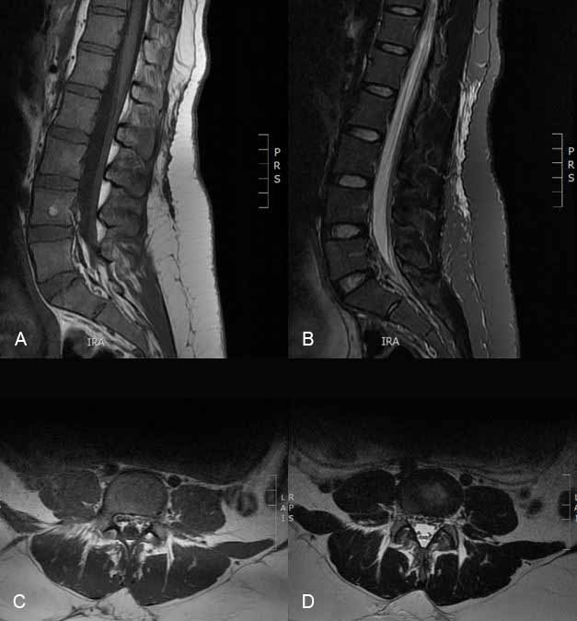
Figure 1. Simple magnetic resonance imaging of the lumbosacral spine. Anterior epidural venous engorgement is observed in L4-S1 segments. A) Sagittal slice in T1 sequence. B) Sagittal slice in STIR sequence. C) Axial cut in T1 sequence. D) Axial cut in T2 sequence.
Recent Publications
- Katonis P, Kampouroglou A, Aggelopoulos A, Kakavelakis K, Lykoudis S, Makrigiannakis A, et al. Pregnancy-related low back pain. Hippokratia. 2011;15(3):205-10.
- Forrester M. Low back pain in pregnancy. Vol. 21, Acupuncture in Medicine. 2003. p. 36-41.
- Munjin M, Llabaca F, Rojas J. Dolor lumbar relacionado al embarazo. Rev Chil Obstet Ginecol. 2007;72:258---65.
- Ardaillon H, Laviv Y, Arle JE, Kasper EM. Lumbar disk herniation during pregnancy : a review on general management and timing of surgery. 2017.
- Okanishi N, Kito N, Akiyama M, Yamamoto M. Spinal curvature and characteristics of postural change in pregnant women. Acta Obstet Gynecol Scand. 2012;91:856---61.
- Kovacs F, Garcia E, Royuela A, González L, Abraira V, Spanish Back Pain Research Network. Prevalence and factors associated with low back pain and pelvic girdle pain during pregnancy: A multicenter study conducted in the Spanish National Health Service. Spine (Phila Pa 1976). 2012;37:1516-33.
- Walde J. Obstetrical and gynecological back and pelvic pains, especially those contracted during pregnancy. Obstet Gynecol Scand 1962;2:11-53.
- Wu W, Meijer O, Uegaki K, et al. Pregnancy-related pelvic girdle pain (PPP), I: Terminology, clinical presentation, and prevalence. Eur Spine J 2004; 13:575-89.
- MacEvilly M, Buggy D. Back pain and pregnancy: a review. Pain 1996;64:405-14.
- Sabino J, Grauer JN. Pregnancy and low back pain. Curr Rev Musculoskelet Med. 26 de febrero de 2008;1(2):137-41.
- Im I-K, Son E-S, Kim DH, Lumbar Epidural Varix Causing Radicular Pain: A Case Report and Differential Diagnosis of Lumbar Cystic Lesions, PM&R (2018), doi: 10.1016/j.pmrj.2018.04.002.
- Casagrande D, Gugala Z, Clark SM, Lindsey RW. Low back pain and pelvic girdle pain in pregnancy. JAAOS-Journal of the American Academy of Orthopaedic Surgeons. 2015;23(9):539–549.
- Sencan S, Ozcan-Eksi EE, Cuce I, Guzel S, Erdem B. Pregnancy-related low back pain in women in Turkey: Prevalence and risk factors. Annals of Physical and Rehabilitation Medicine. enero de 2018;61(1):33-7.
- Gallo-Padilla D, Gallo-Padilla C, Gallo-Vallejo FJ, Gallo-Vallejo JL. Lumbalgia durante el embarazo. Abordaje multidisciplinar. SEMERGEN - Medicina de Familia. septiembre de 2016;42(6):e59-64.
- Pennick V, Young G. Interventions for preventing and treating pelvic and back pain in pregnancy. En: The Cochrane Collaboration, editor. Cochrane Database of Systematic Reviews [Internet]. Chichester, UK: John Wiley & Sons, Ltd; 2007 [citado 13 de febrero de 2018]. Disponible en: http://doi.wiley.com/10.1002/14651858.CD001139.pub2
- Matthews LJ, McConda DB, Lalli TAJ, Daffner SD. Orthostetrics: Management of Orthopedic Conditions in the Pregnant Patient. Orthopedics. 1 de octubre de 2015;38(10):e874-80.
Photograph

Biography
Dr Fernando Alvarado, Physician, specialist in Orthopedics and Traumatology at the Pontificia Universidad Javeriana and subspecialist in spine, pelvis, and acetabulum surgery at the Universidad Militar Nueva Granada. He has special training in pediatric spinal deformities at the Prof. Juan P. Garrahan Hospital in Buenos Aires, Argentina. Specialist in Epidemiology from the Universidad del Rosario. He is currently head of the Spine section of the HU-FSFB Orthopedics and Traumatology department. Clinical professor at the Universidad de los Andes. He is a full member of the Column Chapter of the Colombian Society of Orthopedic Surgery and Traumatology (SCCOT), member of the North American Spine Society NASS. He has been course director and lecturer for AOSpine.
Email: falvaradogomez@gmail.com

Notes/Comments:

