Idiopathic lumbosacral plexopathy associated with foot drop: A case report
Dr Fernando Alvarado, MD, Hospital Universitario Fundación Santa Fe de Bogotá, Colombia
Dr Constanza Bedoya, MD, Hospital Universitario Fundación Santa Fe de Bogotá, Colombia
Dr Luis Pulido, MD, Hospital Universitario Fundación Santa Fe de Bogotá, Colombia
Dr Yuli Fuentes, MD, Hospital Universitario Fundación Santa Fe de Bogotá, Colombia

Abstract

Introduction: lumbosacral plexopathy is an uncommon neurological condition clinically characterized by asymmetrical lower extremity weakness, pain and muscle atrophy, sometimes associated to mild sensory symptoms. The condition has been described to be caused by medical conditions such as neoplasias, infections, trauma, vascular lesions, amyloid infiltration, metabolic and idiopathic causes. The diagnosis is based on clinical history and neurological examination with complementary simple magnetic resonance of the lumbosacral spine. Electrophysiologic studies may also be useful in specific cases.
Case presentation: a previous healthy non-diabetic 19-year-old man consulted with a two-year history of tingling sensation on the right leg, with posterior development of left foot drop and gait impairment. The electrophysiologic study was positive for radiculopathy of the L5 nerve root and the MRI showed active inflammatory plexitis of the left L5 nerve root without features suggesting a specific etiology. The blood tests and lumbar puncture were negative for metabolic, infectious, neoplastic and inflammatory causes. Given the possible complications associated with biopsy in order to determine an exact etiology and the non-disabling symptoms we decided to do imaging and medical follow up.
Conclusion: Lumbosacral plexopathy is an uncommon condition that is challenging to diagnose. Diagnostic tools should be carefully used to determine the appropriate surgical and non- surgical management, based on the correct identified etiology.
Image
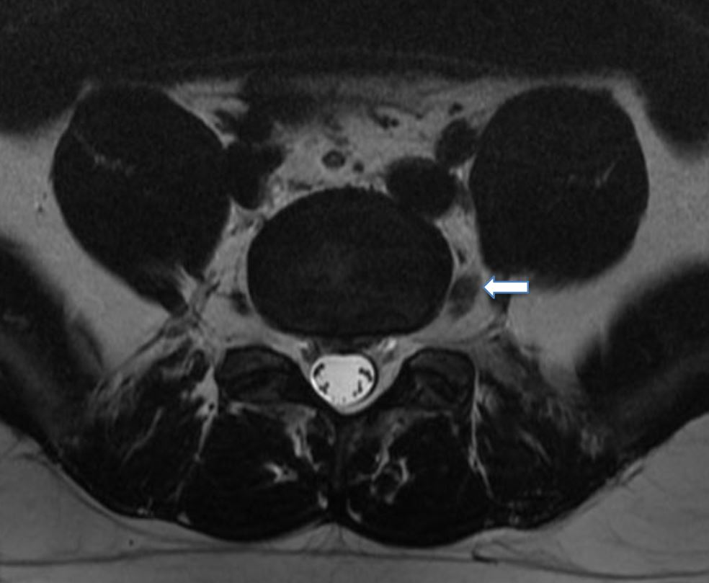
Figure 1: Non-contrast MRI axial T2 sequence shows acute inflammatory plexitis of the left L5 nerve root.
Recent Publications
- Singh O, Al Khalili Y. Anatomy, Back, Lumbar Plexus. [Updated 2019 Jul 22]. In: StatPearls [Internet]. Treasure Island (FL): StatPearls Publishing; 2019 Jan-. Available from: https://www.ncbi.nlm.nih.gov/books/NBK545137/
- Strakowski JA. Electrodiagnosis of plexopathy. PM R. 2013 May;5(5 Suppl):S50-5.
- Planner AC, Donaghy M, Moore NR. Causes of lumbosacral plexopathy. Clin Radiol 2006; 61:987.
- Dyck PJ, Thaisetthawatkul P. Lumbosacral plexopathy. Continuum. 2014;20(5 Peripheral Nervous System Disorders):1343-58.
- Stewart JD. Foot drop: where, why and what to do? Pract Neurol. 2008 ;8(3):158-69.
- Imam Y, Deleu D, Salem K. Idiopathic lumbosacral plexitis. Qatar Med J. 2012; 2012(2): 85–87.
- Van Eijk J, Chan YC, Russell JW. Immunotherapy for idiopathic lumbosacral plexopathy. Cochrane Database Syst Rev. 2013 Dec 31;(12):CD009722.
- Bykowski J, Aulino J, Berger K, Cassidy R, Choudhri A, Kendi A et al. ACR Appropriateness Criteria ® Plexopathy. Journal of the American College of Radiology. 2017;14(5):S225-S233.
- Tarulli A, Rutkove S. Lumbosacral Plexitis. Journal of Clinical Neuromuscular Disease. 2005; 7(2): 72-78.

Photograph

Biography
Dr Fernando Alvarado, Physician, specialist in Orthopedics and Traumatology at the Pontificia Universidad Javeriana and subspecialist in spine, pelvis, and acetabulum surgery at the Universidad Militar Nueva Granada. He has special training in pediatric spinal deformities at the Prof. Juan P. Garrahan Hospital in Buenos Aires, Argentina. Specialist in Epidemiology from the Universidad del Rosario. He is currently head of the Spine section of the HU-FSFB Orthopedics and Traumatology department. Clinical professor at the Universidad de los Andes. He is a full member of the Column Chapter of the Colombian Society of Orthopedic Surgery and Traumatology (SCCOT), member of the North American Spine Society NASS. He has been course director and lecturer for AOSpine.
Email: falvaradogomez@gmail.com

Notes/Comments:

