Diagnostic algorithm for Multiple Myeloma: A guideline for Orthopedic Spine Surgery
Dr Fernando Alvarado, MD, Hospital Universitario Fundación Santa Fe de Bogotá, Colombia
Dr Andres Rodriguez, MD, Hospital Universitario Fundación Santa Fe de Bogotá, Colombia
Dr Luis Carlos Morales, MD, Hospital Universitario Fundación Santa Fe de Bogotá, Colombia
Dr Maria Dominguez, MD, Hospital Universitario Fundación Santa Fe de Bogotá, Colombia
Dr Maria Garcia, MD, Hospital Universitario Fundación Santa Fe de Bogotá, Colombia
Dr Natalia Guacaneme, MD, Universidad de los Andes, Colombia
Dr Kenny Lopez, MD, Hospital Universitario Fundación Santa Fe de Bogotá, Colombia
Dr Yuli Fuentes, MD, Hospital Universitario Fundación Santa Fe de Bogotá, Colombia

Abstract
Introduction: Among the many malignant bone pathologies exists multiple myeloma (MM). Around 60% of patients with this disease develop pathologic fractures, most of which are in the spine (49%). Because these lesions are characteristically osteolytic, imaging studies prove to be an essential diagnostic tool.
Objective: to develop a diagnostic algorithm for MM with an approach based on imaging studies that can be used by spine surgeons using current medical evidence.
Methods and Materials: A systematic search using indexed databases (Medline, EMBASE, Ovid and Cochrane databases) was made, looking for studies that included diagnostic images of MM as an important part of generating a diagnostic algorithm for MM and directed for spine surgeons. Two inclusion criteria were used: first, studies with analyses of imaging diagnostic factors for MM; second, the use of algorithms and imaging classifications for the diagnostic process. And three exclusion criteria were established: first, studies with a focus on treatment rather than diagnosis: second, studies which focused on prognosis and third, those studies that applied imaging diagnostic algorithms for different pathologies.
Results: After a thorough revision, 2969 articles where found of which 2965 were excluded, the remaining 14 were included in this study. The existing evidence shows that spine surgeons should request simple X-rays with axial information as well as long bones and skull. If these results turn out negative and the patient remains symptomatic, a full body magnetic resonance (MRI) should be requested or a hybrid CT scan (PET-CT, FDG-PER CT) in search of osteolytic images. If the MRI is abnormal, further imaging studies like a CT and X-rays should be requested to assess bone stability. Additionally, imaging findings should always correlate to serologic and histologic findings to ensure a correct diagnosis.
Conclusion: The development of new diagnostic imaging techniques has allowed a better characterization of bone lesions for multiple myeloma, creating the possibility of a more accurate diagnosis. A diagnostic algorithm with the new imaging techniques would provide a new approach that could guide physicians, specially spine surgeons, according to the available resources in their specific context.

Image
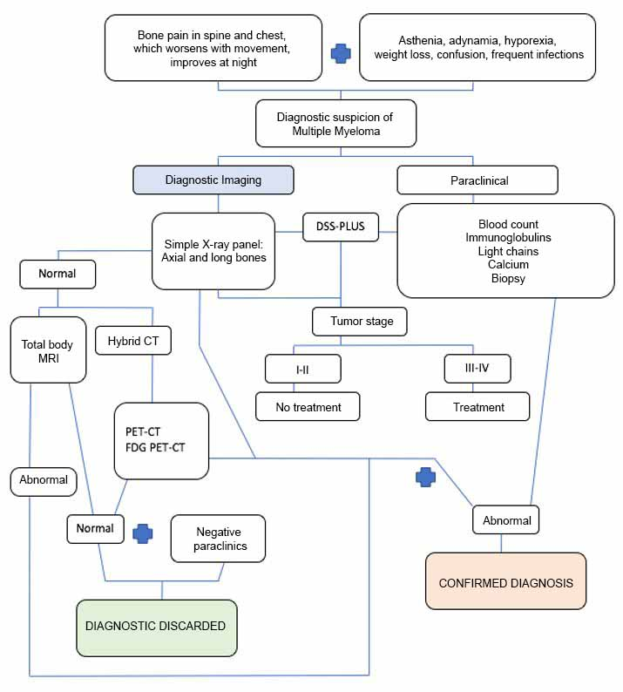
Figure 1. Algorithm of diagnostic imaging extension of multiple myeloma
Recent Publications (minimum 5)
- Bredella M, Steinbach L, Caputo G, Segall G, Hawkins R. Value of FDG PET in the Assessment of Patients with Multiple Myeloma. AJR Am J Roentgenol 2005;184(4):1199-1204.
- Clinica Mayo, múltiple mieloma. (Internet) Estados Unidos. (Citado el 6 de Junio de 2017). Disponible desde: https://www.mayoclinic.org/diseases-conditions/multiple-myeloma/symptoms-causes/syc-20353378
- Ferraro R, Agarwal A, Martin-Macintosh E, Peller P, Subramaniam R. MR Imaging and PET/CT in Diagnosis and Management of Multiple Myeloma. RadioGraphics 2015;35(2):438-454.
- Hillner B, Siegel B, Liu D, Shields A, Gareen I, Hanna L et al. Impact of Positron Emission Tomography/Computed Tomography and Positron Emission Tomography (PET) Alone on Expected Management of Patients With Cancer: Initial Results From the National Oncologic PET Registry. J Clin Oncol 2008;26(13):2155-2161.
- International Myeloma Working Group. Criteria for the classication of monoclonal gammopathies, multiple myeloma and related disorders: a report of the International Myeloma Working Group. Br J Haematol 2003;121(5):749–757.
- Koppula B, Kaptuch J, Hanrahan C. Imaging of Multiple Myeloma: Usefulness of MRI and PET/CT. Seminars in Ultrasound, CT and MRI. 2013;34(6):566-577.
- KyleRA, GertzMA, WitzigTE, etal. Review of 1027 patients with newly diagnosed multiple myeloma. Mayo Clin Proc 2003;78(1):21–33.
- Landgren O, Kyle RA, Pfeiffer RM, et al. Monoclonal gammopathy of undetermined signi cance (MGUS) consistently precedes multiple myeloma: a prospective study. Blood 2009;113(22):5412–5417.
- Palumbo A, Anderson K. Multiple myeloma. N Engl J Med 2011;364(11):1046–1060.
- Roodman G. Skeletal Imaging and Management of Bone Disease. Hematology. 2008;2008(1):313-319.
- SEER. Myeloma - Cancer Stat Facts [Internet]. SEER. 2018 [cited 6 junio 2018]. Available from: https://seer.cancer.gov/statfacts/html/mulmy.html
- Shortt C, Gleeson T, Breen K, McHugh J, O'Connell M, O'Gorman P et al. Whole-Body MRI Versus PET in Assessment of Multiple Myeloma Disease Activity. AJR Am J Roentgenol 2009;192(4):980-986.
- Sociedad Americana de Cancerología. (Internet) Estados Unidos. (Citado el 6 de Junio de 2017). Disponible desde: https://www.cancer.org/cancer/multiple-myeloma/about/what-is-multiple-myeloma.html
- Vigo F, Ciammella P, Valli R, Cagni E, Iotti C. Extraskeletal multiple myeloma presenting with an atrial mass: a case report and a review of the literature. Journal of Medical Case Reports 2012;6(1):1-5.
- Walker R, Lawson M, Buckle C, Snowden J, Chantry A. Myeloma bone disease: pathogenesis, current treatments and future targets. Br Med Bull 2014;111(1):117-138.

Photograph

Biography
Dr Fernando Alvarado, Physician, specialist in Orthopedics and Traumatology at the Pontificia Universidad Javeriana and subspecialist in spine, pelvis, and acetabulum surgery at the Universidad Militar Nueva Granada. He has special training in pediatric spinal deformities at the Prof. Juan P. Garrahan Hospital in Buenos Aires, Argentina. Specialist in Epidemiology from the Universidad del Rosario. He is currently head of the Spine section of the HU-FSFB Orthopedics and Traumatology department. Clinical professor at the Universidad de los Andes. He is a full member of the Column Chapter of the Colombian Society of Orthopedic Surgery and Traumatology (SCCOT), member of the North American Spine Society NASS. He has been course director and lecturer for AOSpine.
Email: falvaradogomez@gmail.com

Notes/Comments:

