PERCUTANEOUS NEUROMODULATION WITH PULSATING RADIOFREQUENCY VS. CRYOABLATION FOR THE TREATMENT OF PATIENTS WITH LUMBAR FACET SYNDROME.
Dr González Ramos Luis Francisco
High Specialty in Column Surgery "Mexican School of Medicine, Universidad La Salle México" based at the Dr. Germán Díaz Lombardo Children's Orthopedic Hospital

Abstract (300 word limit)
Statement of the Problem:
Lumbar spine pain affects a high percentage of the population and has a significant socioeconomic impact, with high rates of absenteeism and work leave. Lumbar facet syndrome is found within the structural etiologies of back pain. Its prevalence as a cause of low back pain is between 15-31% with a lifetime incidence of up to 52% in some series. Due to the use of different types of treatment such as pulsed radiofrequency (RFp) or continuous (RFc), cryotherapy, chemical rhizolysis, nerve blocks; different techniques used and different criteria for patient selection, the success rate varies in the literature.
Material and methods
From January 2019 to November 2019, a total of 8 patients with lumbar facet syndrome were randomly divided into two groups: group A was four patients treated with pulsed radiofrequency and group B was four patients treated with cryoablation. Pain was evaluated with the visual analogue scale four weeks, three and six months after surgery; Oswestry low back pain disability index was also assessed.
Results
The follow-up was 6 months. All the patients were managed on an outpatient basis. In the immediate post-surgery, the 8 patients (100%) reported improvement in symptoms and pain. According to the Oswestry questionnaire, of the 4 patients who were in severe functional limitation, one of them went without functional limitation, and two of them went on to minimal functional limitation and one to moderate functional limitation in the first postoperative month.
Conclusion
The relief of low back pain is accompanied by a significant improvement in the patient's physical abilities as reflected by the parallel improvement in the VAS values ​​and the Owestry disability questionnaire, offering the patient a notable improvement in their quality of life. This improvement can therefore be largely attributed to pain relief.

Image
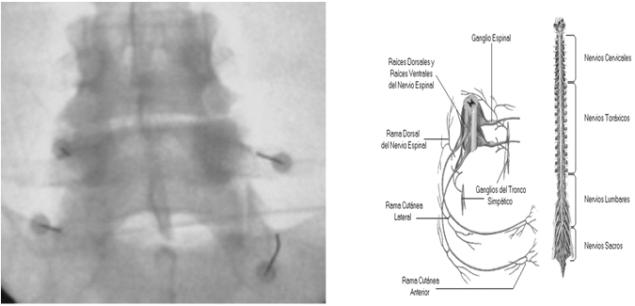Figure 3. Fluoroscopy-guided electrode placement. Placement of electrodes on the dorsal branch.
Recent Publications (minimum 5)
1. Manchikanti L, Singh V, Falco FJ, Benyamin RM, Hirsch JA. Epidemiology of low back pain in adults. Neuromodulation 2014; 17 Suppl 2: 3-10.

2. Van Zundert J, Vanelderen P, Kessels A, van Kleef, M. Radiofrequency treatment of facet-related pain: evidence and controversies. Curr Pain Headache Rep 2012; 16 (1): 19-25.

3. Braulio Hernández Carbajal, Dolor Vertebral Tratamiento Médico y Cirugía Mínimamente Invasiva. Dolor de Columna Vertebral Lumbar, Corinter 2012; 4(41): 41-73

4. Shanthanna H, Chan P, McChesney J, Paul J, Thabane L. Assessing the effectiveness of "pulse radiofrequency treatment of dorsal root ganglion" in patients with chronic lumbar radicular pain: Study protocol for a randomized control trial. Trials. BioMed Central Ltd 2012;13(1):52-4.

5. Muñoz V, Pérez JJ, Pérez-Cajaraville JJ, Berjano E. Aspectos teóricos sobre la biofísica de la radiofrecuencia aplicada al tratamiento del dolor. Rev Soc Esp Dolor 2014; 21(6): 351-8.

6. Trinidad JM, Carnota A, Failde I, Torres LM. Radiofrequency for the treatment of lumbar radicular pain: Impact on surgical indications. Pain Research and Treatment 2015. DOI 10.1155/2015/392856.

7. Nagda JV, Davis CW, Bajwa ZH, Simopoulos TT. Retrospective review of the efficacy and safety of repeated pulsed and continuous radiofrequency lesioning of the dorsal root ganglion/segmental nerve for lumbar radicular pain. Pain Physician 2011; 14(4): 371-6.

8. J. M. Trinidad Martín-Arroyo. Radiofrecuencia pulsada: pasan los años y seguimos con las mismas incógnitas. Rev. Soc. Esp. del Dolor, Vol. 23, N.º 4, Julio-Agosto 2016

Photograph

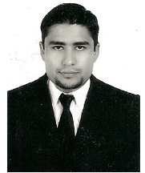 Biography (150 word limit)
Certificate of the Mexican Council of Orthopedics and Traumatology, A.C. with the registration 21/5061/19. Valid from February 23, 2019 to February 23, 2024

• Proof of participation as an assistant in the XX ANNUAL AMCICO CONGRESS from November 13 to 17, 2019, Cancún Q. Roo

• Proof of participation as a Theorist in the XVIII INTERNATIONAL CONGRESS OF MINIMAL INVASIVE AND ENDOSCOPIC SURGERY OF COLUMN, from December 4 to 7, 2019 in the City of León Gto. Mexico

High Specialty in Spinal Surgery, Hospital of Orthopedics German Díaz Lombardo CDMX, March 1, 2019 to February 29, 2020

Author of the articles “Neurological evolution and quality of life of patients diagnosed with Sciwora and Sciworet treated at the Hospital of Traumatology and Orthopedics of Puebla 2016-2018” and PERCUTANEOUS NEUROMODULATION WITH PULSATING RADIOFREQUENCY VS. CRYOABLATION FOR THE TREATMENT OF PATIENTS WITH LUMBAR FACET SYNDROME.
Email: dr.lfgr@gmail.com

Notes/Comments:

DR. LUIS FRANCISCO GONZÁLEZ RAMOS
Puerto Vallarta, Jalisco, México.
Teléfono móvil: 2224 55 6143
Teléfono fijo: (01) 321 38 7 34 48
dr.lfgr@gmail.com
dr.lfspine@gmail.com

