Title: Time before surgery vs recovery of lumbar herniation. Chilean reality in the public health system.
Author: Marcos Ganga Villagràn, Universidad de Chile, Facultad de Medicina, Complejo Hospitalario San José, Traumatology Department, Spine Group, Santiago, Chile.
Co-authors: Juan Pablo Santelices Lopez, Universidad de Chile, Facultad de Medicina, Complejo Hospitalario San José, Traumatology Department, Spine Group, Santiago, Chile; Patricio Omar Almonacid Lorca, Complejo Hospitalario San José, Orthopedics and Traumatology Service, Resident, Santiago, Chile ; Loreto Consuelo Pulido Quintana, Universidad Austral de Chile, Facultad de Medicina, Resident, Valdivia, Chile.; Andrea Cecilia Palacios Castillo, Universidad de Chile, Facultad de Medicina, Traumatology Department, Santiago, Chile

Abstract (300 word limit)
Objective: To evaluate the influence between the time elapsed since the onset of symptoms and the surgery of lumbar HNP in the final functional recovery of the comprehensive treatment of patients. Methods: Retrospective descriptive study of cases of HNP treated by lumbar discectomy between 2009 and 2015 by the spine team of the Hospital San José, using SPSS (version 22 of IBM) for the statistical analysis. Results: Of 110 patients subject to surgery, 54 were recruited (22 women and 32 men), between 18 and 75 years old, with an average age of 43 years. Eighty percent of patients are active workers, 76% without comorbidities. The predominant level affected was L4/L5 with 52% of the cases. The mean progression time of the symptoms before the first consultation was 27 months, the waiting time between the consultation and the surgery was 5.6 months. Conclusions: Eighty-six percent of the patients -presented good results in VAS. The Oswestry questionnaire reached a positive result in 90%, a minimum disability in 40%, moderate in 50% and maximum in 10%. No statistical relationship was achieved between any of the evaluated variables and the outcome of the surgery.

Image
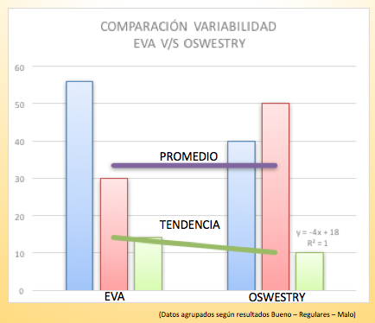
Recent Publications (minimum 5)
- Macchiavello Cornejo Nicolás; Ganga Villagrán Marcos; Pellegrini Pucci Manuel; Schulz Ibaceta Ronald (2009) Columna cervical reumática Coluna/Columna vol 8(1):94-98.
- Ibaceta R.S; Cornejo N.M; Ramirez S; Escobar J; Villagran M.G; Schulz H. (2009) Uso de morfina intratecal en artrodesis lumbar. Coluna/Columna vol.8, n.4, 386-389.

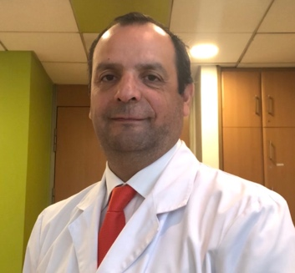
Photograph
Biography (150 word limit)
Dr Marcos Ganga graduated of Medical Doctor from School of Medicin, Universidad de Chile, Santiago, Chile and completed his residency of Orthopedic Surgeon in Hospital Clinico Jose Joaquin Aguirre, Universidad de Chile in Santiago, Chile.
He completed his fellowship at Spine Surgery in SRH Klinikum Karslbad-Langensteinbach, Universidad de Heidelberg, Germany. He is the Chief, Spine Group in Hospital San Jose, Santiago and staff in Spine Group, Clinica Santa Maria, Santiago Chile. Dr. Ganga is a Professor assistance in Department of Orthopedics and Traumatology and General Coordination in Spine Education from Residents and Fellowships. Universidad de Chile.
Email: mgangav@gmail.com

