

Algorithms for Diagnosis and Treatment of Patients with Concomitant Thoracic and Lumbar Spine and Spinal Cord Injury

Abstract (300 word limit)

Statement of the Problem: Concomitant spine and spinal cord injury (SSCI) is diagnosed in 13-63% of patients having thoracic and lumbar spine injury. Main causes of concomitant SSCI include car accidents (22-70%) and height falls (18-61%). At the same time surgery timing, intervention range and staging in patients with concomitant SSCI are to be cleared.
The purpose of this study: to specify the surgical algorithm for diagnosis and treatment of patients with concomitant thoracic and lumbar spine and spinal cord injury.
Methodology & Theoretical Orientation: The total number of 518 surgeries were performed in our Center between 2000 and 2019 in patients with thoracic spine injuries and 910 surgeries in patients with lumbar spine injuries. Concomitant injuries were diagnosed in 46%, while 22% of patients had SCI. All admitting patients were divided into 3 groups. 4% were admitted to the operation room immediately, 71% were admitted to intensive care unit and 25% to Neurosurgical or Orthopedic Departments. Indications for urgent admittance to the operation room included limb open fractures, continuous hemorrhage or internal organ eventration. Contraindications for urgent surgery in patients with concomitant trauma included traumatic or hemorrhagic shock with instable hemodynamics, concomitant internal organ injuries (internal hemorrhage, peritonitis development, heart contusion with acute heart failure, multiple rib injuries with hemopneumothorax and signs of respiratory failure), severe traumatic brain injury with consciousness level decrease (less than 10 points in Glasgow Coma Scale), suspected intracranial hematomas, severe concomitant deceases with severe anemia (Hb level less than 80-90 g/L), cardiovascular pathologies, renal (anuria, oliguria, carbamide level >20 mM/L, creatinine level >180 mM/L) and/or hepatic disorders (protein <50g/L, hepatic enzymes increase more than 3-4 times), fat embolism, pulmonary embolism and non-fixed limb fractures in case of posterior approach. Surgical risk factors include concomitant trauma severity more than 37 points according to ISS scale, ASIA A neurological deficit. Intraoperational risk factors leading to premature surgery end include decrease of hemoglobin level less than 70 g/L, blood pressure level <90 mmHg and pressure medication support, arrythmia, hypoxia (SpO2 <80%), instant blood loss more than 800 mL or total blood loss exceeding 1800 mL.
Conclusion & Significance: Current algorithm application resulted in mortality level decrease from 14% in 2000 to 4.8% in 2010 and to 1.7% in 2019. Number of complication also decreased from 12% in 2000 to 9.1% in 2010 and to 2.4% in 2019.

Image
Algorithm for surgical treatment of patients with complicated concomitant thoracic and lumbar spinal and spinal cord injury.

Stable, dural compression
Stay
conservative
Stable,
no dural compression
Complicated concomitant
SSCI
Unstable
Anterior instability
Laminectomy, decompression, subdural space revision.
Fusion, laminar and/or pedicular fixation
Anterior interbody fusion
Laminectomy, anterior and posterior dural decompression, subdural space revision. Fusion, laminar and/or pedicular fixation

Single-stage surgery
Two-stage surgery
Patient’s severe state

Recent publications:

Grin et al. External Multicenter Study of Reliability and Reproducibility for Lower Cervical Spine Injuries Classification Systems – Part I: A comparison of Morphological Schemes.- Global Spine Jornal, 2019, 1-10. DOI:.10.1177/2192568219868218

Grin et al. External Multicenter Study of Reliability and Reproducibility for Lower Cervical Spine Injuries Classification Systems – Part II: An analysis of the Subaxial Cervical Spine Injury Classification and Cervical Spine Injury Severity Score Scale.- Global Spine Jornal, 2019, 1-9 DOI:.10.1177/2192568219896546

Grin et al. Posterior percutaneous transarticular atand-alone screw instrumentation of C1-C2 with endoscopic assistance: A report of two cases.- Neurocirugia, 2019
https://doi.org/10.1016/j.neucir.2019.08.006

Smirnov et al. Regenerative therapy of spinal cord injury: systematic review. Part 1. – Neurosurgery (Neurohirurgija). – 2019.-Vol. 21.-№ 2.-Pp. 66-75. https://doi.org/10.17650/1683-3295-2019-21-2-66-75
Smirnov et al. Regenerative therapy of spinal cord injury: systematic review. Part 2. – Neurosurgery (Neurohirurgija). – 2019.-Vol 21.-№ 3.-Pp. 83-92. https://doi.org/10.17650/1683-3295-2019-21-3-83-92

Lvov et al. Comparison of the Long-term Results of Posterior Transarticular Stand-alone Screw Instrumentation and Magerl Technique in Patients with Traumatic Atlantoaxial Instability: Mean 5-Year Follow-up Study with a Radiological and Patient-related Outcomes Assessment.- World Neurosurgery.-2019.-Feb.16-Epub. doi: https://doi.org/10.1016/j.wneu.2019.01.263.-PP. 1 – 13.

Photo:

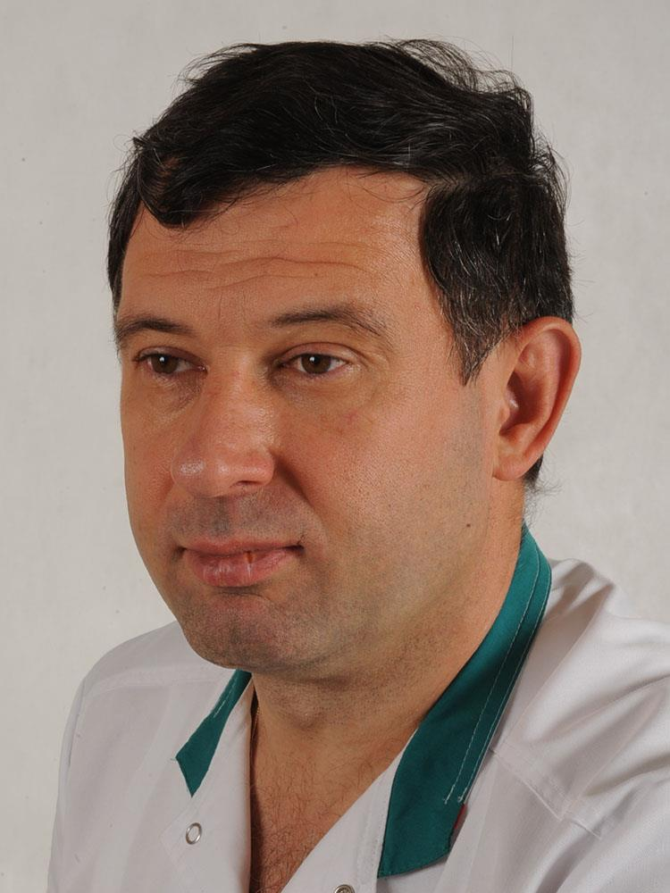

Professional biography:

Andrew A. Grin’ M.D., Ph.D., Prof., is the Head of Neurosurgical Department of N.V. Sklifosovsky Emergency Care Institute, Senior Neurosurgeon of Moscow Department of Healthcare. Highly experienced in spine surgery for more than 30 years. Has more than 500 publications in Russian and International Journals.

