

Systemic cell therapy using human mononuclear cord blood cells (hUCBCs) in patients with acute severe contusion spinal cord injury (ASIA A, B): phases I/IIa of randomized open-label safety and primary efficiency clinical study.
Vladimir A. Smirnov*, Andrew A. Grin’*, Sergey I. Ryabov#, Marina A. Zvyagintseva#, Mikhail Yadgarov#, Sergey Bazanovich#, Vladimir N. Smirnov#
* Department of Neurosurgery, Sklifosovsky Emergency Care Research Institute, Moscow, Russia
# Stem Cell Division, National Medical Institute of Cardiology, Moscow, Russia

Introduction: Spinal cord injury (SCI) is a severe injury of CNS resulting in disability and significant decrease in quality of life. The uncomplicated injury of spine is easily and effectively treated in almost all cases using current surgical techniques, but no effective treatment of SCI is currently available. We published earlier the results of a preclinical study series using human mononuclear UCBCs in animal models of SCI. These studies demonstrated high efficiency of systemic cell therapy resulted in regression of motor deficit up to 53% comparing to placebo and decrease in myelopathy area volume according to 7,0 Tl MRI examination.
Materials and Methods: Phases I/IIa randomized open-label clinical study of cell therapy safety and primary efficiency in patients with acute contusion SCI and ASIA A/B neurological deficit was carried out. 20 patients were included into the study divided into 2 groups. Treated patients obtained 4 iv infusions of 300 x 10⁶ mononuclear hUCBCs weekly. Follow-up period reached 1 year.
Results: Performed study was approved by Institutional Review Board and registered in ClinicalTrials.gov portal. Safety evaluation was carried out using CTCAE v5.0 classification. Overall amount of 392 adverse events were registered in 20 patients. Only 2 of them were likely to be related to cell therapy, both were moderate. No other side effects or complications related to cell therapy were detected in all patients. No signs of immunization were observed. The conducted efficiency analysis demonstrated restoration of spinal cord functions and improvement of outcomes comparing to routine therapy. The mean increase of ASIA scale in experimental group reached 2.2 while in control group it was 0.9. Total index of motor scale in upper extremities (UEMS) and lower extremities (LEMS) in treated group reached 77 ± 19 points while in control group it was 33 ± 21.6. 78% of treated patients were able to stand and walk autonomously while in control group only 30% were able to perform that. Cell therapy also decreased the spasticity level in lower extremities assessed by modified Ashworth scale and promoted the improvement in self-urination ability in patients with neurological urinary retention. Quality of life was also significantly higher in cell therapy group according to FIM scale.
Conclusion: Thus systemic cell therapy utilizing mononuclear human UCBCs is safe and effective method of regenerative therapy on acute contusion SCI.

Recent publications:
Smirnov et al. Improvement of hind limbs motor function evaluation following systemic cord blood stem cell therapy using swimming test computed analysis/ EuroSciCon Stem Cells 2019, Stockholm, Sweden, May 13-14, 2019.
Smirnov et al. Regenerative therapy of spinal cord injury: systematic review. Part 1. – Neurosurgery (Neurohirurgija). – 2019.-Vol. 21.-№ 2.-Pp. 66-75. https://doi.org/10.17650/1683-3295-2019-21-2-66-75
Smirnov et al. Regenerative therapy of spinal cord injury: systematic review. Part 2. – Neurosurgery (Neurohirurgija). – 2019.-Vol 21.-№ 3.-Pp. 83-92. https://doi.org/10.17650/1683-3295-2019-21-3-83-92
Lvov et al. Comparison of the Long-term Results of Posterior Transarticular Stand-alone Screw Instrumentation and Magerl Technique in Patients with Traumatic Atlantoaxial Instability: Mean 5-Year Follow-up Study with a Radiological and Patient-related Outcomes Assessment.- World Neurosurgery.-2019.-Feb.16-Epub. doi: https://doi.org/10.1016/j.wneu.2019.01.263.-PP. 1 – 13.
Ryabov et al. Collagen Implant and Mononuclear Cells of Umbilical Blood Allow the Restore of Movements of Hind Limbs after Removing the Site of Spinal Cord.- Bulletin of Experimental Biology and Medicine.-2018.-Vol. 164.-No. 3.-PP. 390-393.

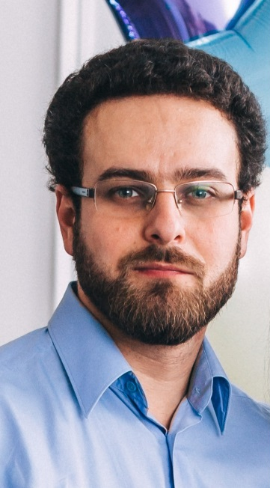

Professional Biography
Vladimir A. Smirnov, MD, PhD, specialized in orthopedic surgery and spine neurosurgery, completed PhD in 2019 at the age of 31 from Sklifosovsky Emergency Care Institute, Moscow, Russia by the topic of “Systemic application of mononuclear cord blood cells for treatment of severe spinal cord contusion in an animal model”. Has completed the series of experimental studies using cord blood stem cells in animal model of spinal cord injury. In 2015-2018 completed I/IIa phases of clinical studies in patients with severe spinal cord injury. Has published more than 17 papers in reputed Russian and foreign journals.

