Title: Patient Blood Management in Major Spine Surgery
Dr. Sandra Giannone, IRCCS Istituto Ortopedico Rizzoli, Bologna Italy
Dr. Daniela Ghisi, Dr Alessandro Ricci, IRCCS Istituto Ortopedico Rizzoli, Bologna Italy

Abstract
Statement of the Problem: Patient Blood Management (PBM) is a multimodal, multidisciplinary strategy that aims at reducing surgical associated transfusions by acting on three great “pillars”: optimizing erythropoiesis, reducing blood loss and promoting the use of restrictive transfusion thresholds while maximizing anemia tolerance. Complex surgical spine procedures have a high peri-operative transfusion rate, up to 60-70%, which is consistent with our current practice. The purpose of this study is to describe how the implementation of a three pillar PBM program has changed the transfusion rate in patients undergoing major spine surgery in our institution. Methodology: We planned a before-after observational study: patients in the “before” group were treated according to standard of care before the implementation of the PBM program. Patient in the “after” group were treated according to the recommendations of PBM, among which the most important were: 1. Diagnosis and treatment of pre-operative anemia: all patients were screened for the presence and causes of anemia at least 4 weeks before surgery, and treated with iron/vitaminB12 supplements according to laboratory results. 2. Use of technical and pharmacological techniques to minimize blood loss: all patients without contraindications received intravenous tranexamic acid; position was optimized; maintenance f normothermia was ensured; diligent hemostatic surgical technique was applied 3. Application of restrictive transfusion threshold: in the hemodynamically stable patients, a threshold of Hemoglobin 7-8 g/dl was applied. Results and conclusion: The study is sill ongoing. We plan to enroll 50 patients per group to perform data analysis.

Image
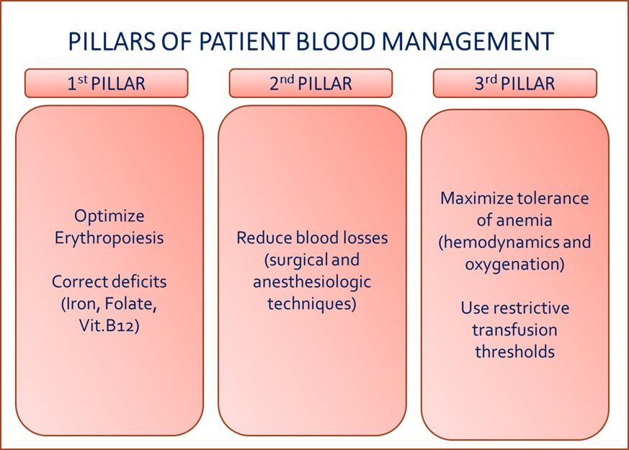
Recent Publications (minimum 5)
- Goodnough LT, Shander A (2013) Current status of pharmacologic therapies in patient blood management. Anesth Analg. 116(1):15-34.
- Muñoz M, Gómez-Ramírez S, Kozek-Langeneker S, Shander A, Richards T, Pavía J, Kehlet H, Acheson AG, Evans C, Raobaikady R, Javidroozi M, Auerbach M (2015) 'Fit to fly': overcoming barriers to preoperative haemoglobin optimization in surgical patients. Br J Anaesth. 115(1):15-24.
- Minhas, S. V., Chow, I., Bosco, J., & Otsuka, N. Y. (2015). Assessing the Rates, Predictors, and Complications of Blood Transfusion Volume in Posterior Arthrodesis for Adolescent Idiopathic Scoliosis. Spine (Phila Pa 1976), 40(18), 1422-1430.
- Elgafy, H., Bransford, R. J., McGuire, R. A., Dettori, J. R., & Fischer, D. (2010). Blood loss in major spine surgery: are there effective measures to decrease massive hemorrhage in major spine fusion surgery? Spine (Phila Pa 1976), 35(9 Suppl), S47-56.
- Torres-Claramunt, R., Ramirez, M., Lopez-Soques, M., Salo, G., Molina-Ros, A., Llado, A., & Caceres, E. (2012). Predictors of blood transfusion in patients undergoing elective surgery for degenerative conditions of the spine. Arch Orthop Trauma Surg, 132(10), 1393-1398.



Photograph
Biography (150 word limit)
Dr. Giannone is an attending anesthesiologist and researcher at Rizzoli Orthopedic Institute, Bologna. Her practice focuses mainly on Patient Blood Management and application of principles of Evidence Based Medicine in anesthesia and transfusion practice in orthopedic surgery.
Email:sandra.giannone@gmail.com

