Prevalence of Neck–Shoulder Pain and Low Back Pain among High School Students in Riyadh, Saudi Arabia.
Rawaf K. Al Rawaf² , Dr Mohammed M. Zamzam MD, PhD¹ , Dr Osama A. Al Rehaili MD¹, Adel F. Al Shihri², Mohammed S. Abunayan², Abdullah A. Al Dhibaib², Abdullah F. Al Jafar², Abdulrahman F. Al Barakah²
1Department of Orthopaedics, King Saud University, College of Medicine, Riyadh, Saudi Arabia.
²King Saud University, College of Medicine

Abstract (300 word limit)
- Statement of the Problem: Neck–shoulder pain and low back pain can interfere with a normal function that affect work productivity, daily activity, and comfortable sleeping. On the long term, it could cause musculoskeletal disability. The prevalence of this pain is unknown among adolescents in Riyadh. The purpose of the study is to measure the prevalence of neck-shoulder pain and low back pain among high schools’ students in Riyadh and to pinpoint the associated possible causes responsible for their occurrence. Methodology & Theoretical Orientation: This is a quantitative, observational cross-sectional study done in Riyadh. We have selected five high schools, from different regions of the city. We have performed the study using a self‐administered questionnaire administered to 596 adolescent students at the five selected high schools in Riyadh. Findings: A total of 563 (56.0% of males and 44.0% of females) participants completed the questionnaire. Around half of the samples (49.7%) reported to have both neck-shoulder pain and low back pain, and 18.1% reported that they have experienced neither neck-shoulder pain nor low back pain. Neck-shoulder pain was reported by 69.4% of participants and was significantly associated with female gender and mood change and abdominal sleeping position. Low back pain, on the other hand, was reported by 62.2% of participants and was significantly associated with female gender and mood change. Conclusion & Significance: Neck-shoulder pain and low back pain are common problems among high school students in Riyadh. Being female, having mood changes, and abdominal sleeping position are risk factors. Further study with expanding the age range to include all adolescents is recommended, which also should have more questions to identify the cause, the degree of the pain, limitations, and disabilities caused by LBP and NSP.

Image
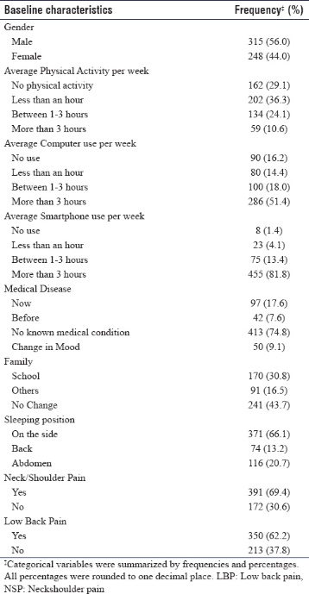
Recent Publications (minimum 5)
- Vikat A, Rimpelä M, Salminen JJ, Rimpelä A, Savolainen A, Virtanen SM. Neck or shoulder pain and low back pain in Finnish adolescents. Scand J Public Health 2000;28:164-73.
- Hakala P, Rimpelä A, Salminen JJ, Virtanen SM, Rimpelä M. Back, neck, and shoulder pain in Finnish adolescents: National cross sectional surveys. BMJ 2002;325:743.
- Minghelli B, Oliveira R, Nunes C. Non-specific low back pain in adolescents from the South of Portugal: Prevalence and associated factors. J Orthop Sci 2014;19:883-92.
- Auvinen J, Tammelin T, Taimela S, Zitting P, Karppinen J. Neck and shoulder pains in relation to physical activity and sedentary activities in adolescence. Spine (Phila Pa 1976) 2007;32:1038-44.
5. Shan Z, Deng G, Li J, Li Y, Zhang Y, Zhao Q. Correlational analysis of neck/shoulder pain and low back pain with the use of digital products, physical activity and psychological status among adolescents in Shanghai. PLoS One 2013;8:e78109.

Photograph

Biography (150 word limit)
Mr Rawaf Alrawaf is a final year medical student in King Saud University in Riyadh, he is interested in researches especially those related to orthopedics. In addition, he has passion in developing more advanced researches, so he is excited to be part of these huge scientific conferences.
Email: Rawaf.k.r@gmail.com

Notes/Comments:
There might be 2 presenters, the author and one of the co-authors.

