Title: Incidence of dysphagia of zero-profile spacer versus cage-plate after anterior cervical discectomy and fusion A meta-analysis
Jiaquan Luo The First Affiliated Hospital of Gannan Medical University

Abstract (300 word limit)

BACKGROUND:
The purpose of this study is to evaluate the rate of dysphagia between zero profile spacer versus cage-plate for the treatment of multilevel cervical spondylotic myelopathy (CSM).
METHODS:The authors searched electronic databases for relevant studies that compared the clinical effectiveness of zero profilespacer versus cage-plate for the treatment of patients with multilevel CSM. The following outcome measures were extracted: the Japanese Orthopaedic Association (JOA) scores, Neck Disability Index (NDI) score and fusion rate, dysphagia rate, adjacent segment degeneration, and cervical lordosis. Newcastle-Ottawa Quality Assessment Scale was used to evaluate the quality of each study. Data extraction and quality assessment were conducted, and RevMan 5.2 was used for data analysis.

RESULTS:
A total of 10 studies were included in our meta-analysis. Our pooled data revealed that zero-profile spacer was associated with decreased dysphagia rate at postoperatively 1, 3, and 6 months, and the final follow-up when compared with cage-plate group. No significant difference was observed in terms of postoperative JOA score, NDI score, and fusion rate. Compared with zero-profilespacer, the postoperative adjacent segment degeneration was significant higher in cage-plate. Pooled data from the relevant studies revealed that cervical lordosis was significantly lower in zero-profile spacer compared with cage-plate.

CONCLUSIONS:
Our meta-analysis reveals zero-profile spacer is better than the cage-plate in terms of dysphagia. This suggests zero-profile spacer is a superior alternative invention for the treatment of multilevel CSM to reduce the risk of dysphagia.

Image

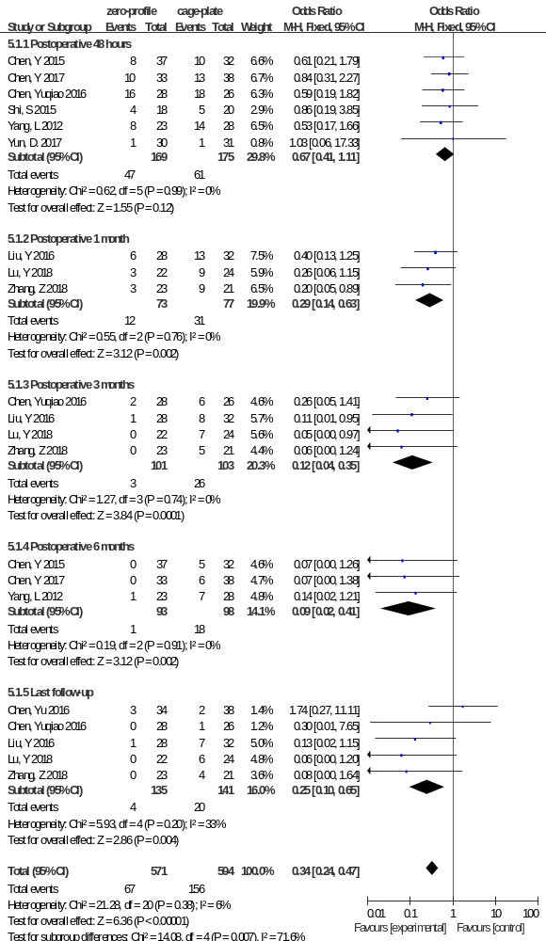

Forest plot of postoperative dysphagia rate between zero-profile spacer and cage-plate groups
Recent Publications (minimum 5)
- Luo, J. and J. Zhong, Letter to Editor Regarding Comparison of Outcomes for Anterior Cervical Discectomy and Fusion With and Without Anterior Plate Fixation: A Systematic Review and Meta-Analysis. Spine (Phila Pa 1976), 2019.
- Yuan, X., Luo J*,et al., Comparison of laminectomy and fusion vs laminoplasty in the treatment of multilevel cervical spondylotic myelopathy: A meta-analysis. Medicine (Baltimore), 2019. 98(13): p. e14971
- Luo J, Wang H, Peng J, Deng Z, Zhang Z, Liu S, Wang D, Gong M, Tang S Rate of adjacent segment degeneration of cervical disc arthroplasty versus fusion Meta-analysis of randomized controlled trials.World Neurosurg 2018 Feb 27. DOI：10.1016/j.wneu.2018.02.113 (IF=2.592)
- Luo J, Zhong Y, Huang S, Li L, Zhang C, Zou X: Ginkgolide B enhances the differentiation of preosteoblastic MC3T3-E1 cells through VEGF: Involvement of the p38 MAPK signaling pathway. Mol Med Rep 2016, 14:4787-4794. (IF=1.692)
- Luo J, Huang L, Chen Z, Zeng Z, Miyamoto T, Wu H, Zhang Z, Pan Z, Fujita N, Hikata T, et al: Increased sorbitol levels in the hypertrophic ligamentum flavum of diabetic patients with lumbar spinal canal stenosis. J Orthop Res 2017, 35:1058-1066. ( IF=2.692)
- Luo J, Cao K, Huang S, Li L, Yu T, Cao C, Zhong R, Gong M, Zhou Z, Zou X: Comparison of anterior approach versus posterior approach for the treatment of multilevel cervical spondylotic myelopathy. Eur Spine J 2015, 24:1621-1630. (IF=2.563)
- Luo J, Cao K, Yu T, Li L, Huang S, Gong M, Cao C, Zou X: Comparison of Posterior Lumbar Interbody Fusion Versus Posterolateral Fusion for the Treatment of Isthmic Spondylolisthesis. Clin Spine Surg 2017, 30:E915-E922. (IF=2.291)
- Luo J, Gong M, Huang S, Yu T, Zou X: Incidence of adjacent segment degeneration in cervical disc arthroplasty versus anterior cervical decompression and fusion meta-analysis of prospective studies. Arch Orthop Trauma Surg 2015, 135:155-160. (IF= 1.942)
- Luo J, Wu C, Huang Z, Pan Z, Li Z, Zhong J, Chen Y, Han Z, Cao K: The accuracy of the lateral vertebral notch-referred pedicle screw insertion technique in subaxial cervical spine: a human cadaver study. Arch Orthop Trauma Surg 2017, 137:517-522. (IF= 1.942)
- Chen Y, Luo J（Cofirst author）,Pan Z, Yu L, Pang L, Zhong J, Li Z, Han Z, Cao K: The change of cervical spine alignment along with aging in asymptomatic population: a preliminary analysis. Eur Spine J 2017. (IF=2.563)



Photograph
Biography (150 word limit)
Education Background
September 2013 to July 2016, Sun Yat-sen University Doctor
September 2009 to July 2012, Nanchang University Master
September 2004 to July 2009, Youjiang Medical College for Nationality Bachelor
Academic posts
Scientific Reports, PLOS One,BMC Musculoskeletal Disorders Reviewer
Email: luojiaquan666@163.com

