Non-surgical management of Failed Back Syndrome
Dr. Akhil Chhatre, MD

Abstract (300 word limit)
There is a large population of patients who have undergone some type of spinal surgical intervention with or without revision and complaints of persistent pain. They are given a label of failed back surgery and offered little hope or answers as to their pain generators, chance of improvement, or sustainable lifestyle options. We will discuss during this talk the pathophysiology, realistic expectations, and treatment options.

Image
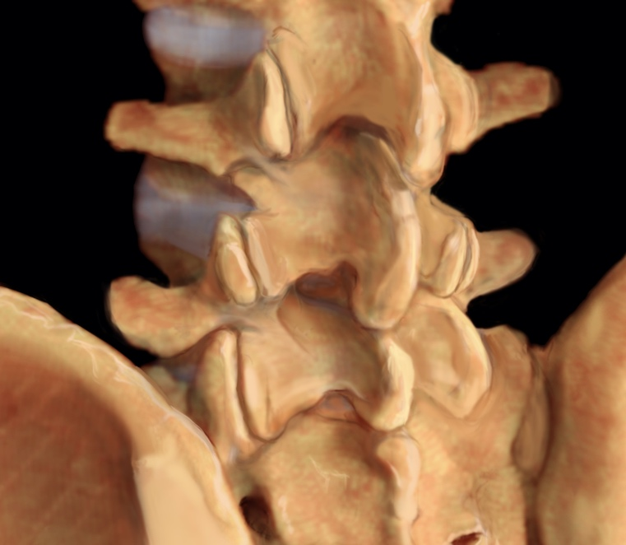

Recent Publications (minimum 5)
- See Rome abstract

Photograph

See Rome Talk abstractEmail: drXXXXXXX@xxxmail.com

Notes/Comments:

