Combination Endoscopic Foraminoplasty
Mr Martin Knight MD FRCS MBBS, UK

Abstract (300 word limit)
Statement of the Problem: Cluneal nerve trigger point irritation (CNTPI) symptomatology and aetiology are poorly recognized and too often treated with open surgery where conservative measures fail. The purpose of this study is to describe the distribution of symptoms shown in Figure 1, which can mimic sciatica and to present a diagnostic and treatment pathway and outcomes thereto. Methodology & Theoretical Orientation: A prospective study of the treatment outcomes based upon the proposed diagnostic protocol deployed in 33 consecutive patients with CNTPI was independently analysed 2 – 5 years following treatment shown in Figure 2. Conclusion & Significance: The diagnostic pathway differentiates the pain from CNTPI from spinal disorders, facet joint or sacro-iliac joint pain and provides a promising treatment alternative to that of open surgery. The proposed treatment is based upon correction of pelvic attitude and radiofrequency ablation of the “trigger points” and offers encouraging outcomes

Image
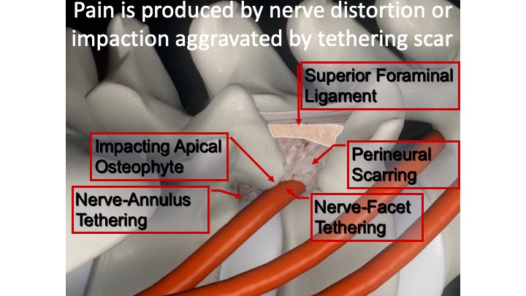
Figure 1 Generators of Foraminal Low Back Pain

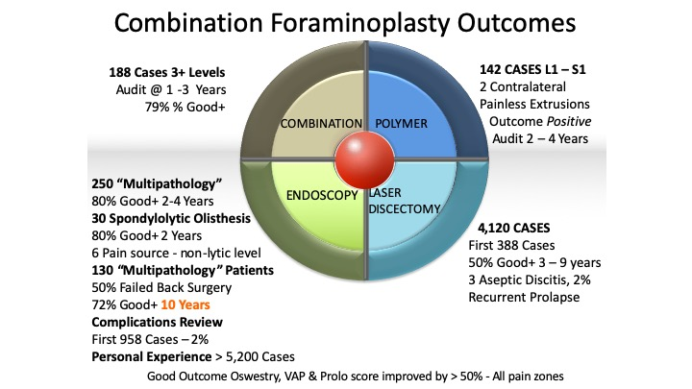

Figure 2 Clinical Demographics & Outcomes
Recent Publications (minimum 5)

1.Freemont, A., et al. (2002). "Nerve growth factor expression and innervation of the painful intervertebral disc." The Journal of pathology 197(3): 286-292.

2. Gerber, B. E. and M. Knight (2001). Lasers in the Musculoskeletal System: 56 Tables, Springer Science & Business Media.

3.Knight, M. (2001). "Lumbar foraminal pain sources: an aware state analysis." Millenium Laser Book.

4. Knight, M. (2001). An x-ray jig to facilitate the percutaneous posterolateral approach to the lumbar spine. Lasers in the Musculoskeletal System, Springer: 277-282.

5. Knight, M. and A. Goswami (2002). "Lumbar percutaneous KTP532 wavelength laser disc decompression and disc ablation in the management of discogenic pain." Journal of clinical laser medicine & surgery 20(1): 9-13.

6. Knight, M. and A. Goswami (2003). "Management of isthmic spondylolisthesis with posterolateral endoscopic foraminal decompression." Spine 28(6): 573-581.

7. Knight, M., et al. (1999). "Endoscopic laser foraminoplasty and a aware-state surgery: a treatment concept and 2-year outcome analysis." Arthroskopie 12(2): 62-73.

8. Knight, M., et al. (2000). "Comparative outcome of Holmium: YAG and KTP laser disc ablation in degenerative cervical disc disease: results of an ongoing study." Ortopedia, traumatologia, rehabilitacja 2(2): 39-43.

9. Knight, M., et al. (2001). Endoscopic foraminoplasty: An independent prospective evaluation. Lasers in the Musculoskeletal System, Springer: 320-329.

10. Knight, M., et al. (1998). "Endoscopic laser foraminoplasty on the lumbar spine-early experience." min-Minimally Invasive Neurosurgery 41(01): 5-9.

11. Knight, M. T. (2000). "Endoscopic laser foraminoplasty." The practice of minimally invasive spinal technique 42: 337-340.

12. Knight, M. T. (2013). "Laser assisted percutaneous and endoscopic lumbar discectomy." Textbook of Surgical Management of Lumbar Disc Herniation: 219.

13. Knight, M. T., et al. (2001). "Review of safety in endoscopic laser foraminoplasty for the management of back pain." Journal of clinical laser medicine & surgery 19(3): 147-157.

14. Knight, M. T., et al. (2001). "Endoscopic foraminoplasty: a prospective study on 250 consecutive patients with independent evaluation." Journal of clinical laser medicine & surgery 19(2): 73-81.

15. Knight, M. T., et al. (2014). "Transforaminal endoscopic lumbar decompression & foraminoplasty: a 10 year prospective survivability outcome study of the treatment of foraminal stenosis and failed back surgery." International journal of spine surgery 8: 21.

16. Knight, M. T. N. (2002). Evolution of Endoscopic Laser Foraminoplasty, University of Manchester.

Photograph

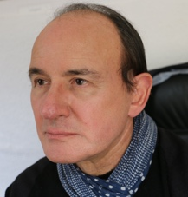
Biography (150 word limit)
Mr Martin Knight is a pioneering endoscopic minimally-invasive spinal surgeon known for pushing the boundaries of surgical techniques and developing what we now know as personalised tailored spinal surgery. Mr Knight is an expert in treating degenerative disc disease, sciatica, slipped disc, spinal stenosis, spondylolisthesis, “Instability”, discogenic pain, annular tears and failed back surgery.
After training at St Bartholomew's and St Thomas', The Royal Postgraduate Medical School he started his consultant career as an Orthopaedic surgeon in the Royal Navy. Thereafter as an NHS consultant, he committed to revolutionising the use of endoscopic techniques in spinal surgery and to this day continues to push the envelope of what is possible.

Mr Knight is an honorary Senior Lecturer at the University of Manchester and the University of Central Lancashire, developing Advanced Instrumentation and Disc Regenerative Surgery. He is currently the medical director of The Spinal Foundation on Harley Street, London.
Email: mknight@spinal-foundation.org

Notes/Comments:

