Cluneal Nerve Trigger Point Entrapment Syndrome and Radiiofrequency Treatment
Mr Martin Knight MD FRCS MBBS, UK
Dr Indu Karangoda MBBS, FRCA, FFICM, EDIC, UK
Dr Rahim Nadeem Ahmed M.B.B.S, FCARCSI, FRCA, FFICM, UK
Dr James Inklebarger MD, UK
Thomas D’Angelo BSc(Hons), UK

Abstract (300 word limit)
Statement of the Problem: Cluneal nerve trigger point irritation (CNTPI) symptomatology and aetiology are poorly recognized and too often treated with open surgery where conservative measures fail. The purpose of this study is to describe the distribution of symptoms shown in Figure 1, which can mimic sciatica and to present a diagnostic and treatment pathway and outcomes thereto. Methodology & Theoretical Orientation: A prospective study of the treatment outcomes based upon the proposed diagnostic protocol deployed in 33 consecutive patients with CNTPI was independently analysed 2 – 5 years following treatment shown in Figure 2. Conclusion & Significance: The diagnostic pathway differentiates the pain from CNTPI from spinal disorders, facet joint or sacro-iliac joint pain and provides a promising treatment alternative to that of open surgery. The proposed treatment is based upon correction of pelvic attitude and radiofrequency ablation of the “trigger points” and offers encouraging outcomes

Image
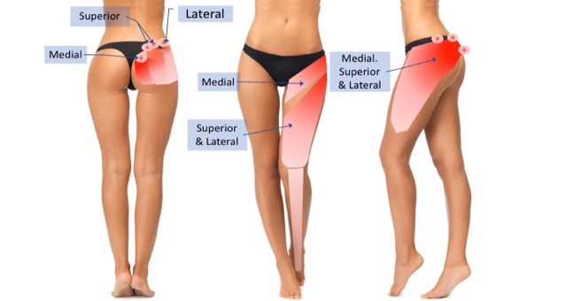
Figure 1 CNTPI Symptom distribution

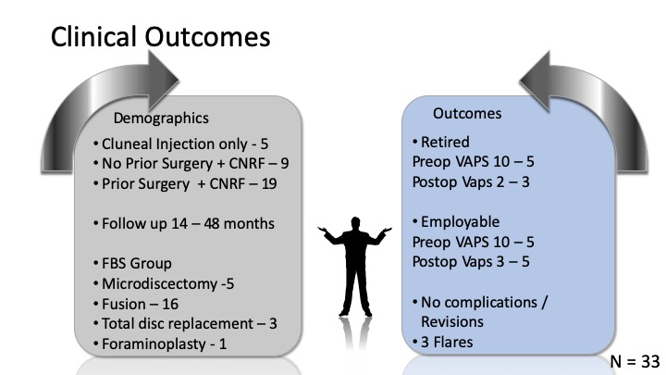

Figure 2 Clinical Demographics & Outcomes
Recent Publications (minimum 5)

1. Lu J, Ebraheim NA, Huntoon M, et al. Anatomic considerations of superior cluneal nerve at posterior iliac crest region. Clin Orthop Relat Res 1998(347):224-8. [published Online First: 1998/04/01]

2. Isu T, Kim K, Morimoto D, et al. Superior and Middle Cluneal Nerve Entrapment as a Cause of Low Back Pain. Neurospine 2018;15(1):25-32. doi: 10.14245/ns.1836024.012 [published Online First: 2018/04/16]

3. Tubbs RS LM, Loukas M, Potts EA, Cohen-Gadol AA. Anatomy and landmarks for the superior and middle cluneal nerves: application to posterior iliac crest harvest and entrapment syndromes. J Neurosurg Spine 2010;13:356–59.

4. Knight MT, Jago I, Norris C, et al. Transforaminal endoscopic lumbar decompression & foraminoplasty: a 10 year prospective survivability outcome study of the treatment of foraminal stenosis and failed back surgery. Int J Spine Surg 2014;8 doi: 10.14444/1021

5. Knight MTN, Krishnan A. Spinal Surgery. In: Whitwam JG, McLoy RF, eds. Principles and Practice of Sedation. Oxford: Blackwell Science, 1998:178-81.

6. Inklebarger J GN. The Management of Cluneal Nerve Referred Pain with Prolotherapy. J Prolotherapy 2018;10:982-91.

7. Kuniya H, Aota Y, Kawai T, et al. Prospective study of superior cluneal nerve disorder as a potential cause of low back pain and leg symptoms. J Orthop Surg Res 2014;9:139. doi: 10.1186/s13018-014-0139-7 [published Online First: 2015/01/01]

8. Konno T, Aota Y, Kuniya H, et al. Anatomical etiology of "pseudo-sciatica" from superior cluneal nerve entrapment: a laboratory investigation. J Pain Res 2017;10:2539-45. doi: 10.2147/JPR.S142115 [published Online First: 2017/11/16]

9. Iwanaga J, Simonds E, Patel M, et al. Anatomic Study of Superior Cluneal Nerves: Application to Low Back Pain and Surgical Approaches to Lumbar Vertebrae. World neurosurgery 2018;116:e766-e68. doi: 10.1016/j.wneu.2018.05.087 [published Online First: 2018/05/23]

10. Knight MTN. Lumbar foraminal pain sources: an aware state analysis. In: Simunovic Z, ed. Lasers in Surgery and Dentistry. Switzerland: European Medical Laser Association, 2001:233-52.

11. Knight MTN, Goswami A, Patko JT, et al. Endoscopic foraminoplasty: a prospective study on 250 consecutive patients with independent evaluation. J Clin Laser Med Surg 2001;19(2):73-81.

12. Morimoto D, Isu T, Kim K, et al. Long-term Outcome of Surgical Treatment for Superior Cluneal Nerve Entrapment Neuropathy. Spine (Phila Pa 1976) 2017;42(10):783-88. doi: 10.1097/BRS.0000000000001913 [published Online First: 2016/09/27]

13. Matsumoto J, Isu T, Kim K, et al. Surgical treatment of middle cluneal nerve entrapment neuropathy: technical note. J Neurosurg Spine 2018;29(2):208-13. doi: 10.3171/2017.12.SPINE17991 [published Online First: 2018/05/19]

Photograph

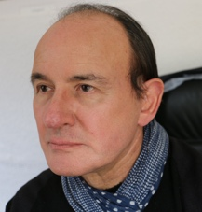
Biography (150 word limit)
Mr Martin Knight is a pioneering endoscopic minimally-invasive spinal surgeon known for pushing the boundaries of surgical techniques and developing what we now know as personalised tailored spinal surgery. Mr Knight is an expert in treating degenerative disc disease, sciatica, slipped disc, spinal stenosis, spondylolisthesis, “Instability”, discogenic pain, annular tears and failed back surgery.
After training at St Bartholomew's and St Thomas', The Royal Postgraduate Medical School he started his consultant career as an Orthopaedic surgeon in the Royal Navy. Thereafter as an NHS consultant, he committed to revolutionising the use of endoscopic techniques in spinal surgery and to this day continues to push the envelope of what is possible.

Mr Knight is an honorary Senior Lecturer at the University of Manchester and the University of Central Lancashire, developing Advanced Instrumentation and Disc Regenerative Surgery. He is currently the medical director of The Spinal Foundation on Harley Street, London.
Email: mknight@spinal-foundation.org

Notes/Comments:

