Prevalence of Low back Pain among Female Health Sciences Students
Sarah Nasser AlJasser, MBBS
Zhour ALHedyan, MBBS
Fahad ALShayhan, MBBS
Dr.Munir Saadeddin, Associate Professor and Orthopedic Consultant

Abstract (300 word limit)

Low back pain (LBP) is a physical and economical dilemma that individuals from all age groups encounter. Interestingly, LBP was considered as the leading cause of years lived with disability globally [1]. A meta-analysis of the prevalence of low back pain in adolescents revealed that the mean lifetime prevalence was 39.9% [2]. Anderrson defined LBP as pain restricted to the area between the lower borders of the 12th rib and gluteal folds [3]. The commonest variety of back pain is LBP, arising in 60-80% of people at a certain point in their lives [4].

Methodology: A Quantitative cross-sectional study was conducted among seven hundred and forty-seven female undergraduates from five health-sciences colleges during the academic year 2016-2017. Self-administered questionnaire was conducted and included 4 sections: demographic characteristics, risk factors, Nordic Musculoskeletal questionnaire and Oswestry Disability Scale. [5,6]

Results: Mean age of participants 20.3 ± (1.5 years). 35.8% of students where physically active. Lifetime prevalence of LBP among female health science undergraduates was 53.1%, 12-months prevalence was 47.4%, and point prevalence was 21.6%. Medical college students reported significantly higher lifetime prevalence (64.3%). Physical activity was not associated with point prevalence of LBP. BMI of more than 25 was associated insignificantly with increased risk of LBP (OR 1.13%; CI 95% 0.74-1,73; p=0.568. Feeling discomfort on bed was significantly associated with LBP (OR 2.49; 95%CI 1.74-3.65; p=> 0.001) Setting on comfortable college furniture was significantly related to decreased risk of LBP (OR 0.56%;95%CI 0.38-0.82; p= 0.003). Psychological factors such as being overwhelmed and feeling sad were associated with LBP. According to Oswestry disability scale, majority of students who have LBP are having minimal disability due to LBP.

Conclusion: This study has shown high prevalence of LBP among future health care providers. Female medical students are at higher risk for developing LBP in comparison to other health science students.

Image

 |  | Point prevalence of LBP (%) | P-value
Physical Activity | Active | 24.3 | 0.179
Physical Activity | Inactive | 20.0 | 0.179

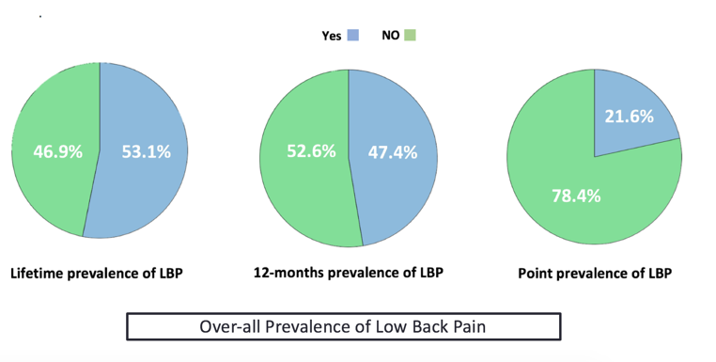

Recent Publications (minimum 5)
- Lim, S.S., et al., A comparative risk assessment of burden of disease and injury attributable to 67 risk factors and risk factor clusters in 21 regions, 1990–2010: a systematic analysis for the Global Burden of Disease Study 2010. The lancet, 2012. 380(9859): p. 2224-2260.Heilig M, Egli M (2006) Pharmacological treatment of alcohol dependence: Target symptoms and target mechanisms. Pharmacology and therapeutics 111:855-876.
- Calvo-Munoz, I., A. Gomez-Conesa, and J. Sanchez-Meca, Prevalence of low back pain in children and adolescents: a meta-analysis. BMC Pediatr, 2013. 13: p. 14.Room R, BaborT, Rehm J (2005) Alcohol and public health. Lancet
365: 519-530.
- Anderson, J.A., Problems of classification of low-back pain. Rheumatol Rehabil, 1977. 16(1): p. 34-6.
- Anderson, L., Educational approaches to management of low back pain. Orthop Nurs, 1989. 8(1): p. 43-6.
- Kuorinka, I., et al., Standardised Nordic questionnaires for the analysis of musculoskeletal symptoms. Appl Ergon, 1987. 18(3): p. 233-7.
- Fairbank, J.C. and P.B. Pynsent, The Oswestry Disability Index. Spine (Phila Pa 1976), 2000. 25(22): p. 2940-52; discussion 2952.


Biography (150 word limit)
Sarah Nasser alJasser is a 1st honor’s degree newly graduate and medical intern at King Khalid University Hospital in Riyadh, Saudi Arabia. She is interested in the prosperous field of spine surgery. She completed her bachelor degree in Medicine in King Saud University on April 4, 2019 and is currently an intern in King Khalid University Hospital. She has been an active researcher in cross-sectional studies and case-series related to spinal surgery more precisely minimally invasive techniques such as ACDF with stand-alone cage VS ACDF with plates and screws in the treatment of degenerative spine diseases.
Email: s.aljasser666@gmail.com

Notes/Comments:

