Treatment of Toracolumbar Transition Fractures type A3 and A4: prospective study of pain and quality of life in open vs. percutaneous arthrodesis
Dr Gibran Franzoni Rufca, Neurosurgery Department, Hospital Santa Casa de Ourinhos, Brazil
Dr Carla de Jiacomo Machado Gazola, Neurosurgery Department, Hospital Santa Casa de Ourinhos, Brazil
Dr Flávio Ramalho Romero, Department of Neurosurgery, Faculdade de Medicina de Botucatu - Universidade Estadual Paulista – UNESP, Brazil
Dr. Flávio Porto Franco Piola, Neurosurgery Department, Hospital Regional Presidente Prudente, Brazil
Dr. Georgea Carneiro, Resident Physician of the Department of Neurosurgery, Hospital Regional Presidente Prudente, Brazil
Dr. Ana Carolina Fonseca Galoti, Department of Neurosurgery, Hospital Regional de Assis, Brazil
Dr. Mario Wolak Junior, Resident Physician of the Department of Neurosurgery, Faculdade de Medicina de Botucatu - Universidade Estadual Paulista – UNESP, Brazil
Leon Cleres Pinheiro, Resident Physician of the Department of Neurosurgery, Faculdade de Medicina de Botucatu - Universidade Estadual Paulista – UNESP, Brazil

Abstract
Approximately 11,000 new cases of spinal injuries occur every year in the United States and approximately 250,000 people in this country have associated spinal cord injury. The life expectancy for patients is shortened from 15 to 20 years. In the treatment, the open posterior approach, with midline incision for decompression and fusion is one of the most used techniques. However, is associated with aggression of healthy tissue, muscle injury and increased rate of bleeding. In this context, minimally invasive techniques have been increasingly used, with less damage to healthy tissues, less bleeding and reduced morbidities and complications. Nowadays, data favoring one technique over the other are insufficient, with a low number of patients studied, leading to inconclusive results and low clinical impact. Therefore, a prospective, longitudinal, multicenter study is being developed with follow-up of individuals for 12 months. The primary objective is of assessing whether, for the treatment of thoracolumbar fractures, minimally invasive surgery is superior to conventional surgery regarding postoperative pain and quality of life (QoL). All patients are being submitted to preoperative X-ray and computed tomography of the spine for decision-making and calculation of deformities. After the patients' written consent, an instrument containing the following data is being applied: demographic, hospitalization, clinical and neurological conditions, and biomechanics. The following intraoperative data are being analyzed: type of surgery, number of levels fused, number of screws used, need for laminectomy, need for previous instrumentation, blood loss, surgical time and occurrence of complications. The prognostic analysis is being performed through the application of pain and (QoL) questionnaires: Visual Analog Pain Scale, Oswestry Disability Index and SF-36. These assessments are being done at 15 days, 03, 06, 12 months after surgery. In this presentation we will present the partial results obtained so far and the comparison of these with current literature.

Image
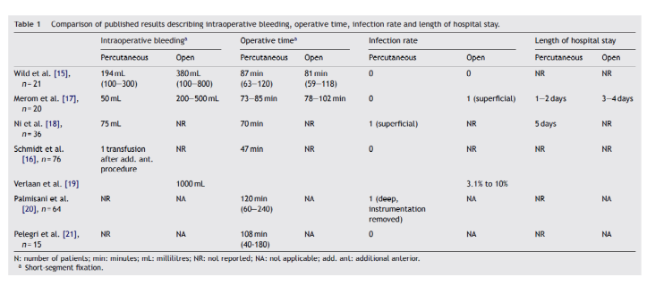
C. Court, C. Vincent. Orthopaedics & Traumatology: Surgery & Research (2012) 98, 900—909
Recent Publications
- McAnany SJ, Overley SC, Kim JS, Baird EO, Qureshi SA, Anderson PA. Open Versus Minimally Invasive Fixation Techniques for Thoracolumbar Trauma: A Meta-Analysis. Glob spine J [Internet]. 2016;6(2):186–94.
- Court C, Vincent C. Percutaneous fixation of thoracolumbar fractures: Current concepts. Orthop Traumatol Surg Res [Internet]. Elsevier Masson SAS; 2012;98(8):900–9
- Rufca GF, et al. Quality of Life in the Pre- and Postoperative Periods in Spinal Fusion And Discectomy. Coluna/Columna. 2019, vol.18, n.1, pp.55-59.365: 519-530.
- Nogueira FM, de Morais DF, Rufca GF, et al. Thoracolumbar spine corpectomy with placement of a cage by single posterior approach: surgical technique and results of six patients. Coluna/Columna [Internet]. 2011 ; 10( 2 ): 97-101.
- Romero FR, Vieira RB, Ancheschi B da C. Open vs. Percutaneous Pedicle Screw Insertion for Thoracolumbar Traumatic A3 and A4 AO Fractures - 18-Months Follow-Up. Arq Bras Neurocir. 2017;36(4):207–11.

Photograph

 Biography
I have a degree in Medicine and Neurosurgery from the School of Medicine of São José do Rio Preto. I live in the State of São Paulo and my main institution is the Hospital Santa Casa de Ourinhos, where my team and I provide neurosurgical treatments, mainly for the pathologies of the vertebral column. We brought to the region that I work the first endoscopic, functional surgeries and the first minimally invasive procedures of the spine. In constant updating, inside and outside the country, I am currently also a master's degree student in the Post-Graduation Program of the University of São Paulo - Campus Botucatu - working in the research of pain and minimally invasive surgeries of the spine, under the coordination of Prof. Dr. Flávio Ramalho Romero.
Email: gibran.rufca@gmail.com

