Abstract Title: Strengthening of Prestressed Steel–Concrete Composite Beams Using Carbon Fiber tendons (Parametic study)

Ashraf Elshihy ¹, Hesham Fawzy ², Hilal Hassan ³, Ahmed Elbelbisi ⁴

¹Department of Structural Engineering, , Zagazig University, Zagazig, Egypt

²Department of Structural Engineering, , Zagazig University, Zagazig, Egypt

³Department of Structural Engineering, , Zagazig University, Zagazig, Egypt

⁴Department of Structural Engineering, , Zagazig University, Zagazig, Egypt

Abstract

Strengthening of structures using external prestressed Carbon fiber reinforced polymer systems have proven to be an effective process as system strengthen the structural capacity and decrease cracks and deformability.

A finite element model three-dimensional is set up to study the impact of composite beams strengthened using externally prestressed Carbon fiber reinforced polymer tendons under flexural behavior studying parameters like prestress level, tendon material and tendon profile elevated from the bottom surface of steel beam flange considered under static loading. Consequences of the parametric study will give reasonable guidelines for the designers.

Ansys computer program has been used to create the non linear analysis. The accuracy of the 3-D model is verified with the available experminatel data . End from the finite element model and design suggestions are given.

Keywords— Composite, prestressed, CFRP, ANSYS 15.0.

Professional Biography (100-150 words)

Ashraf Elshihy has completed his PhD at the age of 29 years from Southampton University. He is the former minister of the Egyptian Ministry of Higher Education. Hesham Fawzy has completed his PhD at the age of 34 years from Dundee University. He is the vice dean of Zagazig University for Environmental Affairs and Development Community Service . Hilal Hassan has completed his PhD at the age of 35 years from Zagazig University . He is asistant professor at Zagazig University.Ahmed Elbelbisi has completed his BSC at the age of 24 years from Zagazig University. He is demonstrator at Zagazig University.

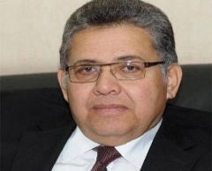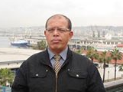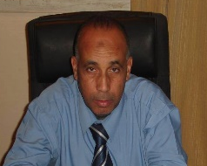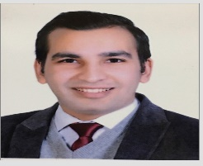

Email Id: Ahmed_elbelbesy@yahoo.com

Any Comments:

