Plenary Speech: Photoactive Materials and Platforms for Biocatalytic Artificial Photosynthesis
Prof. Dr. Chan Beum Park

Department of Materials Science & Engineering, Korea Advanced Institute of Science and Technology (KAIST), 335 Science Road, Daejeon 34141, Republic of Korea

Abstract (not more than 300 words)

The idea of solar energy utilization in chemical synthesis through the combination of photocatalysis and biocatalysis provides an opportunity to make the green process greener. Recent progress indicates that photoinduced electron transfer using organic or inorganic photosensitizing materials can activate a wide spectrum of redox enzymes to catalyze fuel-forming reactions (e.g., H2 evolution, CO2 reduction) and synthetically useful reductions. This talk provides an overview of recent advances in light-driven activation of redox enzymes through direct or indirect transfer of photoinduced electrons. The approaches and understanding in the construction of catalytic assemblies to activate different redox enzymes using organic dyes, carbon-based nanomaterials, semiconductors, and photoelectrochemical platforms will be described. I will discuss how to design photoactive materials and platforms to advance photobiocatalytic transformation as a synthetic tool that meets an ever-increasing demand for sustainable chemistry.

Keywords—photoactive materials, artificial photosynthesis, biocatalysis, photocatalysis

Professional Biography

Chan Beum Park is a professor at the Department of Materials Science and Engineering, KAIST. He received his B.S. (1991), M.S. (1995), and Ph.D. (1999) degrees from POSTECH, then pursued postdoctoral research at the University of California, Berkeley (1999-2002), and worked as an assistant professor at the Arizona State University (2002-2006) before joining KAIST. He is the recipient of the Research Excellence Award (KAIST), the Scientist of the Month Award (Republic of Korea), the Technology Innovation Award (Grand Prix, KAIST), and the Prime Minister's Award (Republic of Korea).
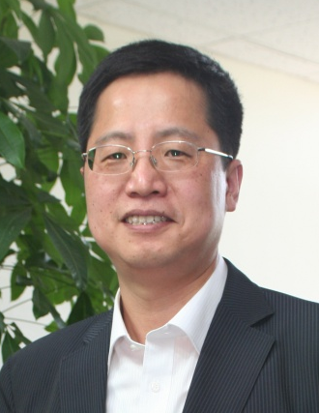

Email Id: parkcb@kaist.ac.kr

Any Comments: This talk has been invited as a plenary talk.

