

Title: Spherical Piezoelectric drive
Grazvydas Kazokaitis, PhD student, KTU, Lithuania
Vytautas Jurenas, Prof. Dr., KTU, Lithuania

Abstract
Piezoelectric magnetic drive is a device which uses two piezoelectric actuators for precise 3 degrees of freedom (DOF) rotation of sphere-shaped rotor. Mechanical part of this drive described further: sphere-shaped rotor inserted between two piezoelectric actuators (Fig. 1). These ring-shaped piezoelectric actuators have polarization in axial direction and one of the electrodes is devided into three equal sectors. Each segmented electrode is excited by separate harmonic signal. All three electrodes can be excited independently i.e. three channels generator is used to drive actuator. Amplitude and duration of the applied signal depends on rotation velocity and motion trajectory of the sphere. The out-of-plane bending and radial vibrations of the piezoelectric rings are excited to obtain elliptical motion of the contacting points and to rotate magnetic sphere in desired direction. In addition, it must be mentioned that actuator can be driven by burst type signal in order to achieve positioning of the sphere with very high resolution. Described system could be used for applications, where precise 3 DOF rotational control of the sphere-shaped rotor is needed. Few examples of such applications: space and attitude control of the satellites, laser beam control, precise mirror deflectors and etc.
(Up to 250 words)

Figures:
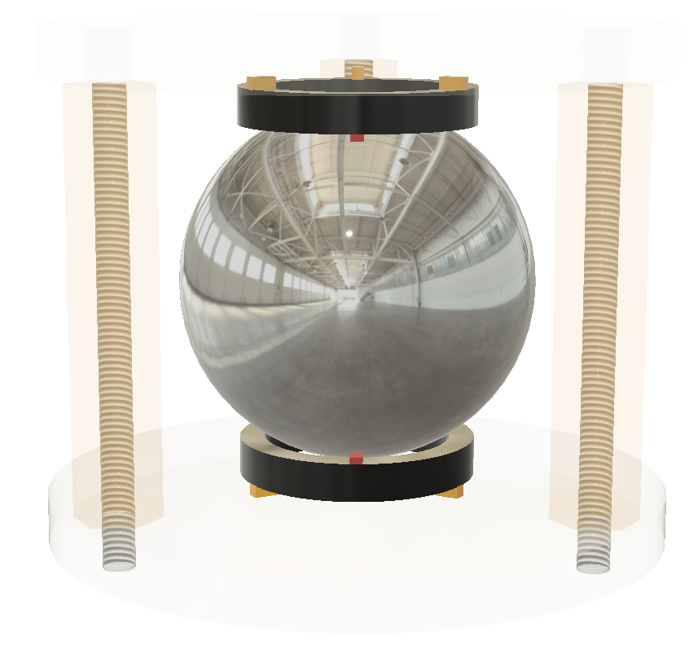
5
4
1
3
2
Fig. 1. 1- sphere-shaped rotor; 2 – piezoelectric actuators; 3- contact points; 4-elastic supports; 5 – flanges.

Recent Publications:
- Kazokaitis, Grazvydas; Jurenas, Vytautas. Spherical magnetic drive for attitude control on nano satellites //Joint event proceedings of 2-nd International Conference on Advanced Robotics, Mechatronics and Artificial Intelligence and 3-rd International Conference on Design & Production Engineering; Valencia, Spain, December 03-04 2018. Journal of Applied Mechanical Engineering. ISSN 2168-9873. 2018, volume 7, p. 73- 74
- Kazokaitis, Gražvydas; Jurėnas, Vytautas; Eidukynas, Darius. Research and analysis of spherical magnetic drive for attitude control on nano satellites // Vibroengineering Procedia. ISSN 2345-0533. 2017, vol. 15, p. 50-56.
- Bansevičius, Ramutis Petras; Mažeika, Dalius; Jūrėnas, Vytautas; Kulvietis, Genadijus; Bakanauskas, Vytautas. Development of traveling wave actuators using waveguides of different geometrical forms // Shock and Vibration. New York: Hindawi publishing corporation. ISSN 1070-9622. 2016, vol. 2016, article 4101062, p. 1-9.
- Grybas, Ignas; Bansevičius, Ramutis Petras; Jūrėnas, Vytautas; Bubulis, Algimantas; Janutėnaitė, Jūratė; Kulvietis, Genadijus. Ultrasonic standing waves-driven high resolution rotary table // Precision engineering. New York, NY: Elsevier. ISSN 0141-6359. 2016, vol. 45, p. 396-402.
- Ostaševičius, Vytautas; Markevičius, Vytautas; Jūrėnas, Vytautas; Žilys, Mindaugas; Čepėnas, Mindaugas; Kižauskienė, Laura Gylienė, Virginija. Cutting tool vibration energy harvesting for wireless sensors applications // Sensors and actuators A: Physical. Lausanne: Elsevier. ISSN 0924-4247. 2015, vol. 233, p. 310-318.
- Šakalys, Rokas; Janušas, Giedrius; Palevičius, Arvydas; Čekas, Elingas; Jūrėnas, Vytautas; Sodah, Amer. Microstructures replication using high frequency excitation // Microsystem technologies. Berlin: Springer. ISSN 0946-7076. 2016, vol. 22, iss. 7, p. 1831-1843.

Biography

Grazvydas Kazokaitis has experience in design and R&D fields developing small and precise mechanisms for ultra-fast laser beam control and machining apparatus. This experience allows provide solid foundation and knowledge creating possible solutions for laser beam orientation mechanisms between small units in space, attitude control and other control tasks.
Vytautas Jurenas is senior researcher in Kaunas University of Technology. The main areas of R&D are dynamics and diagnostics of mechanical systems. His research interests include piezomechanics and its application in hi-tech mechatronics.

Presenting author details
Full name: Grazvydas Kazokaitis
Contact number: +37067220243
Email id: grazvydas.kazokaitis@ktu.edu
Category: E-Poster
Session name:
Research interest: Mechanical engineering; piezoelectric drives and actuators, spaces technologies;
Notes:

