Title: Measurement of natural radiation exposure of building materials used in Sri Lanka based on High Purity Germanium (HPGe) detector
P.A.R.P. Kumara, B.Sc. in Applied Sciences (Physics, Chemistry), Faculty of Applied Sciences, University of Rajarata, Mihinthale, Sri Lanka, M.Sc. in Physics of Materials, Postgraduate Institute of Science, University of Peradeniya, Peradeniya, Sri Lanka, Sri Lanka Atomic Energy Board, Orugodawatta, Sri Lanka
Abstract:
In this work, the natural radioactivity levels of several building materials used in Sri Lanka, were determined in terms of Bq kg⁻¹, and to calculate the radiological effects caused by this radioactivity. Measurement of activity concentrations of radionuclides in building materials is important in the assessment of population exposures, as most individuals spend 80% of their time indoors [2]. Naturally occurring radionuclides in building materials are source of external radiation exposure in dwellings. The radiation is caused by gamma radiation originating from the Uranium, Thorium series and from ⁴⁰K [3]. Activity concentrations of ²²⁶Ra, ²³²Th and ⁴⁰K in eighteen samples of manufactured building materials were measured using gamma spectroscopy based on high purity germanium detector with an efficiency of 48 % at 1332.5 keV. The measurement of the activity concentration in building materials is required to estimate the excess dose to public dwelling in such buildings. BEGe detector is a well- chosen equipment for this purpose. The activity concentrations for ²²⁶Ra, ²³²Th and ⁴⁰K from the selected building materials ranged from (5.0 ± 0.5 to 45.2 ± 2.9 Bq kg⁻¹), (7.1 ± 0.6 to 68 ± 5.9 Bq kg⁻¹) and (42.8 ± 3.8 to 1773 ± 54 Bq kg⁻¹) respectively. Radium equivalent activities, absorbed dose rate, the value of external hazard indexes and alpha indexes were calculated for the measured samples to assess the radiation hazards arising from using those materials in the construction of dwellings. The average value of indoor annual effective doses of Sri Lankan building materials was 0.22 mSv. Also the average value of outdoor annual effective doses of Sri Lankan building material was 0.05 mSv. It has been noted that the values of annual effective dose of Sri Lankan building materials were below the world average value of terrestrial annual radiation exposure which was 0.48 mSv [4]. Therefore, the types used in the current study are quite safe to be used as building materials.

Images:
Table . Locations of the sample collection
Sample Number | Sample Code | Sample Description (Type and Location)
1 | PHM/1/A | Sand- Mahawali River - Mahiyanganaya
2 | PHM/1/B | Sand- Mahawali River - Manampitiya
3 | PHM/1/C | Sand- Kelani River - Avissawella
4 | PHM/1/D | Sand- Kalu Ganga River - Kaluthara
5 | PHM/2/A | Bricks - Negambo
6 | PHM/2/B | Bricks - Hambanthota
7 | PHM/2/C | Bricks - Kurunagala
8 | PHM/2/D | Bricks - Ampara
9 | PHM/2/E | Bricks - Anuradhapura
10 | PHM/3/A | Beach Sand - Beruwala
11 | PHM/3/B | Beach Sand - Kalmunai
12 | PHM/3/C | Beach Sand with removing salt - Kelaniya
13 | PHM/4/A | Locally manufactured Cement - Puttalam
14 | PHM/4/B | Imported Cement - Colombo
15 | PHM/5/A | Asbestos - Colombo
16 | PHM/6/A | Tiles - Negambo
17 | PHM/7/A | Granite - Kelaniya
18 | PHM/8/A | Ceramic Tiles - Dankotuwa

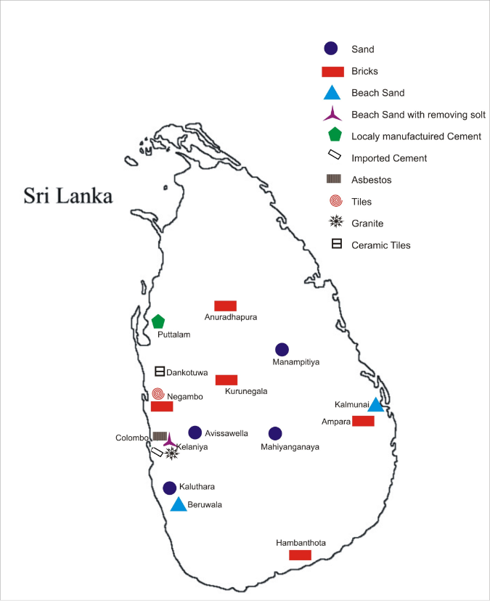
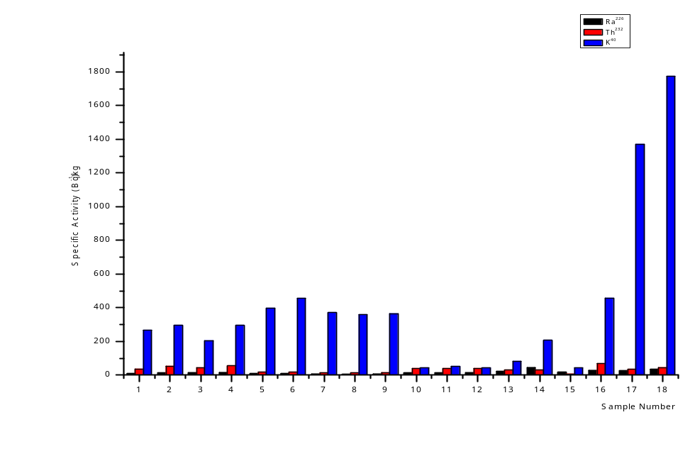Figure 1. Location map of the sampling points in Sri Lanka

Figure 2. Specific activities (Activity concentrations) measured using Ge detector

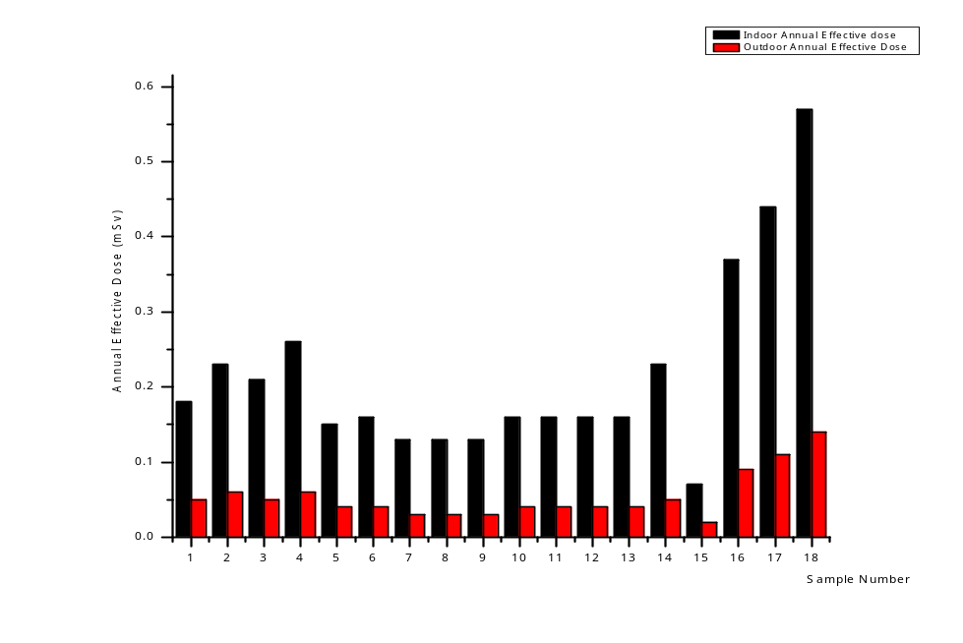

Figure 3. Annual effective doses of Sri Lankan building materials

References:
- Gupta, M., & Chauhan, R.P. (2011). Estimating radiation dose from building materials.
Iran. J. Radiat. Res, 9(3), 187 – 194.
- Merle, Lust, Enn, & Realo. (2012). Assessment of natural radiation exposure from
building materials in Estonia. Proceedings of the Estonian academy of Sciences,
61(2), 107.
- Shoeib, M.Y., & Thabayneh, K.M. (2014). Assessment of natural radiation exposure at radon
exhalation rate in various samples of Egyptian building materials. Journal of
Radiation Research and Applied Sciences, 174 – 181.
- United Nations Scientific Committee on the Effect of Atomic Radiation. (2000).
Source and effects of ionizing radiation. Report to the general assembly, 1,
Annex B.UNSCEAR.

Biography:
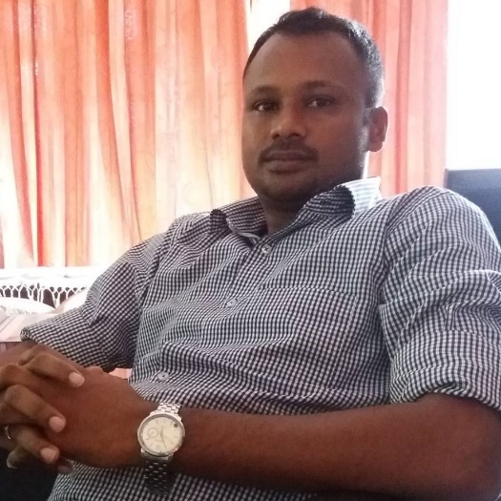
I have published below mentioned research paper as a corresponding author in Journal of Radiation Research and Applied Sciences (JRRAS) in ELSEVIER. It was available from 6th July 2018.
“Estimating natural radiation exposure from building materials used in Sri Lanka”
DOI: 10.1016/j.jrras.2018.07.001
I have completed M.Sc. degree in Physics of Materials at Post graduate institute of Science (PGIS) in University of Peradeniya in Sri Lanka on 5th December 2016. I have done above mentioned M.Sc. research project Sri Lanka Atomic Energy Board in Sri Lanka. Also I obtained B.Sc. degree in Applied Sciences (Physics, Chemistry) at Faculty of Applied Sciences in University of Rajarata from 2003 to 2007. I have worked as a trainee chemist of analytical laboratory of Holcim Lanka Ltd from 2008 to 2009. Under this I have participated Geocycle Asia Network Training Seminar in Bangkok in Thailand on September 2008. The topics of laboratory activities, quality acceptance, and quality control, operational health and safety were included this training seminar. Recently I worked as a research assistant at National Institute of Fundamental Studies (NIFS) in Sri Lanka from 15th June 2017 to 9th May 2018. Now I hope to join Sri Lankan university system as a lecturer for the subject of Materials Technology. Also I am seeking to receive Ph.D. scholarship for the subject of Material Science or Nuclear Physics.
E – mail: ruwanla@yahoo.com

