Title: Rapid sintering of unique material of LNT (Li₂O-Nb₂O₅-TiO₂) with periodical structure by air pressure control
Konatsu Kamimoto, Master, Toyohashi University of Technology, Aichi, JAPAN

Abstract:
In the Li₂O-Nb₂O₅-TiO₂ system, Li_{1+x−y}Nb_{1−x−3y}Ti_{x+4y}O₃ (0.05 ≤ x ≤ 0.3, 0 ≤ y ≤ 0.182) (LNT) forms with a superstructure known as the M-phase, which is formed by the periodical insertion of an intergrowth layer in a matrix with a trigonal structure. To apply this unique structure as a host material of phosphor, new phosphors have been investigated based on LNT or related structures made by a conventional electric furnace [1]. However, the synthesis of a homogeneous M-phase required treatment at 1373 K for over 24 h. The sintering time depended on the Ti content, and annealing was repeated in an electric furnace for 24–264 h until a homogeneous structure was formed by the insertion of periodical intergrowth layers [2]. Accordingly, a fast sintering technique that uses lower energy is required for the practical application of this material as phosphors and electroceramics.
This time, we pioneered a new rapid sintering technique, which uses a simpler furnace that only requires the control of air pressure.
The LNT solid solution material, with various Ti content of 15–30 mol%, was sintered at 1273 K–1373 K for 30 min–1 h under various air pressures (0.35 MPa–0.60 MPa) using the newly developed an air-pressure control atmosphere furnace (FULL-TECH FURNACE CO., Ltd., Osaka, Japan). To clarify the mechanism of the rapid sintering, various microscale to nanoscale characterization techniques were used: X-ray diffraction, a scanning electron microscope, a transmission electron microscope (TEM), a Cs-corrected scanning TEM equipped with electron energy-loss spectroscopy, and X-ray absorption ﬁne structure spectroscopy. As a result, the biggest grain of LNT with Ti 20 mol% could be synthesized at 1373 K for 30 min under 0.35 MPa (Fig. 1). It was confirmed that a homogeneous phase was obtained from the TEM image and selected area electron diffraction (SAED) patterns from the [010] axis.
We concluded that through the control of air pressure, the interstitial oxygen enabled rapid sintering with a combination of vacancies, and that accordingly, grain growth and the distribution of Ti ions improved somewhat surprisingly.
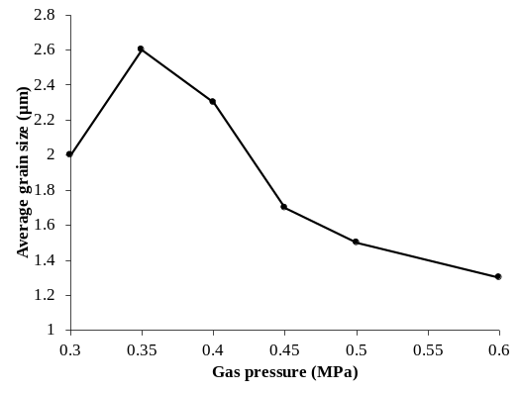
Figure 1 Relationship between average grain size and gas pressure.

Recent Publications
- H. Nakano, K. Kamimoto, N. Yokoyama, K. Fukuda, “The Effect of Heat Treatment on the Emission Color of P-Doped Ca₂SiO₄ Phosphor” Materials (2017) 10(9), 1000.
- H. Nakano, K. Kamimoto, T. Yamamoto, Y. Furuta, “Rapid Sintering of Li₂O-Nb₂O₅-TiO₂ Solid Solution by Air Pressure Control and Clarification of Its Mechanism” Materials (2018) 11, 987.
- K. Kamimoto, H. Nakano, “Rapid sintering of LNT (Li₂O-Nb₂O₅-TiO₂) with superstructure by air pressure control” The 35th International Korea-Japan Seminar on Ceramics (2018), 11/21-24.

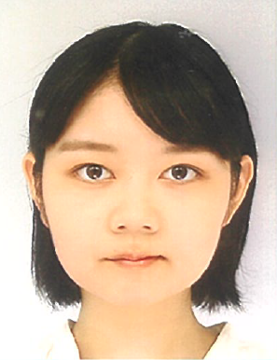 Biography: (150 words limit)

Konatsu Kamimoto is a graduate student of department of environmental and life sciences of Toyohashi University of Technology. She entered Toyohashi University of Technology in 2016 and is currently a graduate first grader. She belongs to the Inorganic Materials Laboratory, and she is doing synthesis and physical property evaluation of phosphors. Currently, she is focusing on elucidating the relationship between the crystal structure of the phosphor and the luminescent properties and analyzing the mechanism.
Email: k163413@edu.tut.ac.jp

