Title: Photoluminescence- and electric- properties using a smart material of Li-(Nb,Ta)-Ti-O system
Hiromi Nakano, Professor, Presidential Advisor, Toyohashi University of Technology, Toyohashi, Japan

Abstract: 300 words
In the Li₂O-M₂O₅-TiO₂ system, Li_{1+x-y}M_{1-x-3y}Ti_{x+4y}O₃ (M = Nb, or Ta, 0.06 ≤ x ≤ 0.33, 0 $≤y≤0.09$≤ y ≤ 0.175 (LMT) forms with a superstructure, and this is known as a smart material. The superstructure is formed by periodical insertion of an intergrowth layer of corundum-type [Ti₂O₃]²⁺ in a matrix having a trigonal structure during the grain growth for a long sintering time. To apply this unique structure as a host material of phosphor, new phosphors have been investigated based on LMT or related structures made by a conventional electric furnace and millimeter-wave heating. Rare earth (RE³⁺: Eu, Er, Tb, Tm, or Dy) doped LMT phosphors with various emitted colors were successfully synthesized. Especially, we synthesized a new red phosphor based on the quaternary Li_{1+x} (Ta_{1−z}Nb_{z})_{1−x}Ti_{x}O₃ (LTNT, 0 ≤ x ≤0.25, 0 ≤ z ≤ 1.0) solid solution. An Eu³⁺-doped LTNT has been prepared in a conventional electric furnace. Interestingly, a bright red emission due to the hypersensitive ⁵D₀-⁷F₂ transition in Eu³⁺ was observed under direct excitation of the 4f electron at 400 nm. In the LTNT host material, the most effective activator was found to be Eu ion and an internal quantum efficiency of 98% was achieved. We found that the high PL intensity was closely related to the polyhedral structure of the [Li (Eu) O₁₂] in the host material. Still more, toward application of the unique qualities of an electro-ceramic, we fabricated oriented the solid solution for Nb system (LNT) balk ceramics by slip casting in a strong magnetic field of 12 T using various sizes of particles. Anisotropic electric properties were found along the c-axis, which were caused by a superstructure. We first clarified the mechanism showing that the anisotropic Qf value was caused by the anisotropic electron conductivity and the anisotropic bonding strength in the superstructure.

Image:
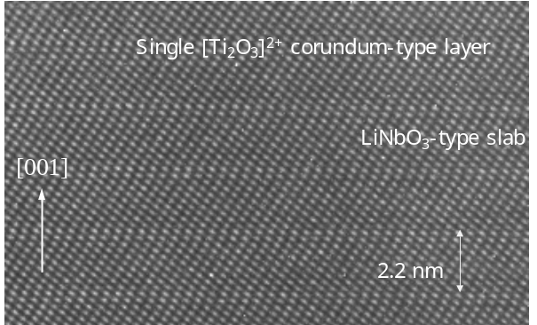
Figure 1 TEM image of superstructure for LNT with Ti-35 mol%.

Recent Publications:
- H. Nakano, K. Konatsu, T. Yamamoto, Y. Furuta, "Rapid Sintering of Li₂O-Nb₂O₅-TiO₂ Solid Solution by Air Pressure Control and Clarification of Its Mechanism" Materials, (2018) 11, 987.
- H. Nakano, K. Kamimoto, N. Yokoyama, K. Fukuda, "The Effect of Heat Treatment on the Emission Color of P-Doped Ca2SiO4 Phosphor", Materials (2017)10, 1000.
- H. Nakano, S. Furuya, M. Yuasa, T. Suzuki, H. Ohsato, "Fabrication and anisotropic electronic property for oriented Li_{1+x-y}Nb_{1-x-3y}Ti_{x+4y} solid solution by slip casting in a high magnetic field", Advanced Powder Technology 28 (2017) 2373-2379.
- H. Nakano, N. Yokoyama, H. Banno, K. Fukuda, "Enhancement of PL intensity and formation of core-shell structure in annealed Ca_{2-x/2}(Si_{1-x}P_{x})O₄:Eu²⁺ phosphor", Mater. Res. Bull. 83, (2016), 502-506.
5. S. Furuya, H. Nakano, N. Yokoyama, H. Banno, K. Fukuda, "Enhancement of photoluminescence intensity and structural change by doping of P⁵⁺ ion for Ca_{2-x/2}(Si_{1-x}P_{x})O₄:Eu²⁺ green phosphor", J. Alloys and Compds. 658 (2016), 147-151.
6. Y. Kinemuchi, H. Nakano, K. Kato, K. Ozaki, K. Kobayashi , "Decoupling grain growth from densification during sintering of oxide nano-particles", RSC Advances, 6 (2016), 24661-24666.
7. H. Nakano, S. Suehiro, S. Furuya, K. Fukuda, “Microstructural comparison between Nb- and Ta-systems in Li_{1+x-y}M_{1-x-3y}Ti_{x+4y}O₃ (M = Nb⁵⁺, Ta⁵⁺) solid solution with superstructure” J. Alloy. Compd., Vol. 618, pp. 504-507 (2015).

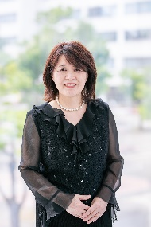

Biography: (150 words limit)
Dr. Hiromi Nakano, Dr. (Eng.), presently holds the post of professor of department of environmental and life sciences, and Cooperative research facility center of Toyohashi University of Technology. She received her B.S., M.S., and Dr. (Eng.) from Toyohashi University of Technology, Japan in 1981, 1983 and 2000, respectively. In 1983 she joined Murata Manufacturing Co., Ltd. then transferred to Ryukoku University in 1989. She joined the Cooperative Research Facility Center in Toyohashi University of Technology as an associate professor in 2009 and works as a professor and presidential advisor (Gender Equality) now. In 2010, she received the 64th CerSJ Award for Academic Achievements in ceramic science and technology. Her current interest is in the synthesis of new phosphors and characterization of ceramic materials using a transmission electron microscope to control the material properties and for the design of new materials.
Email:hiromi@crfc.tut.ac.jp

