A DFT investigation on multiferroism and magnetic coupling in NiBO₃ materials
Sergio Ricardo de Lazaro, PhD; Luis Henrique da Silveira Lacerda; Renan Augusto Pontes Ribeiro; Leonardo Konopaski Andreani, State University of Ponta Grossa, Ponta Grossa, BRAZIL

Abstract: 300 words
In technological field, the emergent materials are known as smart materials because present high sensibility and the ability to adapt to external stimuli. Among the smart materials stand out the multiferroic (MF) materials. The multiferroism effect is associated to the coexistence and coupling between magnetic ordering and ferroelectricity in the same crystalline phase. The most common form of multiferroism is called magnetoelectric (ME) coupling.[1-3] Some example of MF materials are: BiFeO₃ (BFO) which shows a unique set of electronic, optical, magnetic and ferroelectric properties and that can be easily obtained through an epitaxial growing on SrTiO₃ substrates; [4,5] the present abstract aim to show of new MF materials based on PbNiO₃ (PNO) materials with R3c structure considering an occupation in A and B sites. Therefore, the A sites were occupied by Ni atoms while the B sites were occupied by Ti, Ge, Zr, Sn and Hf atoms, respectively. The calculation level was choose as Density Functional Theory (DFT) at set B3LYP hybrid functional; employed in CRYSTAL09 software. For all materials investigated as ferromagnetic (FM) as antiferromagnetic (AFM) ordering were simulated. For NiTiO, the AFM ordering was calculated as more stable, in agreement to experimental and other theoretical results.[6,7] Similar result was calculated for NiHfO, i.e., an AFM ordering. However, the FM ordering was found for NiGeO, NiZrO, NiSnO and NiPbO materials suggesting a relation between structural regularity and magnetic phase. Along the y axis was not observed the formation of charge path between the atomic layers due to proximity between atoms. In case of z direction, discreet charge paths and charge polarization were observed while the higher polarization was exhibited along x direction once superiors charge paths and high polarization are formed. Thus, the ferroelectric properties in R3c materials are preferentially oriented in x direction in crystalline structure as expected for an anisotropic ferroelectric. The multiferroic effect was determined by analysis of magnetic and ferroelectric properties along x, y and z direction of unit cell; it was noted that the magnetic property is oriented along z axis, while the ferroelectric property is oriented preferentially along x axis. Hence, the coupling between both properties evidences a multiferroism effect on NiBO₃ (B = Ti, Ge, Zr, Sn, Hf and Pb) materials [8].
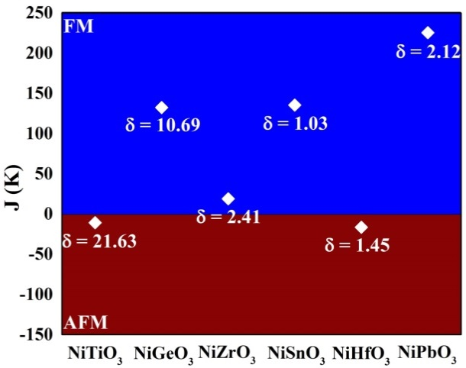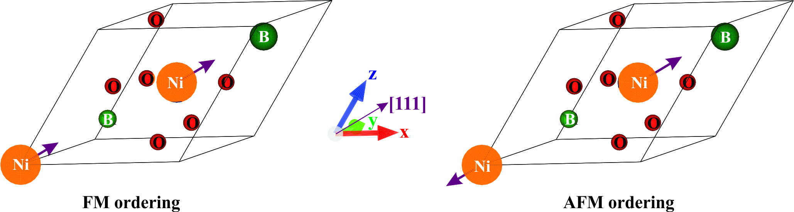
Figure 1: Magnetic coupling constant (J) for NiBO3 (B=Ti, Figure 2: Electrons oriented in [111] direction within R3c primitive cell. [8]
Ge, Zr, Sn, Hf, Pb) investigated materials. [8]

Recent Publications: (Minimum 5)
- S. Picozzi, K. Yamauchi, I.A. Sergienko, C. Sen, B. Sanyal, E. Dagotto, Microscopic mechanisms for improper ferroelectricity in multiferroic perovskites: a theoretical review, Journal of Physics: Condensed Matter, 20 (2008) 434208-434218.
- L.W. Martin, Y.H. Chu, R. Ramesh, Advances in the growth and characterization of magnetic, ferroelectric, and multiferroic oxide thin films, Materials Science and Engineering: R: Reports, 68 (2010) 89-133.
- S. Picozzi, C. Ederer, First principles studies of multiferroic materials, Journal of Physics: Condensed Matter, 21 (2009) 303201-303219.
- H. Tian, X.-Y. Kuang, A.-J. Mao, H.-J. Zhao, H. Li, F.-G. Kuang, Comparing hydrostatic-pressure- and epitaxial-strain-induced phase transitions in multiferroic PbNiO3 from first principles, Solid State Communications, 203 (2015) 75-80.
- L.W. Martin, R. Ramesh, Multiferroic and magnetoelectric heterostructures, Acta Materialia, 60 (2012) 2449-2470.
- A. Jain, S.P. Ong, G. Hautier, W. Chen, W.D. Richards, S. Dacek, S. Cholia, D. Gunter, D. Skinner, G. Ceder, K.A. Persson, The Materials Project: A materials genome approach to accelerating materials innovation, APL Materials, 1 (2013) 011002
- W. Wang, S. Wang, D. He, J.-a. Xu, Pressure induced phase transition of PbNiO3 from LiNbO3-type to perovskite, Solid State Communications, 196 (2014) 8-12.
- L. H. S. Lacerda, S. R. de Lazaro, Multiferroism and magnetic ordering in new NiBO3 (B=Ti, Ge, Zr, Sn, Hf and Pb) materials: A DFT study, Journal of Magnetism and Magnetic Materials, 465 (2018) 412-420.


Biography:
Sergio R. de Lazaro has his expertise in silico experiments, more specifically in solid state chemistry, defects, electronic structure, optical property, magnetism and surface. The main tool used is Density Functional Theory from CRYSTAL code. He proposes a new approach for properties in multiferroic materials and morphology analyses. He is full professor in State University of Ponta Grossa acting as referee in PCCP. Physical Chemistry Chemical Physics, Journal of Alloys and Compounds,, The Journal of Physical Chemistry and others. (orcid.org/0000-0001-9753-7936)
Email: srlazaro@uepg.br

