Tensile, Tribological and Damping behavior of MWCNT/GR/ND reinforced commercial purity aluminum hybrid nanocomposites
Dr. Girisha L, PES Institute of Technology and Management, Shivamogga, Karnataka, India

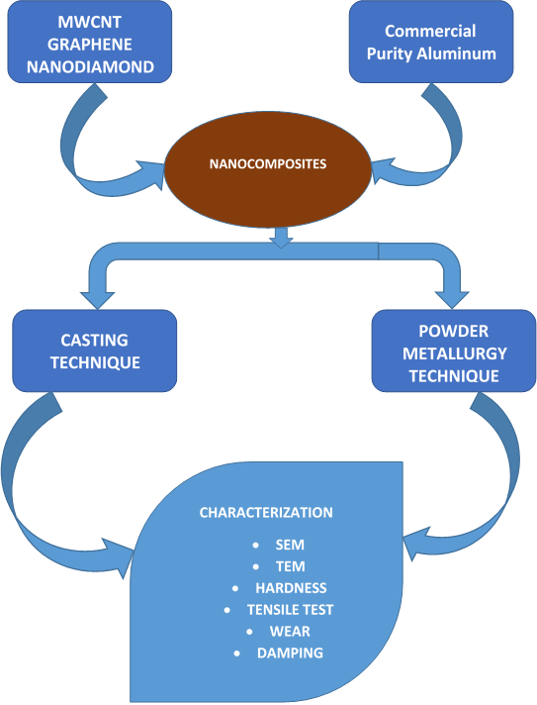

Abstract
Nanostructures are regarded as the ultimate fiber for reinforcement of matrices due to its excellent mechanical and electrical properties. Carbon nanotubes (CNT), Graphene (GR) and Nanodiamond (ND) have created an enormous amount of excitement in research across the world due to their extraordinary mechanical properties. These novel materials have opened up new avenue in the area of multi-disciplinary research and have continued to attract researchers worldwide. These nanostructures that exhibit the extraordinary strength and stiffness with low density are considered as ultimate fibers as reinforcing materials in matrix. The commercial purity aluminum is used as matrix for the present work. Nanostructures with their minute size, high aspect ratio and extraordinary strength were used to reinforce in commercial purity aluminum matrix. Nanocomposites were fabricated by casting and powder metallurgy techniques. Multiwalled carbon nanotubes (MWCNTs) /Aluminum nanocomposites fabricated by both the methods. Hybrid nanocomposites were also fabricated by adding Multiwalled carbon nanotubes (MWCNTs) and Graphene (GR) as reinforcement in commercial purity aluminum and Multiwalled carbon nanotubes (MWCNTs), Graphene (GR) and Nanodiamonds (ND) as reinforcements in commercial purity aluminum. In order to enhance the wetting phenomenon of the nanocomposites MWCNTs were surface coated with potassium fluro zirconate. These surface coated MWCNTs were used as reinforcements in aluminum matrix to fabricate the nanocomposites by casting and powder metallurgy methods and characterized for mechanical properties showed good improvement in both casted and powder metallurgy samples. The dry sliding wear behavior of the fabricated specimens is the one of the objective of the present work. As there are three different nanocomposites were fabricated by both cast and powder metallurgy techniques and with different weight fraction, the experiments to study the wear behavior were more. As more number of experiments to conduct, Taguchi’s orthogonal method is used to reduce the number of experiments. This method is used to analyze the Al/MWCNT nanocomposites, Al/MWCNT/GR hybrid nanocomposites and Al/MWCNTGR/ND hybrid nanocomposites. One of the objectives of this research is to investigate the damping properties of the Al/MWCNT nanocomposites, Al/MWCNT/GR hybrid nanocomposites and Al/MWCNTGR/ND hybrid nanocomposites. From the investigation, powder metallurgy composites have better damping ability than casted composites. It is observed from the free vibration test data, both cast and powder metallurgy specimens have shown significant improvement in damping ratio and natural frequency. Increase in weight percentage of MWCNT beyond 0.5 leads to deterioration in damping ratio and natural frequency.



Figure 1: Hybrid nanocomposites processed by Cast and powder metallurgy techniques

Recent Publications
- Harish G V , Girisha L, Malteshkumar Deshpande, Mahanthesh M R. “Sliding Wear Behavior of Epoxy Based Composites”, International Journal of Engineering and Advanced Technology (IJEAT) ISSN: 2249-8958, Volume-8 Issue-5, June 2019, PP 1314 – 1318.
- Malteshkumar Deshpande, Dr. Girisha L, Kiran T M and Manjunath H K, “Design and Performance of Ball Milling for Powder Metallurgy Composites”, International Journal of Engineering Research & Technology (IJERT), Vol. 7 Issue 7, Special Issue 2019, ISSN: 2278-0181, pp 1-3.
- Dr. Girisha L, Harish G V, Malteshkumar Deshpande, Sachi Gowda S and Ashish K S, “Mechanical Characterization of Asbestos Free Polymer based Brake Liners”, International Journal of Engineering Research & Technology (IJERT), Vol. 7 Issue 7, Special Issue 2019, ISSN: 2278-0181, pp 1-6.
- Ramya. C. R, Dr. Girisha L,Koushik P K, Harish G V and Ravi C C, “Comparison of Performance Parameters of Mild Steel in EDM Process using Copper and Brass Tool”,International Journal of Engineering Research & Technology (IJERT), Vol. 7 Issue 7, Special Issue 2019, ISSN: 2278-0181, pp 1-3.
- Girisha L, Malteshkumar Deshpande, Gururaja Lakshman Naik, Mahanthesh M R, “Mechanical Characterization of Nanomaterial Reinforced Aluminum-based Hybrid Nanocomposites”, Advanced Nano Research, Volume 2, Issue 1, pp 32- 41, 2019, ISSN: 2581-5164, DOI: https://doi.org/10.21467/anr.2.1.32-41

Biography
Dr, Girisha L is working as Associate Professor in PES Institute of Technology and Management, from last four years. He is having 17 years of teaching experience. He is active in research from last 8 years and his area of research interest are Nanomaterials, nanocomposites, vibrations, denture base materials, friction materials. He has completed his Engineering graduation in Mechanical Engineering, Masters in Machine Design and PhD in Nano hybrid materials. He has 15 international journal publications and guiding 3 PhD scholars.

