EFFECT OF CEO₂ INCORPORATION IN NI/YSZ ANODE MATERIALS ON ELECTRICAL PERFORMANCE OF SOLID OXIDE FUEL CELL

Dr RANJAN KUMAR PATI, PhD, Department of Science, School of Technology, PDPU, Gandhinagar, INDIA
Dr ABHIJIT RAY, PhD, Solar Research & Development Center, PDPU, Gandhinagar, INDIA
Dr INDRAJIT MUKHOPADHYAY, PhD, Solar Research & Development Center, PDPU, Gandhinagar, INDIA

Abstract (300 word limit)
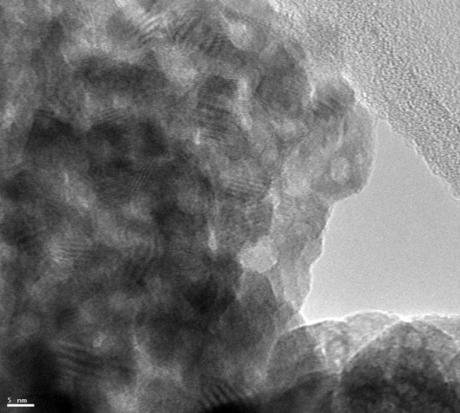
Solid oxide fuel cells are a class of an electrochemical conversion device characterized by the use of a solid oxide material as the electrolyte. The use a solid oxide electrolyte in SOFCs is to conduct negative oxygen ions from cathode to anode. The electrochemical oxidation of the oxygen ions with hydrogen or carbon monoxide thus occurs on the anode side. SOFCs operate at very high temperatures, typically between 800 and 1000 °C. At these temperatures, SOFCs do not require expensive catalyst materials, as is currently necessary for lower-temperature fuel cells such as PEMFC. Although impressive progress has been made in the development of alternative anode materials with mixed conducting properties, Ni/YSZ continues to be the most sought for high temperature SOFC applications so far. Despite of its poor carburization and sulfidation capabilities during the operation of SOFC directly on hydrocarbons, Ni/YSZ continues to be the most widely used anode electrode material because of its high catalytic activity for hydrogen oxidation, hydrocarbon reforming, high electronic and ionic conductivity and durability. The present study explains the effect of ceria incorporation into Ni/YSZ cermet anode layers on the performance of button-cell solid oxide fuel cells operating with n-butane/steam fuel feeds. A series of Ni/CeO₂/YSZ Anode materials were prepared by changing the metal ion concentration. The materials were characterized by powder XRD, and HRTEM. The electrochemical performance was tested at realistic condition on a single cell SOFC. Comparison of the performance with and without the ceria indicated improvements for operation with doped ceria for direct n-butane/steam feeds. For initial cell performance, ceria addition to the anode materials offered improved performance with higher power densities using n-butane suggesting that ceria may enhance water-gas-shift reactions and thereby increase H₂ availability for more effective electrochemical oxidation in the anode layer.

Image


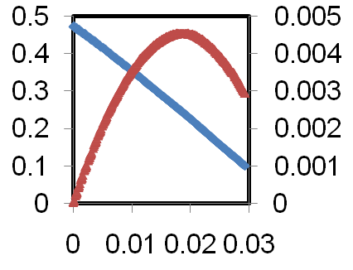

Recent Publications
- Park S, Gorte RJ, Vohs JM, (2016) Applications of heterogeneous catalysis in the direct oxidation of hydrocarbons in a solid-oxide fuel cell Applied Catalysis A: General 200 (1–2): 55-61
- Patel S, Jawlik PF, Wang L, Jackson GS, Almansoori A, (2012) Impact of Cofiring Ceria in Ni/YSZ SOFC Anodes for Operation with Syngas and n-Butane, J. Fuel Cell Sci. Technol, 9(4): 041002
- Atkinson A, Barnett S, Gorte RJ, Irvine TS, McEvoy AJ, Mogensen MB, Singhal S, and Voh JM, (2004) Advanced Anodes for High Temperature Fuel Cells, Nature Materials, 3: 213-223
- Liu M, Ding D, Bai Y, He T, and Liu M (2012) An Efficient SOFC Based on Samaria-Doped Ceria (SDC) Electrolyte, J. Electrochem. Soc. 159(6): B661-B665
- Xu X, Zhou W, Zhu Z (2013) Samaria-Doped Ceria Electrolyte Supported Direct Carbon Fuel Cell with Molten Antimony as the Anode, Ind. Eng. Chem. Res., 52: 17927-17933

Photograph


Biography (150 word limit)
Dr Pati has his expertise in synthesis, characterization and evaluation of the properties of nanocrystalline materials used in energy applications. He has completed his PhD from Indian Institute of Technology Kharagpur and worked as a scientist at the Chemical and Biomolecular Engineering at the University of Maryland. Dr Pati’s research area is mainly on different kinds of fuel cell materials and his group is working on new materials which are used at low temperature SOFC.
Email: ranjan.pati@sse.pdpu.ac.in

