Miniaturization of patterns formed in non-homogeneous soft thin film
Sunita and Jayati Sarkar*
Department of Chemical Engineering, Indian Institute of Technology, New Delhi-110016, India
*Corresponding author: jayati@chemical.iitd.ac.in

Abstract
We are focused to find different techniques to create, miniaturized patterns on such soft interfaces to enhance surface properties like hydrophobicity, adhesiveness, optical and catalytic. In the present work, we study the instability and morphology of a thin incompressible, inhomogeneous elastic soft film, whose shear modulus is exponential function or arbitrary function of film thickness. A LSA (linear stability analysis) has been done to obtain the minimum stress or force required to perturb the top surface of the film. In our study we obtained the smaller length scale features can be formed at the interface in these anisotropic (non-homogeneous) materials where the anisotropy exists only in the normal direction. The present work constituted the range of length scale of instability is $0.3h<λ<2.96$, lower critical stiffness from LSA and total energy minimization, to look out the evolved morphology with high aspect ratio at the interface of film and contactor. Similar length scale of instability can be obtained using different techniques like patterned substrates and bilayers where it was possible to decrease the length scale by about an order of magnitude than those formed in simple elastic thin films because of antagonistic energies (elastic and interaction) present. These techniques are also cost effective than the existing techniques of lithography suitable for hard materials. The LSA gives a 4th order ordinary differential equation, which cannot be solved analytically, so we discretized it using finite difference method with 2nd order accuracy throughout the process. The studies involved numerical techniques for energy minimization, and also finite element schemes to tackle non-linearities.

Biography
Image
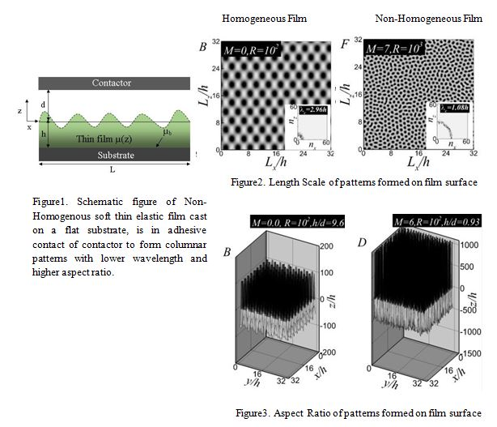
Recent Publications
- Kotni, T. R.; Khanna, R.; Sarkar, J. Kinetics of Sub-Spinodal Dewetting of Thin Films of Thickness Dependent Viscosity. J. Phys. Condens. Matter 2017, 29 (17).
- Wu, Z.; Meng, J.; Liu, Y.; Li, H.; Huang, R. A State Space Method for Surface Instability of Elastic Layers With Material Properties Varying in Thickness Direction. J. Appl. Mech. 2014, 81 (8), 081003.
- Tomar, G.; Sharma, A. Contact Instabilities of Anisotropic and Inhomogeneous Soft Elastic Films. Phys. Rev. E - Stat. Nonlinear, Soft Matter Phys. 2012, 85 (2), 1–8.

- Chen, S.; Yan, C.; Soh, A. Adhesive Behavior of Two-Dimensional Power-Law Graded Materials. Int. J. Solids Struct. 2009, 46 (18–19), 3398–3404.
- Lee, D.; Triantafyllidis, N.; Barber, J. R.; Thouless, M. D. Surface Instability of an Elastic Half Space with Material Properties Varying with Depth. J. Mech. Phys. Solids 2008, 56 (3), 858–868.

Sunita is currently pursuing her Ph.D. at the department of Chemical Engineering at the Indian Institute of Technology Delhi. Her Doctoral research is focus on ‘Instabilities in thin films with material property variation' under the supervision of Dr. Jayati Sarkar. Instabilities in terms of surface morphology, created different patterns in thin polymeric film are of great demand in high end technologies like functional coatings, tissue engineering, electronics and others. Pattern formation through self organization technique in soft thin films, (freely standing or confined ) in the presence of an internal or an external force field like van der Waals or electrostatic forces, has gained a lot of momentum in the last decade because of the cost and time effective edge it offers over other conventional hard lithographic technique.She received her Master Of Technology Degree (M-Tech) from Indian Institute of Technology Guwahati (IITG), India in 2012,where she worked on “Electric Field induced instabilities in thin dielectric bilayer: influence of slippage” under the supervision of Prof. Dipankar Bandoypadhyay. She obtained her bachelor’s degree from M.B.M. engineering college, Jodhpur Rajasthan, India in 2010.

Email: chz148179@chemical.iitd.ac.in.com

