Nano-fabrication of individual nano-devices using mechanical bottom-up nano-assembling and nanomanipulation using shape memory alloy nano-gripper
PhD, Dr Svetlana von Gratowski, IRE RAS, Moscow, Russia
PhD, Dr., Dr habil. Victor Koledov, IRE RAS Moscow Russia

Abstract (300 word limit)
Nowadays many different types of nano-sized materials, like nanoparticles and nanostructures, especially 1D-nanotubes, nanowires (NWs), 2D-nanomaterials such as graphene etc. have been discovered and intensively studied. Nanomaterials as the bulk materials and also as single nanoobjects demonstrate the unique functional properties. Functional properties of single nanoobjects allowing to design many individual nanodevices based on single nanoobjects have been tested recently and have led to a wide range of proofs of the concept of individual nanoscale devices. Those individual nanodevices include NWs- and CNTs-based nano-sensors, FET, nanolasers, etc. Such single nanodevices represent attractive building blocks for a hierarchical assembly of micro/macrodevices. The bottleneck of the design of such nano/micro/macrodevices is missing of the technology for the hierarchical assembly of micro/macrodevices from those individual nanodevices.
The report suggests frontier nanotechnology for the hierarchical assembling of nano/micro/macroscopic functional devices using individual nanoscale building blocks. There are 5 main steps in this “bottom-up” approach for the production of nanodevices: 1) to tailor nanomaterials; 2) to worked out the surface of the nanomaterial; 3) cut nanomaterials into individual components; 4) to organize these components into nanodevices; 5) to interconnect and unite single nanodevices together in micro/macro World. The last 4th and 5th steps are still challenge in modern nanotechnology. In the present report the prospective applications of the new 3D nanomanipulation system based on the smallest and fastest shape memory nanogrippers is discussed. This design system is experimentally proved to provide 3D manipulation of the real nano-objects like NW, graphene etc. In the report the examples of the experimental nanomanufacturing of nano/microdevices, using alternative “bottom-up” mechanical nano-assembly. This breakthrough technology pretends in many cases to compete the manufacturing approaches based on expensive currently available “topdown” nanolithography.

Image
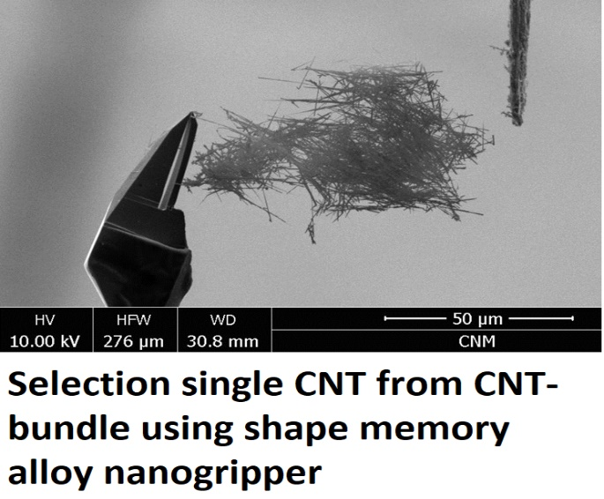
Recent Publications (minimum 5)
- Koledov, V., von Gratowski, S., Nguyen, H. D. (2019). Nano-manipulation and nano-assembling using shape memory alloy nanogripper of metal oxide and semiconductor single nanowires and nanoparticles for biological nanosensors. Advances in Natural Sciences: Nanoscience and Nanotechnology, 10(3), 035003.
- Koledov, V., Shavrov, V., Fawzy, M., Blumenthal, M., von Gratowski, et al (2015). Nano-nanomanipulation of CdSe nanowires using nano-tweezers based on shape memory alloys. In 2015 3M-NANO, pp. 69-73. IEEE.
- von Gratowski, S., Koledov, et al (2018). Advanced System for Nanofabrication and Nanomanipulation Based on Shape Memory Alloy. In Frontiers in Materials Processing, Applications, Research and Technology (pp. 135-154). Springer, Singapore.
- Serdyuk, V. M., Titovitsky, J. A., Von Gratowski, S. V., & Koledov, V. V. (2018). Spatial Structure of Electromagnetic Field Diffracted by a Sub-Wavelength Slot in a Thick Conducting Screen. Progress In Electromagnetics Research, 69, 15-22.
- Zhao, X., Neves, F., Correia, J. B., Liu, K., Fernades, F. B., Koledov, V., (2018). Mechanical activation of pre-alloyed NiTi 2 and elemental Ni for the synthesis of NiTi alloys. Journal of materials science, 53(19), 13432-13441.
- Kamantsev, A. P., Koledov, V. V., Von Gratowski, S. V.,. (2019). Interaction of Optical and EHF Waves With VO 2 Nanosized Films and Particles. IEEE Journal of Electromagnetics, RF and Microwaves in Medicine and Biology, 3(1), 17-24.
- Zhikharev, A. M., Irzhak, A. V. (2016, August). New system for manipulation of nanoobjects based on composite Ti2NiCu/Pt nanotweezers with shape memory effect. In Journal of Physics: Conference Series (Vol. 741, No. 1, p. 012206).

Photograph

 Biography (150 word limit)
Dr von Gratowski has her expertise in research in nanotechnology, nano-manipulation, nano-assembling, shape memory alloys. She has had invented and suggested frontier mechanical bottom up nano-assembling, nano-manufacturing and nano-fabrication of single nanodevices based on individual nano-objects using the smallest and the fastest shape memory alloy nanogripper. This technology opens up perspective of the creation of single nano/micro and macro devices from individual nanotubes, nanowires and other nano-objects. Mechanical bottom up nano assembling is going to overcome the presently existing barrier of the integration of variety of nanoobjects and nanodevices with each other and with convectional integrated circuits. Moreover, the novel technology will provide products not only with the next level high quality, but also extremely low cost. This breakthrough nanotechnology will be affordable for small groups with small modest budget in science, education and SME.
Email: Svetlana.gratowski@yandex.ru

Notes/Comments:

