Stimulation of fracture healing in a murine osteoporosis model by pasty bone cement functionalized with brain-derived neurotrophic factor
¹Lips KS PhD, ¹Kauschke V PhD, ¹Schneider M, ¹Jauch A, ²Kampschulte M MD, ³Rohnke M PhD, ³Bamberg C, ⁴Schuhmacher M PhD, ⁴Gelinsky M PhD, ^{1,5}Heiss C MD
¹Experimental Trauma Surgery, Justus-Liebig-University Giessen, Germany
²Department of Radiology, University Hospital of Giessen-Marburg, Campus Giessen, Germany
³Institute of Physical Chemistry and Center of Material Research, Justus-Liebig-University Giessen, Germany
⁴Centre for Translational Bone, Joint and Soft Tissue Research, Medical Faculty and University Hospital, Technische Universität Dresden, Germany
⁵Department of Trauma, Hand and Reconstructive Surgery, University Hospital of Giessen-Marburg, Campus Giessen, Germany

Abstract (300 word limit)
Introduction: Fragile bone with altered microarchitecture and increased fracture incidence is characteristic for osteoporosis. Failure of implant fixation and low osteoinductivity raises the quest for new supporting bone substitute materials. Brain-derived neurotrophic factor (BDNF) is a growth factor that enhances in vitro the vitality of bone forming osteoblasts but not bone resorption by osteoclasts. Here, we asked whether integration of BDNF into pasty calcium phosphate cement (pCPC) via coating of mesoporous bioglas particles (MBG) is able to stimulate fracture healing in a murine osteoporosis model. Methodology: Female 16-week-old muscarinic acetylcholine receptor M3 knockout mice (M3KO) and their corresponding wild type mice (WT) were used as osteoporosis model and underwent osteotomy and implantation of a mixture of BDNF functionalized MBG and pCPC (pCPC+MBG+BDNF). After a post-operational duration of 35 days, femurs were extracted and analyzed. Findings: The implants were well-integrated into the fracture gap and showed a good biocompatibility. We observed the dissolution of MBG after reaching the implant interface by forming pores that were subsequently filled with new built yet not mineralized bone. An increase of new built bone was found in fracture gap and at implant interface of WT treated with pCPC+MBG+BDNF compared to the group without BDNF. The non-operated contralateral femur of M3KO showed signs of bone loss compared to the contralateral femur of WT mice. After application of BDNF the bone loss in M3KO was reversed. Additionally, we measured a decrease in number of leucocytes in M3KO with pCPC+MBG+BDNF compared to without BDNF. Conclusion: The new BDNF containing implant was able to enhance bone formation in WT mice. In M3KO mice, BDNF stimulated the reversion of bone loss and was involved in the regulation of immune cells. Thus, BDNF is suitable for functionalization of bone substitute materials and treatment of osteoporotic fractures.

Image
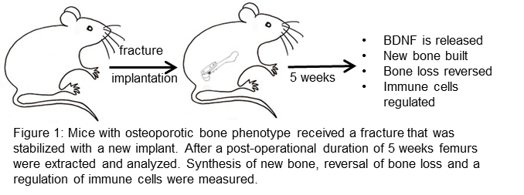
Recent Publications (minimum 5)
- Baumann L et al. (2019) Deletion of nicotinic acetylcholine receptor alpha9 in mice resulted in altered bone structure. Bone 120:285-296.
- Kauschke V et al. (2019) High concentrations of polyelectrolyte complex nanoparticles decrease activity of osteoclasts. Molecules 24(12).
- Kauschke V et al. (2018) Effects of pasty bone cement containing brain-derived neurotrophic factor-functionalized mesoporous bioactive glass particles on metaphyseal healing in a new murine osteoporotic fracture model. Int J Mol Sci 19(11).
- Lips KS et al. (2015) Altered ultrastructure, density and cathepsin K expression in bone of female muscarinic acetylcholine receptor M3 knockout mice. Int Immunopharmacol 29(1):201-207.
- Kilian O et al. (2014) BDNF and its TrkB receptor in human fracture healing. Ann Anat 196(5):286-295.

Photograph

Biography (150 word limit)
Prof Dr Katrin S. Lips is an expert in analyzing the cellular compatibility of new implants and bone substitute materials and investigates signaling pathways in the musculoskeletal system. She is the head of the Experimental Trauma Surgery at the University of Giessen where several animal models and in-vitro system are established that allow the investigation of new implants with suitable cell and molecular biological methods. The Experimental Trauma Surgery is connected with the Clinic of Trauma, Hand and Reconstructive Surgery at the University Hospital of Giessen-Marburg Campus Giessen and uses core facilities of the University of Giessen to improve the methodical repertoire with radiological, physical, chemical, and immunological methods.
Email: Katrin.S.Lips@chiru.med.uni-giessen.de

Notes/Comments:

