Functionalized Covalent Organic Frameworks (COFs) for Photocatalytic Hydrogen Generation
Dr. Pradip Pachfule, PhD, Department of Chemistry / Functional Materials, Technical University Berlin, Germany.
Prof. Arne Thomas, PhD, Department of Chemistry / Functional Materials, Technical University Berlin, Germany.

Abstract
Covalent organic frameworks (COFs) are crystalline, highly porous, two- or three-dimensional polymers with tunable topology and functionalities. COFs consisting of inbuilt micropores are getting considerable attention due to their tunable pore sizes, high surface areas, enhanced chemical stabilities and easier large-scale synthesis.¹ Because of their higher chemical stabilities in comparison to their boron-linked counterparts, imine or β-ketoenamine linked COFs have been utilized for a broad range of applications, including gas storage, heterogeneous catalysis, energy storage devices and proton-conductive membranes.²⁻⁴ Herein, we report the synthesis of highly porous acetylene (-C≡C-, TP-EDDA) and diacetylene (-C≡C-C≡C-, TP-BDDA) functionalized β-ketoenamine COFs, which are synthesized through the condensation of aryl amines and aldehydes under acid-catalyzed solvothermal conditions. These novel COFs have been applied as photocatalyst for hydrogen generation from water. It is shown that the diacetylene moieties have a profound effect, as the diacetylene-based TP-BDDA largely outperforms the acetylene-based TP-EDDA in terms of photocatalytic activity. As a combined effect of high porosity, easily accessible diacetylene (-C≡C-C≡C-) functionalities and considerable chemical stability, an efficient and recyclable heterogeneous photocatalytic hydrogen generation is achieved for TP-BDDA COF holding the diacetylene (-C≡C-C≡C-) moieties.⁵ Recently, we have extended our library of photocatalytically active materials to the triazine-based fully conjugated COFs for their applications in highly active and recyclable photocatalysis.⁶

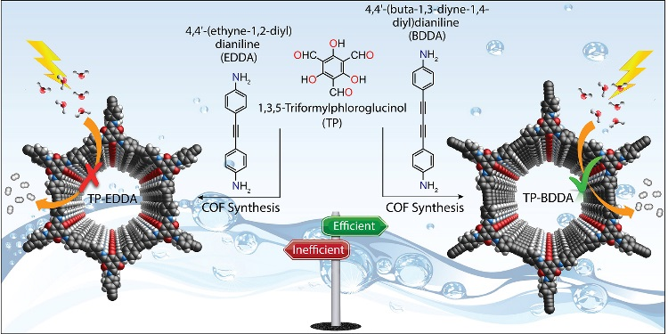

Figure 1: Acetylene- and diacetylene-based TP-EDDA and TP-BDDA COFs for photocatalytic hydrogen generation.

Recent Publications
- J. W. Colson and W. R. Dichtel, Nat. Chem., 2013, 5, 453–465.
- X. Feng, X. Ding and D. Jiang, Chem. Soc. Rev., 2012, 41, 6010–6022.
- J. Roeser, K. Kailasam and A. Thomas, ChemSusChem, 2012, 5, 1793-1799.
- P. Pachfule, S. Kandambeth, D. D. Diaz and R. Banerjee, Chem. Commun., 2014, 50, 3169-3172.
- P. Pachfule, A. Acharjya, J. Roeser, T. Langenhahn, M. Schwarze, R. Schomäcker, A. Thomas and J. Schmidt, J. Am. Chem. Soc., 2018, 140, 1423-1427.
- A. Acharjya, P. Pachfule, J. Roeser and A. Thomas, Manuscript submitted.

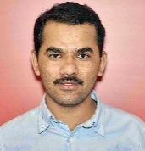
Biography: Pradip Pachfule
Pradip finished his Ph.D. at the National Chemical Laboratory, Pune (India) under the guidance of Prof. Dr. Rahul Banerjee, where he worked on synthesis of functionalized and interpenetrated MOFs, H₂ storage and CO₂ sequestration. Further, he worked as a JSPS postdoctoral fellow in the lab of Prof. Qiang Xu in National Institute of Advanced Industrial Science and Technology (AIST), Ikeda, Osaka (Japan), where his research topic includes the synthesis of MOF-derived materials for catalysis and electrochemical energy applications. Currently, he is working in the department of functional materials at Technische Universität Berlin as an Alexander von Humboldt fellow, under the supervision of Prof. Dr. Arne Thomas. He is interested in the synthesis and post-synthetic modification of covalent organic frameworks for catalytic applications.
Email: ps.pachfule@gmail.com

