Moving from a Linear Economy to a Circular Economy: Investigation into the Development of a ‘Green’ Coloration Method for Cotton
X Mutter, Dr M Rigout, Prof CM Carr
University of Leeds, UK
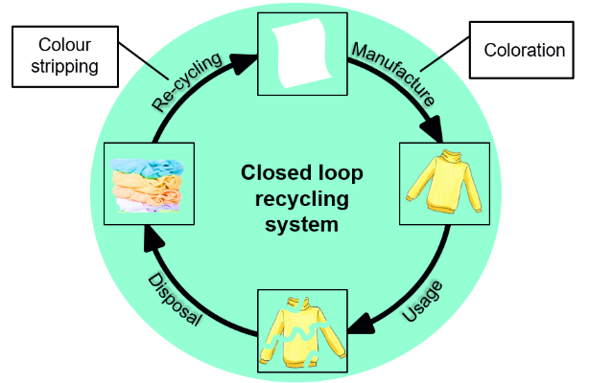

Abstract
The common requirement for coloured textile garments is to have a high level of colour fastness for durability and a long garment lifetime. However, based on a consumer research by WRAP in 2016 the average lifetime of clothing was estimated to be only 3.3 years before the products are discarded or passed on.¹ Discarded garments, also labelled as post-consumer waste, are generally reused, recycled, incinerated or put into landfill. Waste textiles in landfill could result in the production of leachate, potentially polluting ground- and surface water and incineration of textile waste for energy recovery generates ash and toxic gases.^{2, 3} Reuse or recycling of textile waste is suggested to be the better alternative as it could reduce waste and simultaneously prevent the production of more waste. Current recycling limitations include the dyestuff content of textile waste possibly inhibiting chemical recycling.⁴ There is clear need to investigate the removal and potential recovery of dyestuff from waste garments, to accommodate the reuse of the fibres. The main aim of the research is to use natural resources for the production of a binder for the coloration of cotton via ink jet printing. This binder is ideally relatively easy removable using benign chemistry without affecting the colour quality during the garments’ lifetime.
The work described comprises initial experiments using polyamideamine epichlorohydrin (PAE) resin as a starting material for the innovative production of a binder. PAE is generally used as a wet-strength agent in the paper industry and some research has been done on the interaction between PAE and cellulose.^{5, 6} The binder material is applied to cotton fabrics and characterized using Scanning Electron Microscopy, Energy Dispersive X-ray spectroscopy, Raman Spectroscopy and Fourier-Transform Infrared Spectroscopy.

Figure 1. Suggested closed loop recycling system for Cotton garments.

References
- WRAP (2017). Valuing our Clothes: the Cost of UK Fashion.
- Castillo, M, Barcelo, D (2001). Characterisation of Organic Pollutants in Textile Wastewaters and Landfill Leachate by Using Toxicity-Based Fractionation Methods Followed by Liquid and Gas Chromatography Coupled to Mass Spectrometric Detection. Analytica Chimica Acta. 426, 253-264.
- Palm, D (2011). Improved Waste Managament of Textiles – Project 9 Environmentally Improved Recycling.
- Bigambo P, Liu, H, Broadbent PJ, Carr, CM, Rigout, M (2018). Surface Chemical and Colorimetric Analysis of Reactively Dyed Cellulosic Fabric. The Effect of ISO 105 C09 Laundering and the Implications for Waste Cellulosic Recycling. Dyes and Pigments, 148, 91-98.
- Dunlop-Jones, N (1991). Wet-Strength Chemistry. In: Paper Chemistry. 76-96. Springer: Dordrecht.
- Siqueira EJ (2012). Polyamideoamine Epichlorohydrin-Based Papers: Mechanisms of Wet Strength Development and Paper Repulping. Doctoral dissertation, Grenoble.

 Biography
Miss Xenia Mutter is a third year PhD student at the University of Leeds, School of Design as part of the Technical Textile Research Group. She has her expertise in textiles, having completed her B.Eng. degree in Textile Engineering & Management at Saxion University of applied sciences in the Netherlands and her MSc degree in Advanced Textiles at the University of Leeds. She is currently working on a project investigating the development of a durable and ‘degradable’ binder for the coloration of cotton (-based) materials in order to facilitate subsequent recycling processes.
Email: sd15xmm@leeds.ac.uk

