Dysprosium doped Bi₄V₂O₁₁ nanoparticles and its application in visible-light photocatalytic degradation of Tetracycline drug.

Faria K. Naqvi Department of Chemistry, Aligarh Muslim University, Aligarh 202002
Prof. Saba Beg Department of Chemistry, Aligarh Muslim University, Aligarh 202002

Abstract
Recently Bi₄V₂O₁₁ as an electrolyte material has pulled in considerable consideration because of its remarkable novel applications. Bismuth-based oxides, for example, bismuth vanadate (BVO) has pulled in an enormous amount of consideration because of their magnificent properties, for example, protection from corrosion, non-toxic, Ferro elasticity and ionic conductivity. In this study novel, Dysprosium doped (x= 0.2, 0.3, 0.4, 0.5) Bi₄V₂O₁₁ (Dy/BVO) nanoparticles have been synthesized by sol-gel strategy. The photocatalyst Dy/BVO nanoparticles exhibit higher photocatalytic efficiency than BVO nanoparticles assessed by debasement of Tetracycline (TC) drug under visible light illumination. Our work focuses on the phase transformation, conducting properties and mechanisms of the Dy/BVO nanoparticles in relation to execute some methods of processing and manufacturing product in commercial applications. The characterization of Dy/BVO was performed by FT-IR, XRD, SEM, EDAX and UV-vis analysis. AC Impedance spectroscopy was used to analyse the conducting behaviour of synthesised nanoparticles in the temperature range 100-600°C. It is observed that for the high conducting γ phase is stabilised for the compositions 4% Dy/BVO and 5% Dy/BVO nanoparticles. The highest conductivity is observed for sample 5% Dy/BVO is 2.91 × 10⁻² Scm⁻¹ at 300°C. The photodegradation of the TC under visible light irradiation by BVO and Dy doped BVO nanoparticles have been done and it has been observed that the highest photocatalytic was shown by 5% Dy/BVO as compared to the other BVO nanoparticles. The photocatalytic activity also revealed that Dy/BVO remarkably enhanced the activity. This is the first report that Dy/BVO, can destroy the drug effluent which is coming from the drug industry and also worried about humen health hazards.

Image
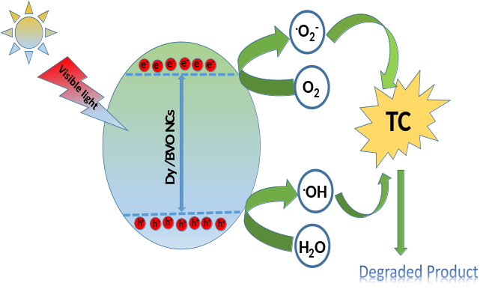
Figure 1: Proposed reaction mechanism for the photocatalytic degradation of TC using 5% Dy/BVO nanoparticles under visible light.
Recent Publications (minimum 5)
1. Faria K. Naqvi, M. faraz and Saba Beg “Synthesis and Phase Transformation Studies of Dysprosium-Doped Bi4V2O11 Nanoparticles and Their Application in Visible Light Photocatalytic Degradation of Tetracycline Drug” ACS Omega 2018, 3, 11300−11306.
2. M. Faraz, Faria K. Naqvi, M. Shakir and Neeraj Khare Synthesis of “samarium-doped zinc oxide nanoparticles with improved photocatalytic
performance and recyclability under visible light irradiation” NewJ.Chem., 2018,42, 2295
3. M. Faraz. Ambreen Abbasi, Faria K. Naqvi, Neeraj Khare “Polyindole/cadmium sulphide nanocomposite based turn-on, multi-ion fluorescence sensor for detection of Cr3+, Fe3+ and Sn2+ ions” https://doi.org/10.1016/j.snb.2018.04.110
0925-4005/ 2018.
4. Khatoon, N.F.; Saba, B.; S, A.-A. N. A. AC impedance and
cyclic voltammetric investigations on BIPBVOX solid electrolyte.
Emerging Mater. Res. 2017, 6, 348−355.
5. Beg S, Naqvi FK and Al-Areqi NS (2014) Study on electrical
conductivity and phase transition in singly doped BIPBVOX
(Bi2V1–xPbxO5·5–x/2) solid electrolyte. Phase Transitions 87:
1225–1236.

Photograph

 Biography
Faria Naqvi currently works as a research scholar in the Department of Chemistry, Aligarh Muslim University. Faria does research in Nanotechnology, Physical Chemistry and Solid-state Chemistry. She has completed her M.Phil in 2016. She has also successfully completed one major UPCST research project 'Study on phase stability and compositionally dependent conductivity of new oxide ion conductors for Intermediate temperature –solid oxide fuel cells (SOFC’s)'. She has more than four years of research experience in the field of solid state and nanotechnology.
Email

